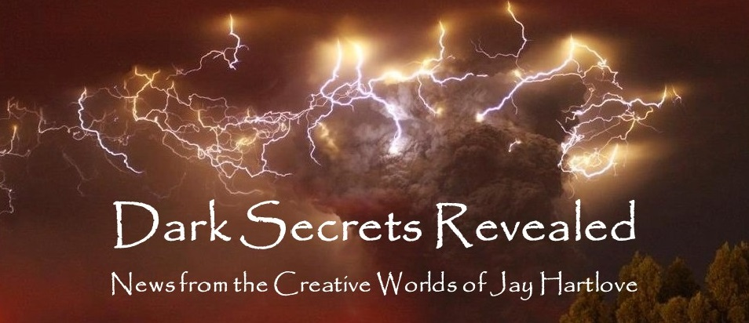

Issue 8 May 2023

Happy Beltane, May Day, and International Workers Day. This month I will be reporting on a different kind of creativity. I spent most of April getting ready for and working with Costume Con 39. My costuming career goes back to the 1970s and my involvement in running science fiction conventions started in the 1980s. I met my wife Denisen helping with a convention. She was directing a costume competition and was her Master of Ceremonies. Two weeks ago I revisited that job as the MC for not one costume show, but two. Read on for the full story.

In my Mr. Wizard advice column for writers, I talk about how to be prepared to answer an online interview. Often when you query a blog for a review, they’ll come back asking you for an interview in the form of a questionnaire. Having established stock answers can help you get back to them right away.

As I usually ask, please tell your friends about me and this newsletter. My most treasured connections have been from word-of-mouth referrals. Even more so, with this being the seventh edition, **I would love your feedback**. Are you finding these articles engaging? Entertaining? Helpful? This newsletter is for you. Let me know what is working, what isn’t, and what else you would like to see instead. Reach me directly at *jay.hartlove@gmail.com*.

Of course, I also have a web site [www.jaywrites.com](http://www.jaywrites.com) that tracks all my projects, past, present, and future. There is a listing (with links) of the interviews I have done in the last couple of years. I invite you to check it out.

Here are the usual newsletter columns:

1. What’s Cooking: Previews/discussion of what I am actively working on. Also links to interviews, appearances, and other current writing news.
2. Mister Wizard: Advice and analysis to help my fellow writers.
3. The Aisle Seat: Recommendations. I am a huge movie fan and watch several every month.
4. Have a Drink: Wherein I will share personal stories.

***What’s Cooking***

**Costume Con 39**

Costume Con is a yearly gathering of costume enthusiasts where they share their creations and teach each other techniques they have learned. All segments of costume fandom are welcome, from high fashion design to science fiction to historical to even fetish. It is a celebration of creativity. My friend Karen Schnaubelt started the first Costume Con in San Diego in 1982, after many years of folks displaying their work at science fiction conventions.

In 2018, before the pandemic hit in March 2019, my friend Jennifer “Radar” Riley won the bid to hold Costume Con 39 in San Jose in 2020. No one held any conventions in 2020, so CC 39 was postponed. Last year CC 40 was held due to hotel contracts that could not be changed, and CC 39 was moved to this year, even though that would mean the numbers would be out of sequence.

No big deal. We all thought it was an amusing reminder of how resourceful we have all been dealing with the pandemic. I bought a couple of memberships months ago, just to support our friend’s event. We haven’t made any new costumes to take to conventions in many years. I figured I would go even if only to help out backstage. Last fall I volunteered at WorldCon in Chicago as a Den Parent to assist entrants in the masquerade costume contest to get their outfits together and to guide them through the logistics of getting on and off stage. Having entered many such competitions over the years, I can usually be some help in the Green Room getting folks ready.

Three weeks before the convention, I got a call from my friend Dorothy O’Hare, who said the Director of the Science Fiction masquerade had to drop out, and Dorothy was the new emergency Masquerade Director. The previous Director never recruited an MC for the show. And could I step in as MC? I said yes. I have MC’d four other convention masquerades, and I wanted to help where I could. A chance to perform? You can take the kid out of the theater, but you can’t take the theater out of the theater kid.

What better impetus to make a new outfit than to be on stage in front of the entire convention? My wife and I consulted and we decided to re-create two outfits from Game of Thrones. In last month’s newsletter I showed the beginning of the work on the Olenna Tyrell dress. Later in this issue I will show you the rest of that work and the outfit I made for Oberyn Martell, my personality for MCing the SF&F Masquerade. Yes, we built these in three weeks.

Two weeks before the convention I got another call, this time from my friend Eric Anderson, who was the Director of the Historical Masquerade. His MC had a sudden change of plans and was not going to go to the show. And could I possibly MC that show as well? I referred him to call our friend Kevin Roche who has also MCd many shows. Turns out Kevin had recently been tapped to step in as the emergency Hotel Liaison for the convention. So I took the second job. I wore a vintage 1950s suit for that gig. I worked into my banter that I was wearing vintage, as opposed to the contestants who had all made their reproduction outfits from bygone eras.

Suddenly I was very busy making costumes for a convention where I was going to be the front man for the two biggest events of the weekend. No pressure. We got the outfits done (granted we were still sewing last detail in our hotel room on Saturday, but this is actually typical of these conventions. We looked great. See the pictures below.

I spent Saturday afternoon in tech rehearsal working with the sound and light guys and the contestants. The change in Director created some confusion for where the contestants emailed their audio files. We accidentally ended up with several different addresses where folks had sent their stuff. Most of the tech rehearsal was spent going through the email boxes finding the right files for each contestant. We thought we had found them all. We had not. During the show we discovered one file was missing. That entry needed to be bounced to the end of the show, when our sound guy thankfully did finally find the file. I did my best to cover the mix up and to keep the crowd entertained. There were other mixups as well, involving presentations of awards given out by various chapters of the International Costumers Guild, the society that helps organize the costuming community. The costumes were all very well done, with many spectacular entries and even some very funny presentations. We started with a line-up of 25, but after drops we ended the show with 20 presented. I think the audience had a good time. But the show lacked the professional pacing I was working to achieve.

With lessons learned, I returned to the battlefield ballroom Sunday for the tech rehearsal of the Historical Masquerade. Eric had been planning this show for months, and his preparation was clear. No lost files, each run-through was scheduled, all of the paperwork was organized. I thought we might have a fighting chance to redeem the previous night’s rough show. That night, everyone showed up and knew what they had to do. The crowd was enthusiastic. Maybe they were forgiving. Maybe they were hopeful. Maybe Saturday’s show hadn’t been as bad as I thought.

The show ran like clockwork. No missed cues, all the right audio files, all the right timing of script versus tape versus action on stage. When we got halfway through, I found myself doubting we would make it, but the entries kept running correctly. When we got to the end without a single hitch, we were ecstatic. The costumes were all very impressive for the care and work the entrants had poured into the creations. I was so glad we could give them such a clean show in which to show them off.

No, I did not get to any of the how-to classes. No, I did not get to see the other two fashion shows. Yes, I got to see lots friends from all over whom I had not seen in many years. It was an exhausting but wonderful weekend.

***Mister Wizard***

**Online Interviews**

When I was a kid in the 1960s, my mom would have daytime interview shows on the TV while she went about running the household. I recall vividly an episode of The Mike Douglass Show where he was reading and answering letters from fans. A viewer said he was an aspiring writer, and asked how could he get on the show. Mike looked straight into the camera and said, “Write the book first.” The rules for getting an interview have not changed.

Once you have written a book, you will want to query bloggers and magazines for them to write reviews. Lots of authors ask them, so their review calendars fill up. It takes them time to read and review a book. It does not take them time to send you a questionnaire that you fill out to create a written interview. They also need content. So it’s a win-win. If an outlet sends you such a questionnaire, it’s best to have your story straight. This is not just a matter of answering their questions, but also a chance to sell your brand. As with any interview, you want to slip in what you have to say while answering what they asked you to say.

First off, you will want to have a bio that is 200 words or less. If you have a particular audience, then have an explanation of who they are and how your work appeals to them. If you have a theme in your writing, you will want a clean pitch so if a reader likes it, they will go buy your books. Whatever brand you have as a writer, be sure to insert it into your answers wherever you can. Remember, you are giving the blogger content and they are giving you a platform.

I recently was offered an interview by Lisa Haselton for her blog <https://lisahaselton.com/blog/>. These are the answers I sent her.

1. Author name: Jay Hartlove

2. Website (and any other links you’d like included: Facebook, Twitter, buy pages, etc.): [www.jaywrites.com](http://www.jaywrites.com)

<https://www.facebook.com/jayhartlovewriter>

<https://waterdragonpublishing.com/book-author/jay-hartlove/>

<https://www.amazon.com/stores/Jay-Hartlove/author/B00ALFXRZY?ref=ap_rdr&store_ref=ap_rdr&isDramIntegrated=true&shoppingPortalEnabled=true>

3. Title of book we’re promoting: Mermaid Steel

4. Genre of book: Fantasy Romance

5. Bio: Jay Hartlove is the multiple award-winning author of the supernatural thriller Goddess Rising Trilogy, about which horror master John Shirley said, “I recommend you buy this crazy novel.” Jay also wrote the fantasy romance Mermaid Steel, which Kirkus Reviews called, “A thoughtful erotic fantasy that asks us to see the best in each other.” His latest novel is The Insane God, which David Brin endorsed, and Kirkus Reviews called, “Nightmare on Elm Street meets The Stand.” Jay also wrote, produced, and directed The Mirror’s Revenge, the musical sequel to Snow White, which had its theatrical run in the San Francisco Bay area in 2018 to rave reviews. He loves to take stories where the reader does not expect, with sympathetic villains, heroes with very dark pasts, and moral dilemmas for readers to ponder. He often turns victims into heroes. He was selected one of the 50 Authors You Should Be Reading by The Authors Show.

6. Send an image that can be included with the interview – book cover, author photo, something relevant. Please attach the jpg/png/gif image(s) as e-mail attachment(s). Do **Not** send a PDF of image(s).

**Book-related questions:**

Please tell us about your current release.

What inspired you to write this book?

The book is about racism and cultural appropriation. I had been wanting to do world building for a mermaid society for a while. I was working on wrapping up my Goddess Rising thriller trilogy and I was anxious about getting everything to work for the finale. I was so nervous I took time off to get out of my head. I wrote Mermaid Steel, which is a different genre, to clear my thinking. I usually plot extensively in advance. To make this book a bigger challenge, I wrote it seat-of-the-pants, publishing each chapter online as I finished it. That way I couldn’t go back and change anything. I had to just keep moving forward. When I got to the end, I was pleasantly surprised the story worked, and I loved the characters. So I went back and included everything I had thought of in the meantime, and made it into a complete novel. I think it is unique in that it shows as much of life underwater as above. Mermaid stories usually take place above water and I always thought you miss out not showing what life is like for them. It is also a romance that shows as much from the male point of view as the female. They have a lot going against them. Everything is different: their food, their religion, their worldview, their music, even their anatomies. Their villages are on the brink of war due to suspicions and prejudice. The only way they succeed in bringing their peoples together is by learning from each other.

Kirkus Reviews called it, “A thoughtful, erotic fantasy that asks readers to see the best in one another.”

[Excerpt can be included here (if you like)] From the front cover flap:

"Somebody's got to stand up for what's right. Bind him!" The men grabbed ropes and tied his arms to his body and his feet together. Sten was undeterred. "Look at me, Selric. I'm standing tall after defeating you in single combat. You're crippled up and need to turn your sailors into lackeys to do your dirty work for you. I'm diving to the ocean floor, trying to find a peaceful solution, looking to the future. You know why I'm not afraid of you, and why you slink out here like a thief? Because I'm right. My righteousness makes me invincible. "The men all stepped back, and Boole clenched his fists and turned bright red around his bandages. "That's right, I'm quoting scripture. I am living the Atlantean ideal. I am seizing every moment for the betterment of all. "Boole screamed and threw down his crutches. He staggered up to Sten, attempting a string of insults that just came out as furious gibberish. "Taunt me with Atlan! Go die with the damn fin where you belong! " He threw his arms around Sten's waist and picked him up while driving him backwards and over the edge. Sten was surprised but not disappointed. "You're going to kill a tied-up prisoner? What a coward!" He had half hoped Boole would lose control and commit a real crime. As he went over the side, Sten saw Boole's men were shocked as well.

What exciting project are you working on next?

I am writing a Fantasy called The Dove and the Crow about a woman who falls into a parallel world and finds her experience with abuse shows her how to help heal her new broken world. A lot of my stories turn victims into heroes. This one does that more clearly than most. I’m a hundred pages into it, and I am having a ball.

**Writing-life-related questions:**

When did you first consider yourself a writer?

I wrote one of the first superhero tabletop RPGs called Supergame in 1980. I ran playtest sessions for years perfecting the game, and then ran hundreds of sessions marketing it at game stores and gaming conventions. I realized I was enjoying the storytelling as much as the game itself. By 1984 I had written my first novel.

Do you write full-time? If so, what's your workday like? If not, what do you do other than write and how do you find time to write?

I have a day job career and I only write part time. It takes me about two years to write an 80,000 word novel. I joke that my muse is named Eleven, because I usually start writing at 11 at night. There is no such thing as finding time to write. You make time to write by choosing to not do other things, like watching TV or going to bed early. It’s a job, the job you chose because you love it, and you have to show up to work.

**Fun questions:**

What would you say is your interesting writing quirk?

Everyone has a method. This is mine. I write in iterative expansions. I will get an idea and jot it down. Then I’ll think about it some more and rewrite it into two or three pages of notes. I keep doing this, adding the answers to lots of what-if questions. By the time it’s ten pages I will have main characters and their background and a conflict worked out. I will then decide if it is worth prioritizing time to really work on it. Maybe it will go onto the shelf for later. Maybe it will go straight onto the “front burner.” By the time it’s twenty pages, I have started ordering a sequence of events, telling the story. I could show someone the twenty-page version and they could see what story I am trying to tell. At that point I will take a step back and decide what the story is about. I will develop a back cover blurb to use as a mission statement for the project – the target state of what I am trying to say. By the time I have started filling in secondary characters and subplots, it’s usually 30 to 40 pages, and then I will start writing the prose first draft. I will of course think of lots of things along the way. So it is not a rigid outline, but it is the accumulated decision making that I want to include.

As a child, what did you want to be when you grew up?

I was raised to believe we are here to make a difference. I was educated to be a scientist. Although I am competent at experimental design and research, my real abilities are to explain complicated things in understandable terms. So I write technically (in finance) as a career and I write science fiction on the side.

Anything additional you want to share with the readers?

Books should be about something. If I’m going to spend two years of my free time on a project, then I should make sure I have something to say to my readers. Even simple stories should be about something that makes an impact, like revenge, or redemption, or the value of loyalty. It doesn’t have to be complex to make an impression on your reader. Winnie the Pooh stories are about the value of teamwork. War and Peace is about making realistic decisions. A well written back cover blurb should tell you what the story is about, not necessarily what happens in the story, but rather what makes this story different than its competition.

***The Aisle Seat***

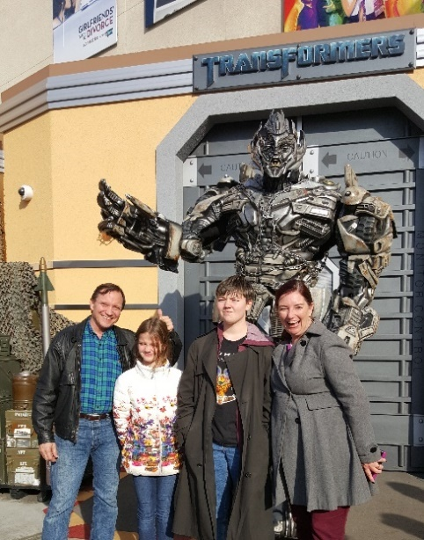

**Dungeons & Dragons – Honor Among Thieves**

In April I came across three very different films, all of which are about people trying to do the right thing.

There have been a lot of movies made either about D&D or that have borrowed extensively from the look and feel of the game. This one finally gets it right by not being driven by plot, but by trusting its actors to run a character-driven story. The band is made of a bard trying to redeem himself, a barbarian with a heart of gold, a shape-shifting cleric with trust issues, a mage who lacks confidence despite his talent, and a thief who (spoilers) acts like a thief. The casting is perfect. Everyone looked and acted like you would expect from the character classes in the game, and then the actors brought their own unique additions. The plot is pretty simple. They start out to steal a fortune and end up revisiting old missteps and

enemies. The strength of the story is it focuses on their personal histories and personalities. Even the villain was fabulous. The effects and humor were also spot-on. Far better than I thought it would be.

**Tetris**

A small-time game salesman comes across a wonder game at a convention and tries to buy distribution rights, thinking he has caught a unicorn. Little does he realize his efforts will drag him into international intrigue with mobsters. Based on an astonishing true story, our hero keeps trying to deal fairly in a world filled with double crosses and secret agendas. Through it all, he meets and befriends the game designer who works for the Russian government and will never see any gain from his work. The only reason he succeeds is his steadfast insistence on square-dealing. A very inspiring little film, especially when we see the real people in the credits at the end.

**Renfield**

The trailers for this film made it clear this was going to have a wide streak of silly running down its back, and it did, until it didn’t. Nicolas Cage finally gets to play Dracula, decades after he played the sad wannabe in Vampire’s Kiss. His no-holds-barred portrayal of the Prince of Darkness starts out looking campy, but then we see it is to prove a point about how miserable Renfield’s life is. This Dracula is unrelenting, ego-driven, power mad, and convinced of his privilege to ruin or kill anyone he wants to. Renfield seeks help from a toxic relationship support group. The filmmakers cover the viciousness and bloodshed with a lot of gallows humor. Nicolas Hoult is convincingly over his head. Awkwafina’s bitter cop becomes Renfield’s role model for the commitment and heroism he needs to break free of his master. The film gets pretty serious, which may or may not sit well with an audience who came for campy laughs. I applaud them for taking on an important topic, but I question whether they picked the right vehicle to do it.

***Have a Drink***

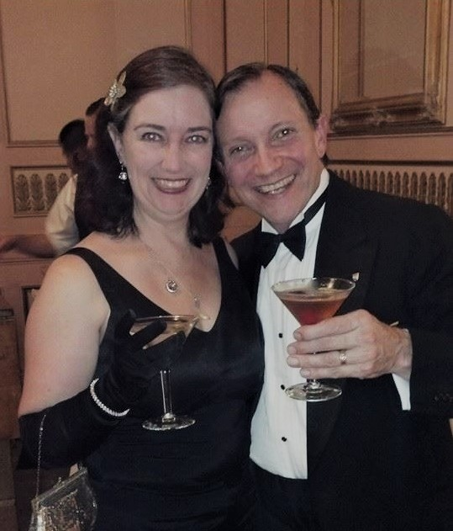

**Building Olenna Tyrell and Oberyn Martell (Part 2)**

In the last issue I showed you how I transferred the paper pattern pieces onto fabric and modified the original coat design to become the Tyrell cosplay.

At the same time I was also researching and designing the outfit I would wear to MC the Science Fiction and Fantasy Masquerade at CC 39. Prince Oberyn Martell of Dorne is a sensual, brash, proud man who wears essentially luxurious bathrobes for every occasion. Working on the Tyrell coat dress, we found we could only get the quality of brocades they used in the show if we ordered them from the factories in India. I was not trying to precisely duplicate any of Oberyn’s outfits, so I took a different route. There is a formal Indian robe jacket called the sherwani that was approximately the shape I had in mind for what Oberyn might wear for riding horses. It’s not

as long as the walking outfits he wears on screen, but it has the right shoulders and lines. I would need to replace the high Nehru collar with a long flat sash collar, but that would not be difficult.

The jacket I bought was made of a tightly-woven polyester that resisted dying. It started out pink with gold embroidery. I finally got the bronze I wanted by boiling it in synthetic brown dye. While I had the dyeworks going, I also dyed the many yards of white organza for Tyrell’s wimple, hat, and veil. Our house became quite the factory with cutting pieces, tailoring collars, dyeing fabric, and sewing all going at the same time.

Here are the rest of the in-progress photos for the Tyrell robe and the finished looks how we appeared at the convention.

How our dining room table looked for a month

Pushing the brocade through the sewing machine, good sides together

The dress as first worn. Very exciting!

First assembly, before final fitting

Oberyn Martell in one of his long robes

Olenna Tyrell

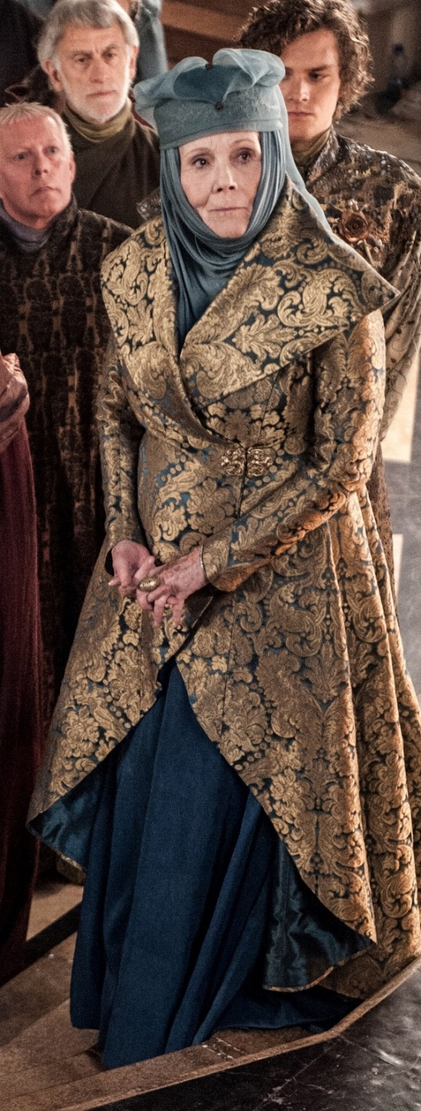

Our final looks!

That’s it for this edition. I hope you enjoyed it. Please invite your friends to sign up. I am actively generating content as I never have before. This newsletter is the best place, and in some cases the only place, to hear about it all ahead of publication.

Until next month, be well.