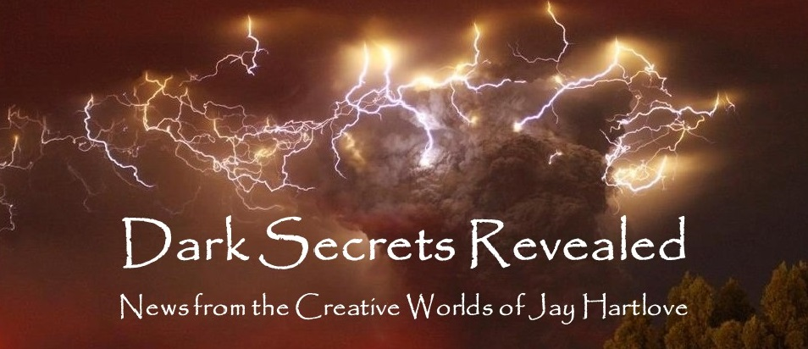

Issue 10 July 2023

June was a whirlwind of me overbooking myself and enjoying every minute of it. Sorry for being late getting this to you. I started the month by helping to throw a Pride Parade. More on that below. That was followed by an actual in-person mass book reading/signing. More on that below too.

Then there was an online interview with author Lisa Haselton on her blog which you can read here: <https://lisahaselton.com/2023/06/21/interview-with-award-winning-author-jay-hartlove/?fbclid=IwAR0bhsNcLua2kK0aGmqudGhl3uhvuxlwR-izFBziANGRu_w7Ops75ZqwDxQ>.

And I finished June with two weeks of business travel to Charlotte, North Carolina for an intensive round of meetings to conclude a project I have been working on for months.

The fun didn’t stop there. The day after I returned from Charlotte, I went to Baycon, the regional San Francisco Bay Area science fiction convention, where I spoke on three panels over 4th of July weekend. I will tell you all about that in next month’s newsletter.

I do get into a lot, but then, I make all my own trouble.

As I usually ask, please tell your friends about me and this newsletter. My most treasured connections have been from word-of-mouth referrals. Even more so, with this being the tenth edition, **I would love your feedback**. Are you finding these articles engaging? Entertaining? Helpful? This newsletter is for you. Let me know what is working, what isn’t, or what else you would like to see instead. You can reach me directly at *jay.hartlove@gmail.com*.

Of course, I also have a web site [www.jaywrites.com](http://www.jaywrites.com) that tracks all my projects, past, present, and future. There is a listing (with links) of the interviews I have done in the last couple of years. I invite you to check it out.

Here are the usual newsletter columns:

1. What’s Cooking: Previews/discussion of what I am actively working on. Also links to interviews, appearances, and other current writing news.
2. Mister Wizard: Advice and analysis to help my fellow writers.
3. The Aisle Seat: Recommendations. I am a huge movie fan and watch several every month.
4. Have a Drink: Wherein I will share personal stories.

***What’s Cooking***

**The Return of Public Book Events**

On June 17th I was privileged to join the Berkeley Branch of the California Writers Club at a book reading/signing at a not-yet opened new bookstore in Oakland called Clio’s. I had forgotten how much fun these are. Clio’s is a basement full of alcoves and sitting areas lined with bookshelves that are arranged by the century in which the books were written. Clio is the Greek goddess of History, so owner Timothy Don has arranged his books chronologically. Browsing is full of lovely revelations as to who was contemporary with whom. The bookstore is still being built, but they have held several preview reading events to grow interest. They expect to open this fall. There will be a bar. At the moment there is no signage except for a post-it note on a painted door. It is a speakeasy for book lovers.

The reading event was well attended by around forty folks, with thirteen of us reading. We each had fifteen minutes. I read two short passages from The Insane God, one demonstrating the benevolent god and another about the malevolent one. Here was the line up.

* Beth Barany, Red Running Deep (Firewolf Books, 2022)
* Jim Brosnahan, Justice at Trial (Roman Littelfield, 2023)
* Kristen Caven, The Winning Family: Where No One Has to Lose (Uplift Press, 2022)
* Paul Corman-Roberts, The Sincere (Libran Apocalypse Press, 2022)
* Gary Durbin, Sentient (Spark Press, 2022)
* Jasper Ezekiel, Good, Clean Mania: Collected Poems 2020-2022 (Draft2Digital, 2023)
* Keith Mark Gaboury, The Boy Born With A Pinhole Heart (Finishing Line Press, 2022)
* Lin Gentry, Episodes in a Cultural Revolution (Fulton Books, 2022)
* Jay Hartlove, The Insane God (Water Dragon Publishing, 2022)
* Jessi Honard, Unrelenting (Not a Pipe Publishing, 2022)
* Lily Iona MacKenzie, California Dreaming (Shanti Arts Press, 2023)
* A. L. Kucherenko, Knight’s Pawn (Cuidono Press, 2022)
* Terry Tierney, The Bridge on Beer River (Unsolicited Press, 2023)

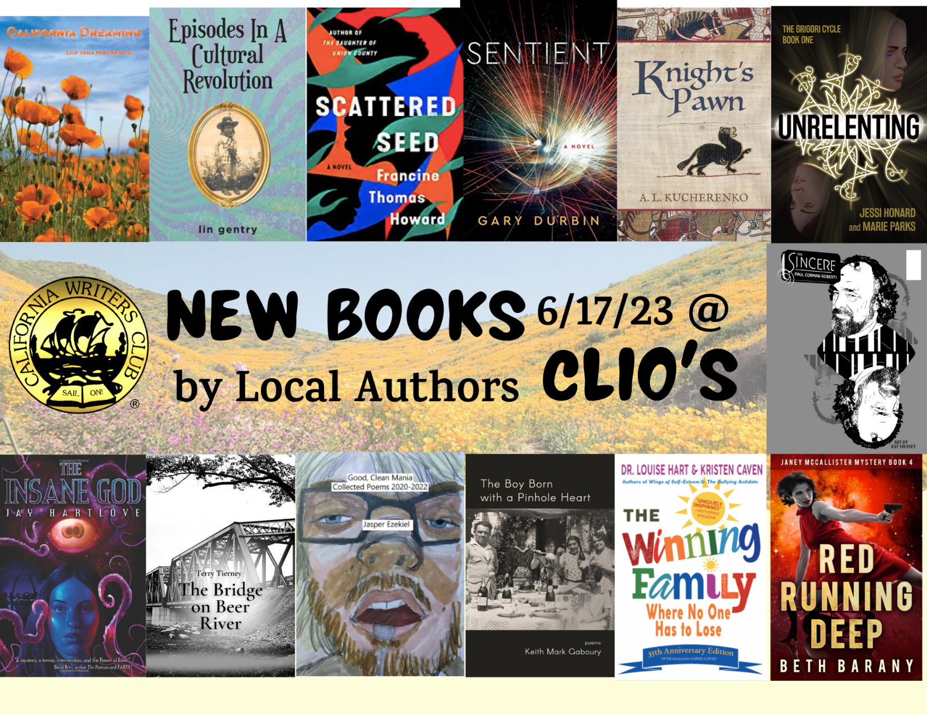

As much fun as it was to hear other people’s creativity, I found it even more satisfying to feel like I was part of a community of like-minded folk. Meeting everyone before the reading began and hearing about where they were on their creative journey was comforting and affirming in a way I had forgotten. As you have read in these pages, I have been to writers’ conferences and science fiction conventions where I have been on panels with interesting people, but usually only three or four at a time. Not since before the pandemic have I met and chatted with a whole room full of writers, all of whom were ready to talk about and share their work.

I’ve also written here about how writing is a lonely avocation. Self-doubt is all too tempting when you are alone with your keyboard at 2 am and a scene is just not working. Meeting with others in your same boat, and knowing that they survived and thrived, helps a lot when defending yourself from those dark moments. The last time I felt that was when I was huddled against the pandemic in Montreal with two hundred writers for the World Fantasy Convention in 2021. This meeting was a lot less tense.

During the pandemic I reached out to writers’ groups like the CWC and the Sisters in Crime mystery writers club. I am looking forward to future events with these groups, especially in-person events.

***Mister Wizard***

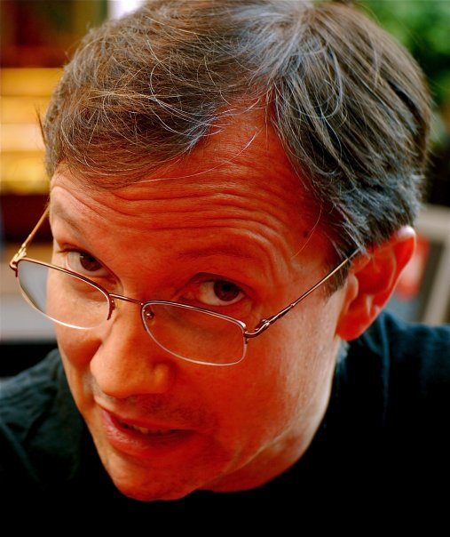**Confessions of a Long-winded Intellectual**

Last month I lamented the shortening attention span of audiences. Fifteen- second book trailers only get watched for ten seconds. I have done a bit of introspection and I’ve come to realize I may be speaking from a bias. I don’t speak in sound bites. I know how to write crisp, snappy dialogue. Critics praise how believable the dialogue is in my books. My critics also consistently say they are blown away by my creativity, that I am a source of surprise and invention. You cannot convey a new idea, something that no one has ever seen before, without context. When I am sharing an idea or an observation with someone, I want them to understand the context as well. Hence I speak in sentences that have pauses and clauses. I speak in two and three sentence deliveries.

My wife says I lecture. A coworker recently called me long-winded. She actually called me a long-winded fuddy-duddy, and then insisted she did not mean it as an insult. Clearly, she does not know the meaning of the term, since it means an inflexible thinker. On the other hand, my boss also recently asked me why I am not as vocal in social settings as I am in private. He appreciates the creativity I bring to my work. He and I have meaningful conversations about how to get enormous amounts of work done efficiently and effectively. Yet, he noticed, I don’t speak much in social settings. When being social, people usually talk about people and events. Eleanor Roosevelt put it nicely when she said, “Great minds discuss ideas; average minds discuss events; small minds discuss people.” I am perfectly happy to listen, and listen attentively, to people chatting idly about people. But you will only find me engaging when someone has invited me to discuss ideas. That’s just where I live.

I have had many people wonder at how I can be so good at analytical problem solving and still be a creative artist. There is no paradox. I live creatively all the time. That they don’t understand how this works says more about how our society has separated scientists from artists, probably to pigeon-hole intellectuals and keep the masses safe from them.

By the way, the only person who was ever brilliant in ten seconds was Phyllis Diller.

I do not talk over people. I do not hog the mic. Whenever someone has something to respond or add, I stop and listen. I know what it’s like to be talked over and drowned out, and I hate that. Lecturing is when you seize the microphone and never give it back. I do not do that.

I have another coworker who is an intellectual and who has a lot of good, big ideas. He has also encountered this accusation of being long-winded. He gets around it using a cultural tool. He is from New York where competing for air time is a lifestyle. When he talks in three sentence bursts, he talks twice as fast to get it all out in less time while he still as his audience’s attention. I really don’t want to work that hard.

The inventiveness that my critics and my boss appreciate is not some task I work at, it’s where I am all the time. David Brin, one of the most accomplished writers in his field, called me, “an interesting and accomplished man.” I am accomplished. I own a paid-for million-dollar house, I raised two competent, creative adults into the world, I have a job that I love and worked for decades to finally get, I have written five published and acclaimed books and a musical. I graduated at the top of my class in both law school and business school. I got a late start with mental illness. I inherited only bitterness from my parents. Of course I did not do all this by myself. I have had some wonderful people help me along the way. I have been married 28 years. Even my first marriage lasted 15 years before we finally grew apart. But I did not achieve this life by chatting about people. I got here by always looking for new ways to see things. I got here with ideas.

In The Mirror’s Revenge, I wrote a character, Sister Katherine, who is a lonely intellectual. Snow White comes to her for advice on dealing with black magic that is threatening her. Katherine is a recluse who studies ancient and questionable books. She wants to help Snow, and is unabated in giving Snow context as well as facts. This contrasts with the other characters who speak in much shorter bursts. It is part of her character to usually answer in three or four sentence answers. The actress I hired to play Sister Katherine fully understood the character, and brought her fully to life. But she could never get the longer passages right. This was an experienced actress who had memorized thousands of lines of dialogue in her career. But she couldn’t remember everything Sister Katherine had to say. We had to cut her lines.

The next time you watch a film that features an intellectual, take note of how they speak using more than one sentence at a time. See how they give context to their facts. See also how they don’t spend time chatting in quick exchanges about trivial things. These characters are believable on the screen (or stage) because we’ve all met people like that and we recognize them. They are curious and often the ones who look a little deeper to find answers in the plot. These are also often the characters who move the story further faster because they see things everyone else misses.

I recently met some old friends of my wife. They are extremely well-read, far better than me. Their front room is proudly lined with books they love. Yet when I engaged them on books, they were limited to name-dropping their favorites, and had no interest in talking about storytelling. Moreover, they ignored that I am a writer. We have been to their house three times now. Every time we go, the husband tells the same story about how he grew up in his father’s shadow. It’s as if he has learned nothing of life from all those books he has read. I have given up trying to engage with this otherwise delightful man. He is a consumer of ideas, not a creator. At least he has the attention span to read and appreciate full-length novels. Not mine, of course.

I believe the shortening attention span we are witnessing goes hand in hand with a dumbing down. You can’t discuss new ideas in sound bites. And if sound bites are all that hold anyone’s attention, then no one will listen to new ideas. What’s the rush? You got a date? What’s so damned important in your next moment of life that you can’t invest another twenty seconds and discover something someone has worked hard to create and who wants to share it with you for free?

Am I arrogant for complaining that my gifts are pearls before swine? Am I out of my lane to say I don’t like how I get discounted because of other people’s short attention spans and lack of curiosity? Am I a blowhard for singing my own praises as an intellectual? No one else is. Am I angry when someone cuts me off and says I’m lecturing them when I can count that all I said was three sentences in a row? Yes. Am I pleased with where my creativity and my embrace of bigger ideas has gotten me? Yes. As Brandi Carlile sings, “Let them laugh while they can. Let them spin. Let them scatter in the wind. I’ve been to the movies. I’ve seen how it ends. The joke’s on them.”

Yeah, this was a bit long-winded, wasn’t it.

***The Aisle Seat***

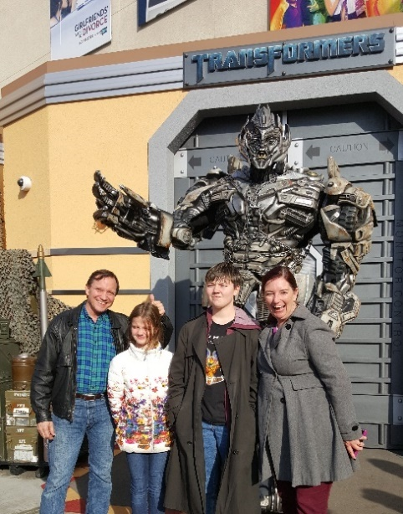

**Indiana Jones and the Dial of Destiny**

This month I watched three very different action films that randomly turned out to all be about time travel. Sort of.

I love the character of Indiana Jones. Harrison Ford has done a great job building this character over the course of five movies and about fifty years of Indy’s life. My favorites in the series are the original Raiders of the Lost Ark (even with its Deus ex Machina ending), Indiana Jones and the Last Crusade, and this one, Indiana Jones and the Dial of Destiny. Temple of Doom and Kingdom of the Crystal Skull tried too hard and missed the mark, in my opinion.

This film surprised me. I hoped they would be careful to get the last of the series right, and they did. Indy is retiring after ten years as a professor at his latest job. This tells you he never gained tenure

anywhere and has had to start over mid-career, maybe several times. He is divorced from Marion (Karen Allen), whom he got back together with at the end of Crystal Skull. His son (Shia Lebeouf) whom he just met in Crystal Skull, enlisted in the army and was killed in Vietnam. Our hero is looking at the end of his life with nothing to show for any of his good works. In contrast, his friend Sallah is happy being a grandfather.

What better set up for a story about picking up long lost pieces of your life, culminating with (spoilers) actual time travel. Indy finally learns what it means to make a real difference.

Mads Mikkelsen is the perfect villain (love me some Mads). The chase scenes are classic and the pseudo-archeology is exactly what this series has always thrived on. More than all of this, though, is the heart the third act brings back to the series. I will say no more, than to tell you please go see this film. What a grand way to conclude a series.

**Flash**

This is an ambitious film. DC needed a hit. The DCU paved the way for a multidimensional tale once the Flash discovered he could exceed the speed of light at the end of the Snyder cut of Justice League. The good news is, they had so much fun taking advantage of how Batman has been played by multiple actors over the years. They smartly took a page from Marvel and had Barry’s motivation for taking such a dangerous risk be family. It was great seeing Gal Gadot, Ben Affleck, and Michael Shannon reprising their earlier roles. But Michael Keaton steals the show. Batman can be pretty dangerous when he has no more f*cks to give. His explanation of cause and effect in the multiverse is the best one anyone has put on screen so far.

I particularly liked how they played with the audience’s expectations. The story starts out with one conflict (Barry impulsively going back in time), but soon you realize that problem has opened up into to another bigger problem (Zod with no Kal El). And when that problem appears a lost cause, the real conflict emerges (Alt-Barry stuck in an obsessive loop). This evolving crisis tied nicely back to the original motivation. All in all, a pretty well told story, especially given its size.

The visuals for the multiverse were weak compared to what we have seen over at Marvel. It looked like they ran out of money and tried to cut some corners, which was disappointing, but not so much as to wreck the film. See it for the story and the performances.

**65**

I went into this film with very low expectations. Adam Driver is not going to win any acting awards for this one, and it’s not going to be remembered as groundbreaking science fiction. On the other hand, the third act develops what has got to be one of the most compelling race-against-the-clock sequences in recent memory. I liked that Driver’s pilot is competent and determined throughout. The troubles he gets into are because the dangers he faces really are overwhelming. The child in his charge makes mistakes, but they are mistakes a kid might really make. In spite of the somewhat absurd situation (ancient astronaut crashes on Jurassic Earth) it is all played earnestly and believably. A worthwhile sci-fi adventure.

***Have a Drink***

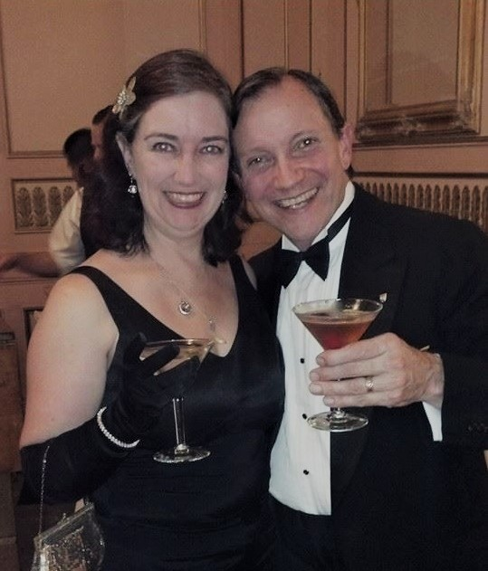

**The Clayton Pride Parade**

Yes, I helped throw a parade, twice. Last year, we joined a handful of our friends to throw a pride event in our very conservative small suburban town. Among our friends are city council members and former mayors of Clayton who had some political capital to throw around. This was an ally event. Most of us are straight and most of us are white. Several of us have queer kids, including Denisen and me. To be clear, a major motivation was to drag this sleepy right-wing town into the 21st Century.

The turnout was amazing. We had 30 entries (after scratches) and about a thousand people showed up. The village square was filled with local businesses in booths embracing our “Every Color ot the Rainbow” theme. Seeing the town festooned in rainbows was something our gay friends said they had never expected to see. There are a lot of closeted gay folk in this town, and the joy on their

faces more than justified the effort.

And what an effort it was. There were only a dozen of us. And the project grew as it developed. Between fundraising, organizing, and running the parade, it took over our lives for two months. We ran it as a non-profit by having the Contra Costa Rainbow Community Center act as our fiscal sponsor. By having all the funds route through the RCC, the entire project avoided taxation. It was complicated enough without having to figure taxes as well. My wife Denisen was on the RCC Board of Directors and cleared that path of us.

The turnout was so much more enthusiastic than we expected. So we immediately started planning the next one for this year. With the success in 2022, a lot of people showed up to help in 2023. This year we had a crew of over 50. Things were much less hectic. We took on more and grew the parade. It ran like clockwork. The folks who run the 4th of July parade, which is Clayton’s biggest event, talked to us about how we organized it and took notes. We had 55 entries, including several groups that had waivered and pulled out last year. Around the same 1000 folks came to watch. It’s a small town.

One thing I noticed walking the parade route: most of the cheering was from the moms. The local schools have a reputation for bullying gay kids. Guess who’s sick of that? I’m glad we could help.

The conservative politicians who run the town are taking action to make it more difficult to throw the parade next year. We will continue the good fight. How disappointing that there has to be a fight.

Why did we ever think we could throw a parade? When friends hear that Denisen and I both used to work in the law, it is easy to assume we met at work. We met working at science fiction conventions. Throwing events is baked into our relationship. Having two queer kids who were targets of school bullying gave us a clear path.

I advocate for the downtrodden in my books. I keep my allyship subtle, writing about racism with mermaids and transgender bravery in horror settings. I am well-aware that I am an old, white, straight male, and the last thing I want to do is take the microphone away from folks I want to elevate. I do what I can to keep the dialogue open. Throwing a pride parade was a great way to take more visible action.

That’s it for this edition. I hope you enjoyed it. Please invite your friends to sign up. I am actively generating content as I never have before. This newsletter is the best place, and in some cases the only place, to hear about it all ahead of publication.

Until next month, be well.