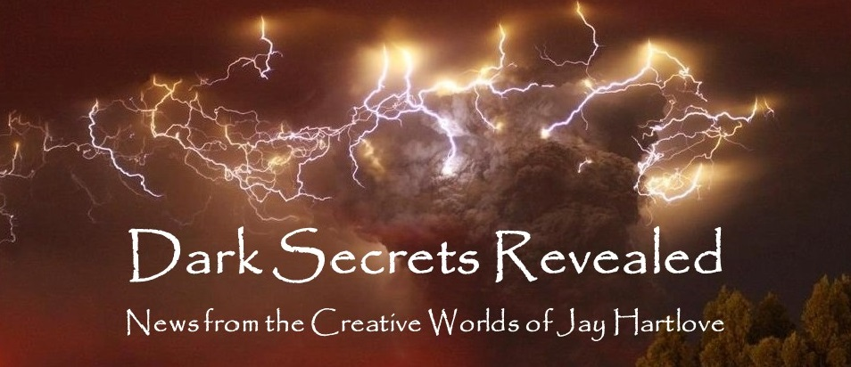

Issue 5 January 2023

A new year!

Yes, this issue is late. The excitement of Halloween through New Years left me in rather a deep funk. I found myself questioning the real value of a lot of good things, including my creative efforts. I think Denisen and I are finally hitting our stride as empty-nesters. I can now look back at the Thanksgiving dinner, my son’s wedding, and Christmas and see they were all joyous times, not just work wasted on people who did not appreciate it. You set high hopes to drive your enthusiasm, but those high hopes set high bars that can leave you feeling unsatisfied afterwards. Taking a month off has given me some much needed perspective.

Having The Insane God selected as a Finalist in the Cygnus Awards has reminded me that my writing is not a waste of time. I am getting absolutely zero traction on the Nebula nomination. (Know any SFWA members you can ask to vote for me?) And while I always enjoy seeing my friends publishing new work, from down in my hermit hole their success has only heightened my sense of aimlessness in my WIP. Not a good place. I am very glad to say I have my head back out in the sunshine.

I also see that my decades of experience as a writer has left me with something valuable to add to discourse. As I have described in these pages, I have wrestled with being an advocate for the disenfranchised while staying in my lane as an old white guy writing about other people’s struggles. Stephen King wrote a book about the horrors of the American-Mexican border called American Dirt. The New York Times called him out for cultural appropriation. He fired back that he thinks people who accuse writers of cultural appropriation are guilty of the same overreach as people who ban books about Black history. Yes, he called his detractors Nazis. That is just petty. And I tweeted him to say so. It felt good to have thought through something more thoroughly than one of the most successful writers in history.

Staying in my lane is kind of a hot topic these days. I am speaking at a major literary conference this spring on that topic. More about that in an article below. And I am still collecting inspiration for my Lemurian opera. I’m listening to a variety of music, researching costumes and architecture, generally immersing myself in potential puzzle pieces. I’m having fun. I need to get this right. I am too old to think I still have time to write multiple productions. The Mirror’s Revenge took ten years. This one has been simmering for about that long.

As I usually ask, please tell your friends about me and this newsletter. My most treasured connections have been from word-of-mouth referrals. Even more so, with this being the fifth edition, **I would love your feedback**. Are you finding these articles engaging? Entertaining? Helpful? This newsletter is for you. Let me know what is working, what isn’t, and what else you would like to see instead. Reach me directly at *jay.hartlove@gmail.com*.

Of course, I also have a web site [www.jaywrites.com](http://www.jaywrites.com) that tracks all my projects, past, present, and future. There is a listing (with links) of the interviews I have done in the last couple of years. I invite you to check it out.

Here are the usual newsletter columns:

1. What’s Cooking: Previews/discussion of what I am actively working on. Also links to interviews, appearances, and other current writing news.
2. Mister Wizard: Advice and analysis to help my fellow writers.
3. The Aisle Seat: Recommendations. I am a huge movie fan and watch several every month.
4. Have a Drink: Wherein I will share personal stories.

***What’s Cooking***

**Music in My Writing** *or Life Should Have Theme Music*

Music is a big influence on my fiction. Not only does it give me inspiration, but I pick songs that keep me on target. My best advice to writers is to figure out what your story is about, write it down in a couple of sentences, and refer back to it often when the story has stalled or squirmed out of your grip. (You’ve heard me talk about why “what your story is about” is not the same as “what happens in the story.”) I do the same thing with songs or playlists of songs.

Here is a tour of how music has helped me.

One of my goals in writing Goddess Chosen was to make Silas Alverado as ruthless as possible yet also make the audience sympathize with his motives. He has discovered a way to force the Devil to divulge the secrets of creation. Silas has in mind to use those secrets to make a better world with free energy, and no

disease or hunger. But, as the tag line on the book says, “The man who would beat the Devil isn’t a hero but a ruthless madman.” He is driven to success regardless of who he has to kill to get there. He has embraced that the ends justify the means. That makes him a villain, or at best an antihero, but one readers will hopefully find themselves rooting for him to succeed. The book is about revenge and redemption. Several critics commented on the delicious conundrum I gave the reader. The book is a complicated thriller with lots of moving parts. The song I used to make sure I did not lose this key mission for my antagonist was, “Behind Blue Eyes” by The Who. “No one knows what it’s like to be the bad man.” “My dreams they aren’t empty as my conscience seems to be.” This is totally Silas’ song.

Goddess Daughter is about loss and forgiveness. At the center is Randolph Macklin’s heartbreak at having lost his wife Cheri. Again, this is a complex, fast moving thriller. I draw lots of connections about scientific breakthroughs and magical things around the world. I devised what critics have called the most evil twist they have ever read. But the emotional center had to be Randy’s heartbreak. The song that kept me focused was, “Paint It Black” by the Rolling Stones. “I see a red door and I want it painted black.” “I could not foresee this thing happening to you.” Perfect match.

Goddess Rising is about an innocent who strikes a bargain with a goddess to keep her own individuality while agreeing to help the goddess achieve her justice quest. There are many songs about a variety of kinds of justice. This book also has the biggest cast of characters I have ever written. I draw them from the previous two books and then add a bunch of new ones. It would be all too easy to be distracted from the central theme of Desiree’s struggle for identity. She learns to live symbiotically with Isis, and to share the goddess’ pain and triumphs. The song that helped me find and hold that was, “I’m Only Happy When It Rains” by Garbage. This became such a theme that I have the band Garbage appear at the benefit concert that turns into the final battleground with Lucifer. “I’m only happy when it’s complicated.” “Pour your misery down on me.” Indeed.

Mermaid Steel is a story about racial injustice and cultural erasure, but at its center is a forbidden love affair between a human and a mermaid. I had a lot to say about prejudice, and I had a lot of world building to show both above and below the waves. I needed a song to remind me to not lose the joy Chielle and Sten share. And then I found, “The Rhythm of Love” by the Plain White Tees. “She’s got blue eyes deep like the sea, that roll back when she’s laughing at me. She rises up like the tide the moment her lips meet mine.” Well, duh.

I listened to a lot of music while I was writing The Insane God. So much so that I decided to share the playlist with the reader. The chapter names are the titles of the songs I listened to while writing each chapter. I mention this in the Forward so the reader can “listen along” as they read. I wanted to be mindful of copyright, so I quoted little to no actual lyrics in the book. I am not trying to make money on someone else’s work. I did want to share my inspiration, hoping the reader will gain an appreciation of the songwriters’ talent. The one song that reminded me the most that the story is about staying strong in the face of rapid unwanted change was, “Brain Damage” by Pink Floyd. “There’s someone in my head but it’s not me.” “I’ll see you on the dark side of the moon.”

My next book is The Dove and the Crow. It is a high fantasy, with gods and monsters, and a dose of high tech meets magic. At its center is a culture clash personified by a budding love affair between Willa, the woman who falls into another world and Naomi, the witch she befriends there. I struggled for months to find the emotional center of this story. I always knew it was about healing. Willa has had a string of abusive relationships. Naomi’s world Hern is broken because a love triangle between the gods has ended in murder. Willa’s healing journey becomes a mission to heal her new world. In the midst of this, Naomi has her own motives which threaten to break her new bond with Willa. When I finally realized that, my target came into view. “Knots” by Anna Nalick is now the theme song of this book. I have always loved this song. The lyrics fit my story so well, it is possible my subconscious has been running this song all along, influencing my work on this story. Either way, I plan on sending a copy of this book to Anna as a thank you for the inspiration.

If you’ve read my books, listen to the songs and let me know what you think of how they fit. If you haven’t read my books, then obviously you need to remedy that right away!

***Mister Wizard***

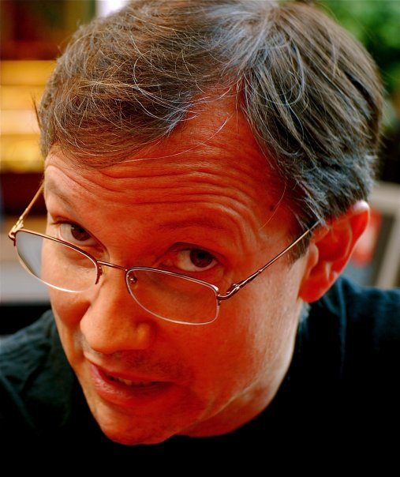**AWP In Seattle**

I have been invited to speak at the Association of Writers and Writing Programs annual conference to be held in Seattle March 8 through 11. I am moderating a panel on writing inclusive voices for a young adult audience. This panel was pitched by my Publicist Cristina Deptula, and all of us on the panel are her clients. To organize our content, we pooled questions we want to see addressed, and each of us wrote draft responses.

I have done many written interviews over the ten plus years I have been a published novelist. Getting a list of questions from the interviewer tells me a lot about whether they have looked up who I am and what I write. This time the questions were written by the panelists to cover what we want to talk about. Our answers were all delightfully individual. They say a lot about who we are as writers. Here are the answers I wrote.

* Why the decision to self-publish, go with a small press, or traditionally publish with a larger press? And what did that journey look like for you?

I tried the traditional big house publishing route many years ago, but came to realize my work at that time was not good enough to attract good agents. A good agent is necessary to become successful in traditional publishing. After seeing how much work my self-published friends do just to get their books into the world, I decided it was worth it for me to take a smaller cut of the profits in exchange for having a lot more time to write. Small press was the right balance. After a couple of tries, I was lucky enough to eventually find a good one. They do an excellent job of editing, getting cover art, publishing, and getting my books into all formats, including ebook, paperback, hard bound and audiobooks, and all the sales channels.

* Why YA for these particular stories -- especially if advocating for marginalized groups/individuals?

I write about marginalized people and troubling topics no matter which audience I am writing for. I was abused as a child and feel it is important to use my writing to address the plight of the disenfranchised. If the subject is more mature, then I will write for an adult audience. If the story is best told from a younger person’s perspective, then I will pull in the conventions of a Young Adult book. Book marketing is all about labels so readers can find what they are looking for. Cover art and cover copy also help steer the book into the right audience’s hands. My latest novel, The Insane God, needed an innocent protagonist who had nonetheless faced great change and was equipped to handle the changes the story pushed on her. I call it YA because she is 16 and comes from an innocent viewpoint, but the cover looks like horror, and the cover copy talks about scary events. My hope is these will all work together to paint an accurate picture so a reader will know what they are buying.

* What advice would you give someone looking to publish something that may seem too niche for a traditional market?

There are agents and big publisher editors who will take on your niche subject, but they are rare and it may take you a long time to find them. Small presses often specialize in certain kinds of books because they are growing that niche audience. I would suggest finding other authors who have gotten published with similar material to yours, and ask them who they work with. You’ll still have to pitch your story, but at least you’ll know the publisher has been interested in your kind of book already.

* Who do you write for? (Aka who do you think your audience is? And how does that differ from who you've found your truest or largest audience to be?)

I write for different audiences depending on what I am writing about. I have a trilogy of supernatural thrillers written for grown-ups who have seen something of the world and are ready to be challenged by what happens in the stories. The characters are educated and in their forties and fifties. Critics have used terms like “moral core” and “mind expanding” to describe those books. I have a fantasy romance that I could have written for a YA audience, except that sex plays an important part of the story, so I left the lights on and it is an adult book. My science fiction thriller is YA because of the young age and viewpoint of the protagonist. I still challenge the reader with some very big ideas. But you should not play down to an audience. Teen readers want to be challenged. Finding different audiences for my different kinds of books has kept me off any bestseller lists. But I write the stories I need to write.

* What does your revision process look like? Or rather, how different does your first draft look from the final book product?

I write in ever-expanding iterations. I start with a couple of pages of notes which I add to as I think about how to tell the story. A lot of my early thoughts are about the characters and how they will react to the situation. Once I have five pages of so, I will start ordering a sequence of events. Again, I read and re-read and add new ideas as I go. By the time I have ten pages, it starts looking like a story I can actually tell. By the time I get to twenty pages, I am usually ready to start writing prose. I often start with a scene in the middle of the story that has come to me fully realized. Once I start hearing the characters’ voices, I can start at the beginning. If a story has a lot of ideas and the characters are especially deep, I may keep this designing phase going for a while. I didn’t start writing at the beginning of my current WIP until I had a 40-page outline. Once I finish the first draft, all the way through, I will put it down for a while and come back to it with fresh eyes and fresh ideas my subconscious has been working on. The second complete draft should include everything I didn’t think of the first time. I am fond of a quote from Neil Gaiman, where he says the second draft is where you make it sound like you knew what you were trying to say all along.

* Who gets to tell a story about a particular group of people (e.g., neurodivergent, a particular culture, etc.)? If you're not personally in that group, how do you ethically research and tell a story focused on that group?

I am a firm believer that you can only write what you know. When I looked back on my first couple of novels, I realized I was turning victims into heroes, and this has been a driving theme through all of my writing. I know from my unfortunate history about being a victim. I have also always written in the science fiction and fantasy genres where aliens and supernatural creatures are going to be non-human. Research, even if it is working out the details of your made-up world, is essential for you to speak with authority on the subject. If you don’t know something and you have a story that compels you to write about it anyway, then do the research necessary to become an expert. If you’re writing about mermaids, then go diving and see what that feels like. If you’re writing about aliens who have some different biology, then go read up on the science so you can write from a place of knowledge.

If you are writing about a people who are here and now, then you must stay keenly aware of the line between telling a story that is interesting because of their different viewpoint, and telling a story about them because they are different. We are all different from one another in some way, even if it’s not immediately visible. People being different is not interesting, it can be insulting. Exploring different viewpoints is broadening and enlightening. If you are taken by a story idea about a people with a different heritage than you, then go learn everything you can about their culture. Meet them, befriend them, learn from them. Share your story idea with them and see what they think.

An important touchstone is to remember not to take the microphone away from anyone who should be telling their own story. Cultural appropriation usually focuses on how different a group is. You are an expert at writing and storytelling. You also have to become an expert on what and who you are writing about. If at some point you see that your story really is about how different they are, then abandon that story and move on to the next one. The world has seen too many divisive stories about how different we are from one another.

* What's next on your publishing journey? What would you keep doing and what might you do differently for future books/projects? (E.g., PR budget, agent, etc.)

My plan is to try traditional publishing again with my next book. I have embraced my victims-to-heroes theme and am tackling a very complicated set of characters and situations. My first five books are all around 80,000 words. This one will easily top 100,000. It is also more mainstream in its interpersonal relationships. I just think this one might allow me to break the ice. I met a couple of agents at a writing conference last year who said they would like to see this book. I have a couple of other back-burner books cooking on low simmer. I will wait to see if I land an agent with the next one before making plans for where I will take those. My small press publisher still loves my work.

***The Aisle Seat***

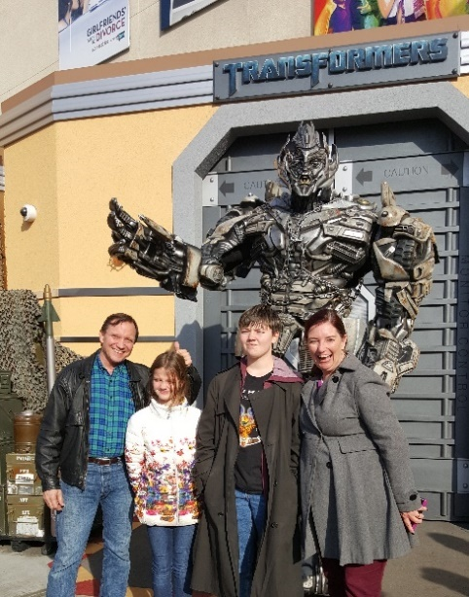

**White Noise**

This is a film adaptation of a recent bestselling book. The book was lauded as daring and groundbreaking. I have not read the book, but the critics who liked the movie said the director captured the genius of the book.

Yikes. What a mess. I appreciate that the three acts are how the same set of people cope with three different catastrophes, only the first of which is the toxic spill you see in the trailers. You learn a lot about people when you see them under different kinds of pressure. If you’re going to show us how a group of people cope with different situations, then you do need to do one important thing – you need to make us care about them. These people were so annoying, I wished they hadn’t survived even the first disaster.

The author/director’s intent was to say something about keeping your head straight while being deafened by the white noise of news, gossip, and panic. Unfortunately, the family in the crucible all speak rapidly over one another in complete sentences that make them sound like college professors on crack. If people talk fast, or over one another, they usually truncate sentences or slip into vernacular. Their speech reflects the urgency and hurry. These poor actors had to recite entire paragraphs at speed while being interrupted by one another. And often, they discuss how important their discussion is, as if the filmmakers needed to tell you how important this film is. I just wanted to slap them. And to top it all off, the director added a bizarre fantasy dance number in a supermarket for the end credits. I am not an anti-intellectual by any stretch of the term. This was erudite overreach.

**M3gan**

On the other hand, here is a director who understood the assignment. Yes, the slow creepy build-up leading to the out-of-control disaster ending was predictable. But what a great ride along the way. There is a reason Isaac Asimov’s First Law of Robotics is robots shall do no harm to humans. That set up is played out beautifully with a parent figure who knows nothing about being a parent, either for the girl who lost her mother or for the rapidly learning AI in the playmate doll. I would like to add to Asimov’s laws to say only people who have been good parents should be allowed to nurture budding AIs. Thrills and gore are freely mixed with humor, the effects for Megan are completely believable, and the actors all do fine work telling the story. The star of the show is Megan’s side-eye. This was a really good time at the movies.

**Guillermo del Toro’s Pinocchio**

This one showcases a director of great vision, but who has clearly reached that point in his life where reflection has taken over his thinking. Reports are that he worked for ten years to get this film made. Then even ten years ago he was wearing an old man’s glasses. What do you think Pinocchio is about? It’s about love protecting innocence. Right? This one is about a boy’s unflagging dedication finally melting an old bitter heart. It is an interesting interpretation. It means some very dark things happen in this version that you haven’t seen before. It is set in war-torn mid-20th Century Italy. Mussolini makes an appearance. A lot of people die on camera. By the end, I think we are supposed to be glad the family finally pulled it together and lived out their lives happy. I found myself happy for them to have finally made it to the end of their miserable lives.

***Have a Drink***

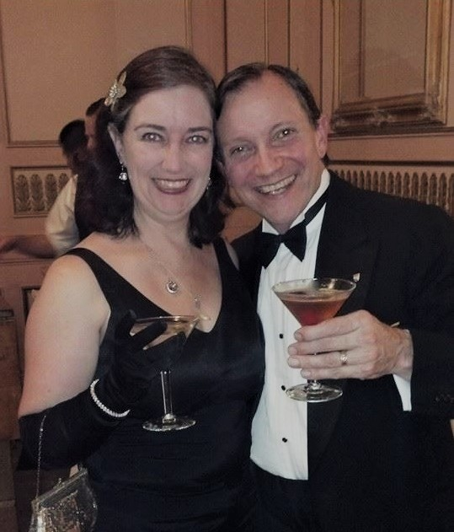

**A Costumer Becomes a Writer** *or He’s wearing what?*

Back in the day, I was a Big Deal costumer. I was part of teams that won Best in Show at San Diego Comic Con and the World Science Fiction Convention. I won dozens of awards for my individual work. I was known as in innovator in papier mache armor and foam latex. I was among the very first to explore full makeup Klingons and Steampunk. I costumed my Renaissance period Snow White musical out of my garage clothing racks.

Since then, I help folks with their costumer presentations. I joined my friend Julie Zetterberg as Den Parents for costumers competing at Worldcon in Chicago last August. I’m also very handy on repairs around the house with my fabrication skills.

Therefore you might think my fiction would be full of descriptions of what my characters are wearing. Not so fast. There are a couple of reasons that is not the case.

Science fiction and thrillers are both notorious for not telling you what people are wearing. Going back to Poul Anderson and Dashelle Hammett, if it didn’t directly impact the plot, the reader was left to assume the characters were not naked, because no description was given. Context was everything. He’s wearing a slouch hat and overcoat. Is that all? No, but you weren’t told anything more. He’s wearing a high-tech spacesuit. What makes it high-tech? She’s wearing high heels and a dress slit up to there. Any colors or fabrics? Nope. Everything else was left to the imagination. It wasn’t until movies came along and supplied costumes that audiences got actual details about what a high-tech space suit looks like. I’ve even heard old timer Science Fiction authors bragging to one another about how they never described clothing. Not because they didn’t know in their mind’s eye what people looked like, but rather they wanted to leave non-story-critical details to the readers’ imaginations.

By comparison, I share far more details about what my characters are wearing. I give details when I want the reader to know what the character is feeling, too hot, too cold, too restricted. Also if they need to recognize each other, or I want the reader to be able to spot them in a crowd because they always wear a favorite coat or a favorite color. Same goes for hair color and style. You don’t have to paint a complete picture if the focus of a scene is in the dialog or in the action, but it helps make sense of why people are moving the way they are.

In Goddess Chosen, Silas Alverado’s magical regalia is Important with a capital I because a) he’s using it to perform magic in our real world, and b) Alec Doogan copies a bunch of his regalia in Goddess Rising.

In Goddess Rising, the wooly scarf Desiree is wearing in Ireland becomes a talisman for channeling her healing powers. She later regrets her clothing when she is accidentally stranded in Egypt wearing the sweater and boots she was wearing in Ireland. This is before we watch Michael and Sammael progressively destroy their street clothes in various battles.

In Mermaid Steel I take the time to show you what Sten is wearing, all the way down to his skin, because I then compare it to what Chielle is wearing. Clothing also plays a big part of telling the cultural erasure that is going on between the white and brown races of humans on land. I let my costumer flag fly in that story. It informed me to tell a deeper story (no pun intended).

And of course, in The Insane God, clothing plays an important role as Sarah gets choices for how to show herself as a transgender woman.

Maybe years behind a sewing machine lets me think of how clothing is important to the story I am telling. I still don’t give details that don’t matter to the story. But you are likely to find stories where clothing plays a role.

That’s it for this edition. I hope you enjoyed it. Please invite your friends to sign up. I am actively generating content as I never have before. This newsletter is the best place, and in some cases the only place, to hear about it all ahead of publication.

Until next month, be well!