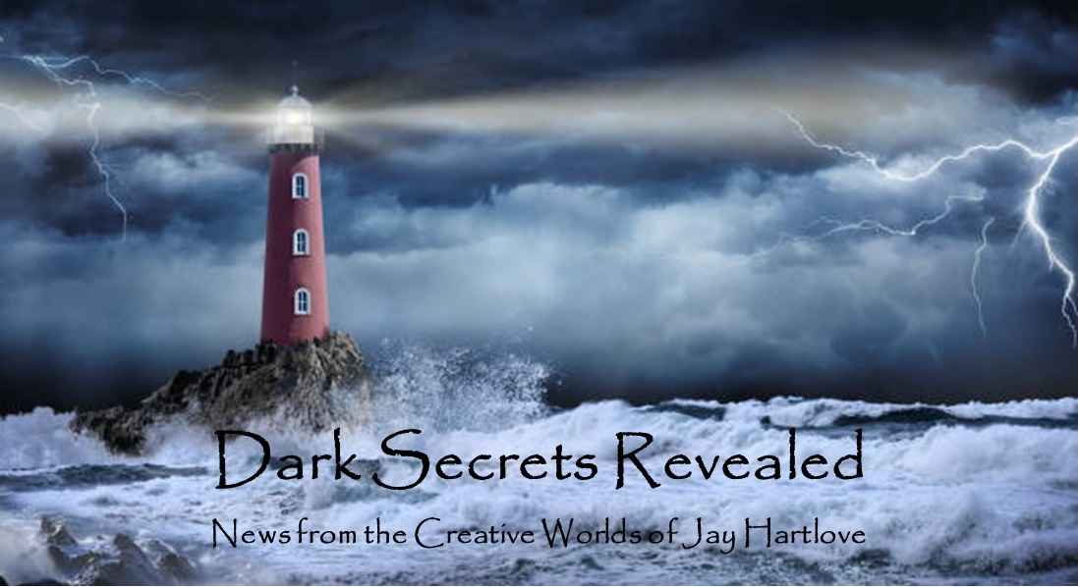

Issue 18 May 2024

My apologies for this issue being so late. I considered skipping an issue, but I promised you certain updates last month. And lots of things happened in April – too many in fact, which is why I’m just getting to writing this newsletter now. I will keep this one short, to get myself back on schedule.

My big news is that there is no news. The three agents I sent The Dove and the Crow have all let their eight-week review period expire with no feedback. The time and money I spent last year going to writing conventions and meeting agents has amounted to nothing. Back to square one. This is why so many writers give up. I’m not giving up. I will be attending World Fantasy Con in October, and I will be participating on panels next February at AWP in LA. Never give up, never surrender. This book is worth it. And I’m nearly satisfied with the plot for the sequel. No name yet. You’ll be the first to know.

I put all the back issues of this newsletter up in an archive on my website [www.jaywrites.com](http://www.jaywrites.com). Check them out if you joined late and missed some editions.

I would very much like your feedback on this newsletter. Please feel free to write me at [jay.hartlove@gmail.com](mailto:jay.hartlove@gmail.com) and let me know your thoughts. This newsletter is for you. I could set it up as a sales tool, with lots of buy links, but that’s not why I write it. I do this to share my work and insights with you.

Also, let me know what you thought of Goddess Revealed. Did you find it interesting? Did it make you want to go back and read the trilogy? Do you think it is a good incentive to sign up for this newsletter?

Here are the usual newsletter columns:

1. What’s Cooking: Previews/discussion of what I am actively working on. Also links to interviews, appearances, and other current writing news.
2. Mister Wizard: Advice and analysis to help my fellow writers.
3. The Aisle Seat: Recommendations. I am a huge movie fan and watch several every month.
4. Have a Drink: Wherein I will share personal stories.

***What’s Cooking***

**Mermaid Steel Merch – Follow Up**

I finally got the Mermaid Steel tourist poster tee shirts done. Of course it was more hassle than I bargained for. My son got sick and couldn’t get me the art until late April. The screen printer I hired also had workers out sick and had a last-minute rush to get them done. I had a deadline because I needed them for the California Mermaid Convention. They got them done, but half of them are off-center or crooked and will have to be re-done. I swear, life ready puts up a fight when you want to bring something new into the world.

So, without further ado, here is the art, and a completed shirt. Depending on the venue, I will be selling these for $20 to $25. You can have one for $15, shipping included. Let me know.

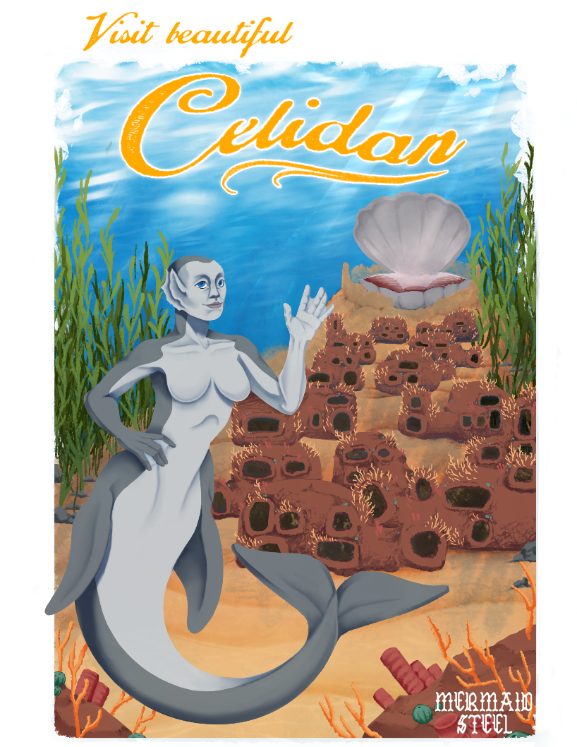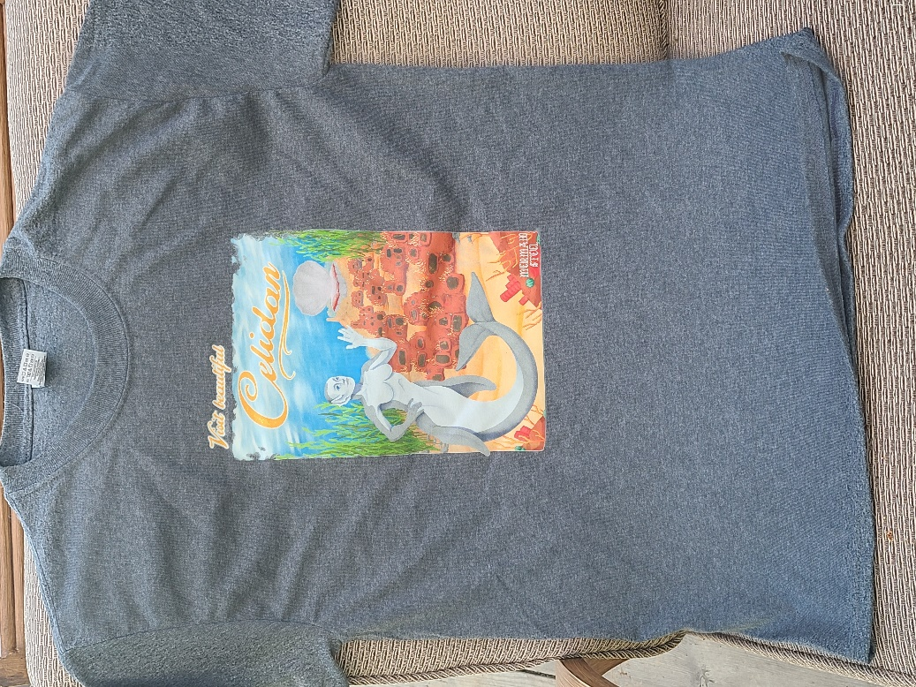

***Mister Wizard***

**Pitching Snow**

I spent a lot of time in April preparing for a pitch fest held by New Musicals, Inc. from April 19 thru 26. They instructed us on how to construct a pitch, and then had us run practice sessions with the two instructors and a couple of guest producers who agreed to help get us ready. There were teams pitching 15 new shows. We listened in on each other’s pitches to learn from the feedback they got. It was a very productive, highly interactive learning environment, all run through Zoom.

As we ran each round, it was fun to see how the playwrights refined their pitches to include the feedback they had gotten so far. We started adding cut-aways to play clips of the songs. We slowly got better at working the Zoom menus to be able to cut seamlessly away to our media and back to ourselves without wasting time fumbling. By the time we got to the actual pitches to the real prospective producers, we only had a total of eight minutes. Eight minutes flies by faster than you would imagine.

The actual pitches were to groups of three or four producers. We were scheduled to each get three sessions, on days across the last full week. The producers I pitched to ranged from the Artistic Directors of major regional theaters, to Marketing Directors, to independent producers. There was one fellow who had spend his career working on Broadway but became disillusioned with how the huge budgets have stifled creativity and opportunities. He is now growing a business that films shows to be able to present them in the best possible way to larger and larger theaters. So he is actually in the pitch business himself.

The plays I saw pitched ran a huge spectrum. One was a very serious look at immigration. One was a high-energy, tap-dancing show about theater people falling in love. One was a fantasy about a cruise ship that wanders into the Bermuda Triangle and the people need to decide whether to live in that very limited paradise forever or to return to their lives. One was an aggressively feminist take an ancient war in Africa, while another was a fairly light-hearted feminist take on the Medusa myth. The shows also ran the spectrum from only just getting started with an idea all the way up to finished and already produced on major stages.

A couple of the producers I pitched to asked good questions and showed some interest. It has been a few weeks since then, and none of them have contacted me for more info. I’m not surprised. These people see hundreds of pitches a year and only have limited budgets and calendar space at their theaters. On the other hand, I did get some good resources for pursuing further pitches. There are trade organizations that keep lists that help you grow your own pitch strategy. Since I am interested in continuing in this field, both to find a bigger audience for The Mirror’s Revenge and to complete The Two Flowers, I will keep my notes handy.

In case you want to see how little you can say out loud in eight minutes, here is the script I developed during the fest.

Thank you for coming today. I am Jay Hartlove, the playwright and lyricist for The Mirror’s Revenge.

Why did the Evil Queen want to kill Snow White instead of marrying her off strategically to grow her kingdom? How “happily ever after” could Snow White live after being dead for six months? How did Snow White’s father die? Who was really behind the mayhem and are they done?

Welcome to The Mirror’s Revenge! This sequel picks up right after the traditional tale and reveals what was really going on in the first story, including mature details like we got from other grown-up fairy tales like Wicked and Malificent. It is the rest of the story you think you know.  
  
As the author of five fantasy novels, I object to the retellings of Snow White where she is made powerful by putting a sword in her hand. In this show, we see her grow under duress from the abused, naïve victim into a self-reliant heroine. She discovers she is strong enough to love and forgivein spite of the dark forces that try to kill her.

The magic mirror turns out to be the actual villain. The mirror convinced the Queen by subtle manipulation to kill Snow White. The mirror is in fact the spirit of the dead sorcerer King Krosus, the archenemy of Snow White’s deceased father. Having failed to end his enemy’s bloodline by having the Queen kill Snow White, he is back to try again. Hence, The Mirror’s Revenge.

The show ties in lots of original ideas. For example, the dwarves are displaced Buddhist monks. They taught Snow White to meditate while she was living with them, which is how she survived the Sleeping Death.

It is ironically the original apple’s poison, that the mirror helped create, that leads to Krosus’ defeat. As an added bonus, this story changes canon and let’s the Evil Queen off the hook because she was gaslit.

I produced this show five years ago at Bay Area Stage in Vallejo California in a three-week run. I have sheet music and a recorded score. There are 14 original songs. There are 30 roles which can be scaled down to as few as ten actors. The music is Celtic Renaissance Rock fusion, written by my composer Kristoph Klover of the band Avalon Rising. I have some sample tracks I’d like to share with you.

Play music (3 song clips lasting 2 minutes total)

In its first staging, I wrote, directed, produced, costumed, acted in, and built the sets myself. I want to find a production company whom I can work with to polish the show. The 300 people who saw the first production loved it. I still love it. It deserves to be seen by a larger audience. I just don’t want to do it all myself again. That was too much.

Given that pitching is an important part of selling any art, including books and short stories, you writers would do well to practice your pitch until you get it down to a) really short and concise, and b) focused on why a publisher or producer would want to invest in your work over everything else they’ve seen recently. I thought I was good at summarizing stories. I talk a lot about how important the back of the book cover blurb is. Having to actually practice a pitch was quite eye-opening.

***The Aisle Seat***

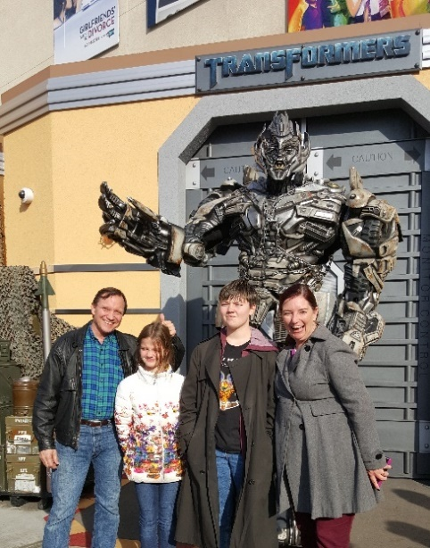

**Late Night with the Devil**

The audience of a horror film often sees the danger before the characters on screen because we know we are watching a story where things will go wrong in a certain cadence of storytelling. Bad horror movies have characters do things that they would see are bad decisions if they stopped and thought first. These leave the audience rolling their eyes at the clumsy, you-must-die-now, heavy hand of the plot.

In contrast, this film gives its protagonist a completely believable motive for moving ahead with what the audience sees is a terrible idea. A late night television show host is about to have his show cancelled because other shows with a lot more money have stolen away his audience. His back is to the wall. So he goes ahead with a line up of guests that will either be a huge audience draw or a bad

joke. He is willing to risk failure. Turns out the show is a huge draw, and having a possessed girl and her psychiatrist (who has adopted her – red flag) on stage with a well-known skeptic turns into not a cheesy joke, but utter demonic mayhem. The film is told as a docudrama, with lots of behind-the-scenes footage. This makes the first act a little choppy, but it really adds to the urgency as the story progresses. Clever, engaging, and actually scary in places. I recommend it for horror fans and film storytelling fans alike.

**Godzilla X Kong**

I wish there was some way to package this differently, but this was a bad movie. I really liked the earlier Monarch kaiju movies. They’ve given the monsters personalities and personal histories that make them sympathetic and interesting. This film reduced them back to being giant rubber monsters that you really could not care about. The special effects, which have been excellent in some of the earlier installments, were laughably bad in this film. And that’s not just because I am spoiled by modern FX work. There were many times where the creatures just didn’t look big and did not move as if they were heavy. The humans were given dialogue so cringy I had to feel sorry for the actors. I tried to find something clever or fun, I really did, but there just wasn’t anything. Don’t waste your time. Maybe the next in the series will be better and we can all just pretend this one was never released.

**The Ministry of Ungentlemanly Warfare**

This film was a blast from the opening scene. Based on the hard-to-believe-but-true story of how the British SAS was formed, the film is built around interesting characters that are easy to care about. The rule-breaking troublemaker with the courage to try anything, the spy who has spent months building a cover that could be blown with a single misstep, the Prime Minister who has run out of time, these are people we find easy to root for. We all know Henry Cavill can deliver on sarcastic cool, but this entire cast really came together. The fact that Ian Fleming was an officer involved in the operation makes a lot of sense when you consider his inspiration for the character of James Bond. Beautiful cinematography, believable action sequences, and spot-on art direction and costumes lend great support to a story that rides on the crisp dialogue and daring-do of our heroes. I guess you can tell, I really enjoyed this movie. Recommended, especially for action fans, history fans, and spy story fans.

***Have a Drink***

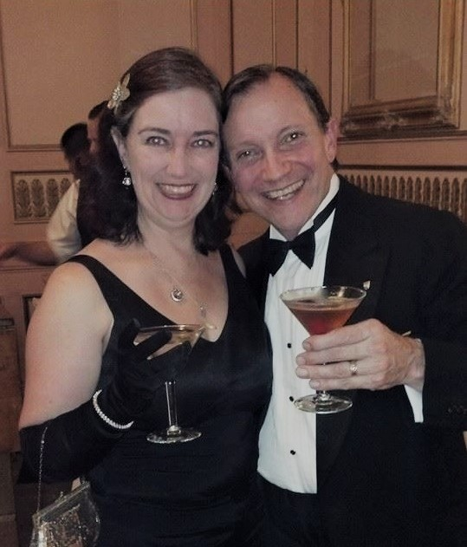

**The Mirror’s Revenge Coloring Book**

No, you didn’t miss anything. This is a project that never took flight. Getting the pitch ready reminded me of the long and strange journey the show took over a fifteen-year period. Here is a glimpse of one of the dead-end trails.

After Margaret Davis and Kristoph Klover pressed the album of the studio recordings of the songs, I started keeping records of all the decisions I had been making about what the play would look like on stage. Recall I originally wrote the story as a screenplay, so I had those visuals to start with. But fitting the story onto a stage with actors and sets and props was going to look different. I had a hard time wrapping my head around how to play out the action in a way that an audience, off to one side of the action (the fourth wall) would see everything they needed to see. I had no timeline for putting it on stage, so I started doodling.

Doodles turned into renderings. Those showed me points of view. I made more decisions, and scenes took shape.

With no playbook for how to launch a show, I was still grasping at how to build an audience and attract backers. The album was a great first step. Not only would it preview the show to a potential audience, but it would give us the instrumental tracks that would become the score over which the actors would sing.

Playing on that same notion of building support one step at a time, I thought I could turn my renderings over to an artist who could fix them in line art, and turn them into a coloring book. This was about ten years ago, and coloring books for grown-ups were just becoming a big thing. So I went back and got serious about the drawings. After I finished a few, I saw that I really needed to focus on finding a stage and making it all fit in the real world. So I abandoned the coloring book.

The drawings below were an important step in getting my thoughts organized, even if they didn’t amount to much else. I share them with you here as a view into my stumbling process. Those of you who know the show will recognize them as the first few scenes. First is the opening flashback of the Evil Queen being gaslighted by the Mirror. Then is the opening duet of Snow welcoming Karl home from a hunt. Then we see the nightmare Snow is plagued with every time she falls asleep. Then she goes to see Father Heinrick, who says the church has deemed her possessed and unclean. Lastly, we see the dwarves arguing about who will go visit Snow.

That’s it for this edition. I hope you enjoyed it. Please invite your friends to sign up. I am actively generating content as I never have before. This newsletter is the best place, and in some cases the only place, to hear about it all ahead of publication.

Until next month, be well!