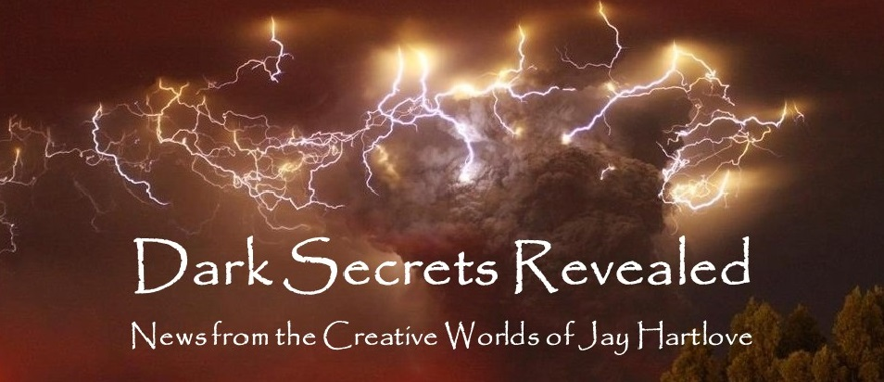

Issue 3 November 2022

I recently attended a reading by Laura Anne Gilman from her new book Uncanny Times. It is the first in a new series about a brother and sister who belong to a secret society of paranormal hunters. She openly admits to her longstanding fandom of the show Supernatural. I suspect this series was borne out of ideas she wishes she had seen on the small screen. I am looking forward to her version.

She and I have a cute history. Thirty something years ago, she was an editor at a major publisher. I sent her a manuscript for a sword and sandal fantasy book that will mercifully remain unpublished. She sent me a handwritten rejection letter to say my writing had promise and I should keep at it. Those words of encouragement helped me get through a lot of tough times. Yes, I thanked her when I caught up with her at WorldCon this year.

In this month’s What’s Cooking column, I talk about something Laura said and how it got me thinking about my brand as an author.

As always, please tell your friends about me and this newsletter. My most treasured connections have been from word-of-mouth referrals.

Of course, I also have a web site [www.jaywrites.com](http://www.jaywrites.com) that tracks all my projects, past, present, and future. There is a listing (with links) of the interviews I have done in the last couple of years. I invite you to check it out.

Here are the usual newsletter columns:

1. What’s Cooking: Previews/discussion of what I am actively working on. Also links to interviews, appearances, and other current writing news.
2. Mister Wizard: Advice and analysis to help my fellow writers.
3. The Aisle Seat: Recommendations. I am a huge movie fan and watch several every month.
4. Have a Drink: Wherein I will share personal stories.

***What’s Cooking***

***Author Brand****, or How I found mine after writing for decades*

Since leaving the editor game, Laura Anne Gilman has written about thirty novels, several novellas, and lots of short fiction. She freely mixes genres to tell stories she wants to tell. One series is hardboiled detective fiction in an urban fantasy setting with magic. Several of her books are mixes of fantasy and romance that do not fit the usual formula for mixing those together. Her willingness to mix and match to tell her stories has been an inspiration to me, since I do the same thing. So I asked her the other night, how does she maintain an audience when readers use genre distinctions to find the books they want. She laughed and said there is a reason she isn’t a top list bestseller. She said she hopes to broaden the interest of her readers, to lure detective fiction fans into fantasy, or to make fantasy fans reconsider how they read romance.

This got me thinking about my own quest for an audience. You would hope that with five novels published, I would have found a readership. But by mixing and matching genres to tell the stories I want to tell, those books ended up being a supernatural thriller, a medical thriller, a superhero team, a fantasy romance, and a science fiction thriller. And my musical is a reworked fairy tale in the form of a sequel. Since genre labels are one major way audiences find the books they want, this has worked against me.

Thankfully I have developed a brand. My stories are 1) usually very fast paced, 2) often have a villain who is not who you thought it was, and 3) almost always turn a victim into a hero. This has not been as effective at reaching an audience as clear labeling. To be honest, I did not know about this pattern until I wrote all these books. In Goddess Chosen, Charles Redmond goes from radicalized terrorist to become the savior of his faith. In Goddess Daughter, Randolph Macklin goes from betrayed puppet to saving his daughter’s life. In Goddess Rising, Desiree Macklin goes from manipulated pawn to decisive judge. In Mermaid Steel, Chielle Mmava goes from oppressed by racism to risk-taking heroine. In The Insane God, Sarah Meyer goes from mental patient to change master. And in The Mirror’s Revenge, Snow White goes from abused child to strong anchor.

I also mess around with the role the villain plays. In Goddess Chosen, it appears Silas Alverado is the villain, but it turns out to be Sammael, his adversary. In Goddess Daughter, it starts out looking like the villain is Lo Cheung, but by the third act we see it is not. In Goddess Rising, there was no way I could hide the fact that Lucifer waked among the heroes, so I showed this to the readers immediately. The reader then gets to yell at the protagonists for the whole book, “But he’s right there!” In Mermaid Steel, there is no personified villain. Captain Boole is an adversary, but he is just a symptom of the real conflict, which is racism that has captivated both villages. In The Insane God, the ancient gods appear to be the source of conflict, but then we see Jefferson Davis has risen to become an actual enemy. And of course in The Mirror’s Revenge, the revealed story is how the Evil Queen was gaslighted into murdering Snow White by the real villain who is the Mirror.

Looking ahead at my next projects, the patterns hold true. In my new high fantasy The Dove and the Crow, Willa Freedlund goes from spousally abused to become the healer of a broken world. Oh, and the villain is already dead at the start, so the story is about cleaning up the mess he made.

Now my readers know what to expect. I just need to find a way to let a broader potential audience know this is what I do. Then they can decide to take me on.

***Mister Wizard***

**Just who is the villain?**

At World Fantasy Con this weekend I virtually moderated a panel called, “Just Who is the Villain?” The catalog description reads, “A well-developed villain in fantasy and horror must be portrayed far beyond the traditional "figure dressed in black". Perhaps, at times, they may even be someone the reader finds more sympathetic than the hero. What are alternate ways of representing forces of "good" and "bad"? Which books (and authors) are pushing the boundaries between hero and villain?”

The convention did an excellent job running the tech. David Boop and Ryan McFadden were in the room in New Orleans, I was in the San Francisco Bay Area, Susie Williamson was in England, and Colin Alexander was in Maine. The in-room tech team said the audience was thoroughly engaged and everyone enjoyed the panel.

I opened the topic by suggesting a sympathy scale for how the author hoped the reader would see the villain. I included a few examples from popular culture.

Irredeemable

Uncompromising, entitled, must win, very bad goal, evil, must be defeated

Tai Lung (Kung Fu Panda), Terminator, Freddy Kruger, Sauron

(From my own work: Young Nae Yoon, Sammael, Jefferson Davis)

Justified

Understandable motive even though wrong, small chance of redemption

Scarlet Witch, Dexter

(From my own work: Silas Alverado)

Sympathetic

Audience almost wants them to win especially if the hero is annoying

Dr. Victor von Doom, Walter White, Roy Batty (Blade Runner)

Or comedically: Dr. Heinz Doofenshmirtz (Phineas & Ferb), Professor Fate (The Great Race)

Antihero

Not evil, good motive and objective, but broken moral compass

Batman, The Punisher

Systemic

Bad guys are a symptom of a larger problem, like racism or corruption, that must be solved apart from defeating the villain.

Most of the cast of Gotham

(From my own work: Mermaid Steel)

Absent

The villain is already dead. Story is about healing the damage they did.

(From my own work: The Dove and the Crow)

Not who you think

Malificent

(From my own work: The Mirror’s Revenge)

After discussing some examples from the panelists’ favorite books, we arrived at a conclusion that a well-written villain is an adversary who brings out the best in the protagonist, usually by presenting a situation that the protagonist must rise to meet. I think the best example was when Susie talked about Killmonger and T’Challa in Black Panther. Killmonger drove T’Challa to make tough decisions and step up as a leader, and his motives were so sympathetic they changed T’Challa’s mind about allowing Vibranium to be used outside of Wakanda. We also discussed how the protagonist can be their own adversary when the conflict is getting out of their own way or overcoming a bad habit. Everyone had lots of good things to add. It was a very good discussion.

***The Aisle Seat***

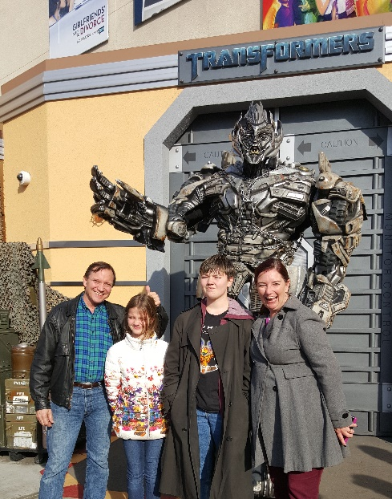

**Ticket to Paradise**

Yes, sometimes I check out a RomCom. Romantic Comedies tend to follow a formula, which was brilliantly parodied by Rebel Wilson in Isn’t It Romantic. I expected this one to be predictable but enjoyable because Julia Roberts and George Clooney are usually charming. I am happy to report, this film went a little deeper, and although it was predictable in places, it did not follow the usual formula. It is the story of two estranged but still controlling parents trying to stop their daughter from throwing away the life they had planned for her. The parents screw things up worse and the story plays out with more honesty than I thought it would. My only beef is the set up has the parents so wealthy they can afford to take the time to work things out – a luxury few of us have. I applaud the filmmakers for having these characters make the tough decisions that real life requires.

**Smile**

This one left me smiling (pun intended). What looks in the trailers like a cheesy monster/slasher flick turns out to be one the best and most original depictions of demonic possession I have seen in a long time. This story does not use a single cliché from the usual demon portfolio, and by the second act, the film establishes its own mythos. Everyone acts with agency, facts are followed up, a genuine mystery is unraveled, and really scary things happen. The sense of dread and being overpowered and outmaneuvered is built steadily from the very start. The enemy is smart, ruthless, and powerful, but our heroine is determined to find a way to fight it. There are a lot of jump scares and grisly visuals that could be seen as excessive. I found it easy to root for the heroine and to care about her. I’m glad I gave this one a chance.

**Emily the Criminal**

In a press interview, Aubrey Plaza said she worked hard to capture the sense of desperation that drove the Emily character. I think she did an excellent job. Emily is a fighter. She doesn’t take no easily. She is smart and resourceful. But all the cards she has been dealt are crap. She is underemployed, overextended, and underappreciated. She is in exactly the kind of corner to be preyed upon by scammers looking to use her as a pawn in crime, credit card fraud in this case. She makes some money at it but soon realizes she has real talent for this. Emily befriends her recruiter and sets herself up in business. Lie down with dogs and get up with fleas. She soon gets entangled in her lover’s gangster family and everything comes apart. This film walks the same rails as other over-your-head crime stories, and to its credit, it does not try to go where films like Scarface go. Emily is too smart for that. But is she too smart to know when to quit? Heck of a ride.

***Have a Drink***

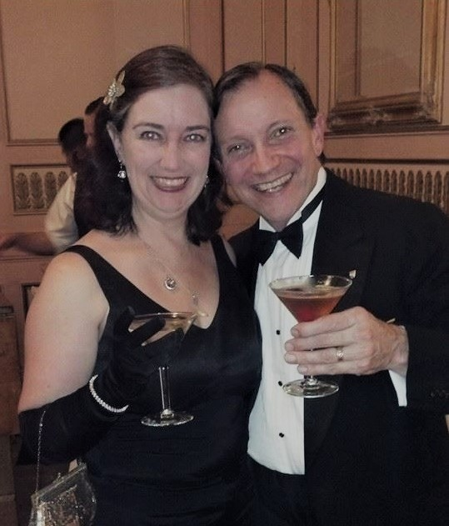

**Regina Snow Victorious** or *More than I ever imagined*

This is the first half on an article that was published in 2018 in Christopher Garcia’s Hugo Award winning fanzine Drink Tank. It reviews the ordeal I took on of writing, producing, directing, and acting in a full-blown musical show. The second half will appear in next month’s newsletter.

From Idea to Stage

In the fall of 2006, I saw Evanescence perform “Bring Me to Life” at San Jose State University. The song inspired me to think about the untold journey Snow White took in surviving the Sleeping Death spell. Last weekend I premiered my original musical The Mirror’s Revenge at WorldCon 76 in San Jose, just a few blocks from SJSU. That twelve-year journey is my testament to the power of tenacity when it is fueled by love (and naiveté) and tempered by flexibility.

The Many Forms of Snow

The show is pretty dark. It explores themes that are in the original folk tale like child abuse, and takes them further with PTSD, gaslighting, betrayal, and the nature of evil. Snow White emerges victorious without having to gain agency by picking up a sword. The story was compelling and needed to be told. It really is what Dark Fantasy should be.

The inspiration first took form as a screenplay for the sequel to the Disney classic. A film critic judge at a screenplay contest advised me to take the Disney out and let the story run on its own power. My friend and veteran actor Jeffrey Weissman told me the revised script wasn’t a movie but a play, and I need to let actors live the nasty little family revenge drama on stage. My friend Ann Thomas let me conduct a cold table reading with actors from her drama circle, and their feedback was fantastic. Then I realized music had always been part of the genesis, so I approached my friends Kristoph Klover and Margaret Davis to write songs from my lyrics. I parsed out those parts of the script that were better told in song, and over the next two years, they wrote melodies for my lyrics. Next Kristoph and Margaret brought in musician friends and recorded a soundtrack album of the songs. I raised the money to record it with a Kickstarter. We showcased the album with my story narration at BayCon in 2016. “When are we going to see the play on stage?” came the rallying cry.

After ten years of showing the story to critics, actors, and musicians, and after having everyone who ever read it love it and offer to help, I had reason to believe the show deserved the investment of mounting a production. I have had at least one foot on the stage since high school. My competition costuming at science fiction conventions in the 1980s and 90s always felt like theater to me. I have helped several shows to reach their potential, both at conventions and in theaters. So I thought I knew what would be involved. Ah, ignorance is bliss.

A Play Takes Shape

Margaret and Kristoph had explored the possibility of the album being nominated for a Hugo in the Alternate Form category. I thought, why not run the show itself at WorldCon and get it nominated. I wasn’t going to get a Tony, so why not try for a Hugo? My friends who were running WorldCon in San Jose were looking for entertainment, so I agreed to move my show to their convention for a day.

This is why ignorance and ambition do not mix.

I saw “Once Upon a Mattress” at the theater run by dear old friends who finally got their own venue after decades of renting out other houses. The show is complicated, with dozens of actors running on and off stage throughout. The show ran flawlessly, even in that tiny space. That kind of precision is not due to a good director, but a good stage manager. I made inquiries, and made her my first hire. Ashira Macy has been my cornerstone anchor though this entire journey. I literally could not have done this without her at my side. I cannot overstate the importance of having a good stage manager.

I networked and placed ads starting in August 2017, one year out, and found a director who had just finished a run of Who’s Afraid of Virginia Woolf, which is a challenging play to direct. She was smitten with my story and had big ideas about how to mount it. Unfortunately, her big ideas eventually outstripped my budget (even after an attempted Kickstarter) and we parted ways in March 2018.

Casting A Dream

I found a very talented ingenue lead in a teen theater troupe my daughter belongs to. At fifteen, Kristina Jewett is the right age for Snow White in my story. I attempted to recruit the chorographer from that troupe to direct my show, but there were conflicts of interest that prevented that. I recruited a number of actors I had worked with before. Some dropped out after considering their other commitments, and some stayed on. I networked, placed ads, and held open auditions all through the spring of 2018. Over and over, I would get an actor on board, only to have them change their mind.

I wondered why I was having such a hard time casting a show everyone loved at first sight. Then a took a step back. The theater I rented, the same one where I saw Mattress, was in rather remote Vallejo. My rehearsals were going to run through the summer, when folks go on vacation with their families. Several summer stock programs at colleges and other established community theaters had already cast their shows well in advance, thus draining the Bay Area talent pool. And my show was new. Given the choice between playing a known role in a known show and taking a chance on the unknown, many picked the safer choice.

I also asked at local high schools and colleges for interns to help with building sets and running things backstage. Turns out state budget cuts have scrapped drama departments at high schools, and even shut down the summer sessions of the two closest community colleges. So, no interns.

Oh, and there was another wrinkle. This is a recorded show. I had in mind to leverage all the work we had put into the album, and simply have Kristoph strip the voice tracks out, creating a karaoke soundtrack that my actors could sing to. Needless to say, it did not turn out that easy. More on that in a moment. I also thought recorded music would be a whole lot easier to transplant to San Jose for the one convention show. But because recorded shows have notoriously bad orchestrations and sound, several actors who were otherwise interested, walked when they heard I was not going to have live musicians.

Because the show was committed to play during WorldCon, there was no moving the date out if things got difficult. Anyone who has ever run any kind of project knows that having a fixed deadline multiplies stress. As casting difficulties continued, the show’s original run before WorldCon (ending on August 16) was moved to after the premier at WorldCon (starting on August 16).

Not being able to wait any longer, I had to have faith that I would finish casting the show once rehearsals started on July 2. On July 5, one of my actors walked in with a buddy on her arm, and he signed on as my last cast member. That night after everyone left rehearsal, I lied down on the stage and laughed out loud. I finally had a show.

Working with Absent People

My younger brother is an electrical engineer and also very good at building things. He had said he wanted to help my production, so I counted on him to build my sets. Then he had medical issues that took him away for the entire month of July.

I finally secured my cast, just in time to realize I had to build the sets myself while running rehearsals. My brother did become available in August, and he did help me build stuff. So that did work out eventually.

Then the conflict calendars rolled in. Because all these other shows are running, several of my actors were in rehearsals and in performances during my rehearsal period. That means putting together call schedules around who can be present, when some actors could not be present for up to a week at a time. We managed to get everyone rehearsed on all their scenes, with the right other actors, over the course of six weeks. Again, Ashira worked magic to pull it off. Our first day with all ten actors on stage at the same time was August 8, the day before we started Tech Week.

The Music

Early on, I had invited an opera singer friend of mine who lives in Rome, Alexandra Montani, to record a demo of our rock solo Summer Ended Early. It was to be a promo piece upon which we would build publicity for the larger plan. Alexa visits family each year here in the Bay Area, and being a Snow White fan, agreed to help us out. Alexa is a Coloratura Soprano, like Adriana Caselotti in the 1937 Disney film. I wanted to evoke people’s memories of the film when considering my sequel. Recall, I wrote the first version of this story as the sequel to the Disney film.

When Kristoph and Margaret invited their musician friends to come record the album, I did not think to insert myself in the process. Kristoph, quite understandably, continued with the notion that we wanted the album to still sound like Disney, so he and Margaret hired singers and arranged the music with lots of soprano music for Snow, and lots of hearty baritones and basses for the men.

This created a couple of problems for turning it into a show. For every male actor who does musical theater, there are ten women. And only a fraction of musical theater actors are baritones or basses. So the chances of me casting men to sound like the fellows on the CD were very slim. Even more importantly, I was open to the idea that the Sleeping Death spell had changed Snow White in a variety of ways. Not only was she tired of being a victim and now willing to stand up for herself, but maybe her voice had changed as well. When I found Kristina, I knew I had found my Snow White, even though she is an alto.

My final casting also gender bent two key characters. Brother Daniel became Sister Katherine. And Master Wing went from wizened warrior to kick ass woman warrior.

So much for a simple karaoke version of the CD.

Knowing how the musical deck was stacked against me, I hired a Music Director to sort out the music and teach my actors the songs. Jay Krohnengold has been performing, coaching singers, and directing shows for fifty years. He and Kristoph worked together for the entire six-week rehearsal schedule changing keys, adjusting phrasing, and fine-tuning harmonies to turn what was already a great songbook into one that matched my actors on stage. It was a titanic effort for which I will be eternally grateful to both.

On the Nature of Collaboration

I have spent most of my creative life alone, typing away at 2 am in my office. I write and edit iteratively, going back over material many times, adding in things I missed or thought of subsequently. But no matter how many times you revisit something, you can only see what you can see.

I had rewritten this story a dozen times. I thought it captured absolutely everything I ever wanted to say in its 110 pages. When I handed out the script to my actors, I was confident they were getting a story that worked, with characters that audiences would believe and care about. All that was true, but there was so much more to be discovered. Jeffrey Weissman was right. Give it to actors who can occupy the roles, and only then will you see who these characters really are.

The magic started happening with the first rehearsal. Nuances, motivations, personal hopes and fears, layers of humanity I had assumed but not actually written suddenly were up walking and talking and singing. I starting seeing depth in this story I had not seen before. It was as if some other, much more talented playwright had crafted this tale with these fascinating characters.

Directing became the joy of my life. Producing had been so much work under so much pressure. Being able to work with the actors for a few hours a night was pure storytelling bliss. The actors brought so much life to the characters, I wanted to give them something in return. Of course, occupying roles is what actors love to do. But it was time for our big roadshow opening. My hope was it would be a unique experience that would add to their love of their craft.

Next time, the rest of the story, including how we opened at the World Science Fiction Convention in San Jose on a Thursday night, then moved the show 40 miles back to our home theater to open Friday night in Vallejo. Stay tuned.

That’s it for this edition. I hope you enjoyed it. Please invite your friends to sign up. I am actively writing two new novels, a comic book, and two short stories. I am generating content as I never have before. This newsletter is the best place, and in some cases the only place, to hear about it all ahead of publication.

Until next month, be well!