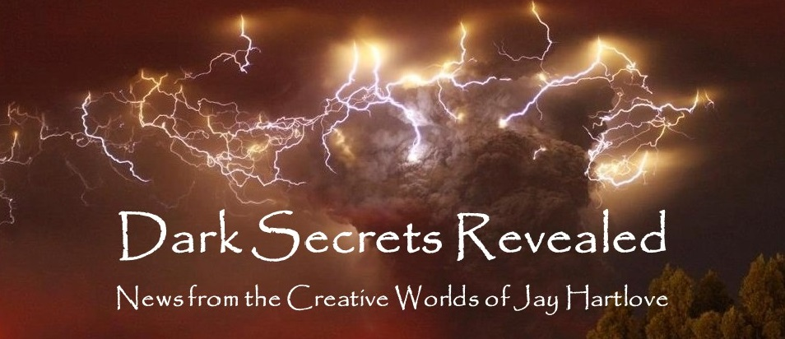
Issue 11 August 2023
July found me getting back into regular routines after the first part of the year being very hectic with bank work. My son and his husband moved in with us from Chicago for the rest of the year as they finish outfitting a school bus into a mobile home. This is apparently a thing now. They’re called Skoolies. I can never say no a good DIY project. Hotel Hartlove is back in business.
I finally got back to work in earnest on my fantasy novel The Dove and the Crow. More about that in an article below.
I had fun putting together a fun adventure for my wife Denisen’s birthday. Also more about that below.
Last month I promised to show you the step-by-step from a couple of years ago when I built the Chielle model. I have taken her to several book signings at science fiction conventions, as well as to the mermaid convention where she is now a regular. Most recently she appeared at Baycon, where the staff gave her a membership badge. Much fun.
As I usually ask, please tell your friends about me and this newsletter. My most treasured connections have been from word-of-mouth referrals. Even more so, with this being the tenth edition, I would love your feedback. Are you finding these articles engaging? Entertaining? Helpful? This newsletter is for you. Let me know what is working, what isn’t, or what else you would like to see instead. You can reach me directly at jay.hartlove@gmail.com.
Of course, I also have a web site www.jaywrites.com that tracks all my projects, past, present, and future. There is a listing (with links) of the interviews I have done in the last couple of years. I invite you to check it out.
Here are the usual newsletter columns:
- What’s Cooking: Previews/discussion of what I am actively working on. Also links to interviews, appearances, and other current writing news.
- Mister Wizard: Advice and analysis to help my fellow writers.
- The Aisle Seat: Recommendations. I am a huge movie fan and watch several every month.
- Have a Drink: Wherein I will share personal stories.

What’s Cooking

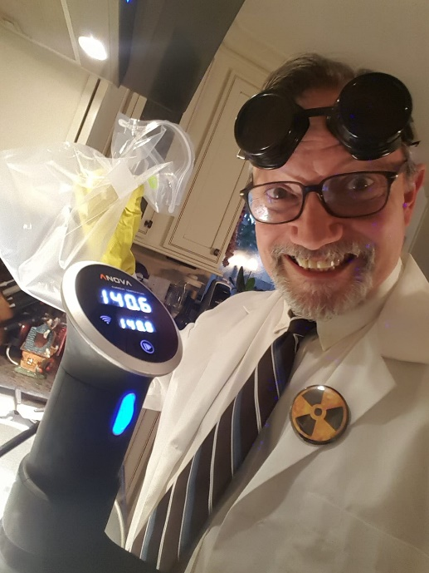
WIP Report
I am now 120 pages into The Dove and the Crow, and right on time, I am having doubts. This is a fantasy novel. I’ve been writing fantasy in one form or another for forty years, including my superhero game books and all five of the novels I have in print. I like the world I am building. I love the characters who are telling the story. I really like the plot I am playing out. What’s different is how much of myself I am investing in the story. I thought this would give me more to work with and create a more satisfying product. It has also set a higher bar.

As I have discussed here before, I am a survivor of childhood abuse. Making victims into heroes has been a therapeutic theme in a lot of my writing. I have written protagonists from different kinds of abusive backgrounds. Charles Redmond of Goddess Chosen
was radicalized as a youth into doing crimes for which he never forgives himself. Desiree Macklin from Goddess Rising became a hero by dying in a failed mad scientist experiment. Chielle Mmava of Mermaid Steel grew up under the heel of racial prejudice.
This time I am tackling relationship abuse. One of my two heroines was married to a man who beat her. She left him, upon a friend’s insistence, and fell for a man who also belittles her, even if not physically. She gets no respect at work. Her beloved dog just died. Misery has become normal for her. When she falls into a parallel world where the pace is slower and her life has little pressure, she can’t help but feel it is a hallucination from a head injury. When she is accosted by a drunk, her self-confidence unravels and she falls back into expecting blame and disrespect.
This is the woman who will bring her new world back from the brink of destruction.
The new world, called Hern, is a near copy of Earth, with the major difference being the presence of powerful extra-dimensional creatures who have set themselves up as gods. They are so powerful, their mere presence unleashes magical forces that magicians and witches are able to manipulate. They are mercurial and not concerned with the affairs of men. Their battles among themselves have upended civilization several times, leaving the world scarred, and with normal evolution interrupted. Mankind had achieved an advanced civilization at one point, but it was decimated and has only grown back to a level equal to our European Renaissance. Willa notices the wrong animals filling ecological niches, and other kinds of animals she expected are not present at all. People either live in fear or have given up and adopted a cavalier attitude.
Hern is in particular trouble now because three of the most powerful gods had a tryst that ended in a murder. One brother is dead, one brother (the killer) is depressed and withdrawn, and the lover they both vied for is imprisoned. The magic that holds the planet together is dwindling, and with it, the continents are crumbling. The magicians and witches have tried everything they know, but they can’t get the surviving free god to respond.
This is where our damaged heroine steps in. A lot happens to bring the pieces together, mostly driven my Willa’s understanding of myth from her being an English professor and folklorist. At the heart of the story, Willa knows what it is like to be an abused woman. She convinces the brother god to rescue his lover, that after being abused by his dead brother, she will welcome his kindness.
Along the way, Willa and Naomi deal with local politics, angry magical races, and the inexplicable gateways that keep opening due to an Earthly scientist who is working with a reckless Hernian wizard. And of course, there is Naomi’s entire story arc.
Sounds fun, yes? Except it has taken me a lot longer to establish Willa’s background and character flaws and relationships than I am used to taking in my stories. It feels like a mainstream character piece with magic sprinkled in for color. I am used to chase scenes and explosions in the first fifty pages. Building the layers of this story has time spent on Willa adjusting to a non-tech world, fitting in and making a living, being amazed at Naomi’s pedestrian daily magic, and having a common cold leave Willa deathly sick because of immunities. Yes, there is wonder. I still fear I will bore the reader. I am finally getting to the starting place for the main plot conflict at page 130. The book will probably go over 300 pages. This is typical of thoroughly built-out fantasies. But is it all right for the protagonist to not find out about the main conflict of the story until a third of the way into the book?
In Goddess Chosen, our heroes think they are dealing with the villain (starting at the very beginning) only to realize the real villain halfway through the book. That’s building suspense. This is not. This is all character development. This is walking the reader alongside Willa as she explores her new world, letting the reader see how badly she reacts based on her abused background. It’s the only way I see of getting the reader to understand her before I launch her against overwhelming odds.
I am running the risk of being criticized for a slow start. Slow starts are not a good way to hook an editor or publisher. My plan is to forge ahead, finish the first draft, then go back and reconsider the pacing of the first part. I am hoping I will see that this self-doubt is just the expected nerves at this point in the process. Wish me luck.

Mister Wizard
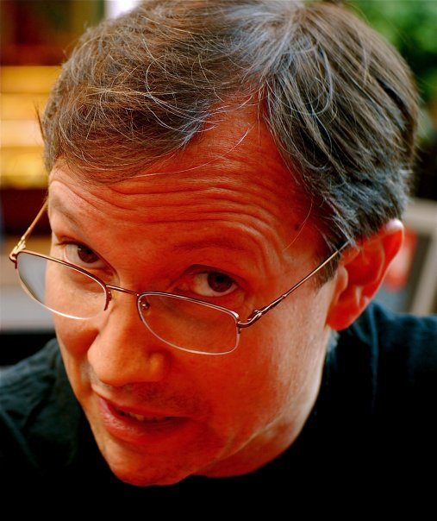
Sculpting the Chielle MerMannequin
Three summers ago, I found out a bunch of mermaid enthusiasts were holding a poolside convention about an hour from my house. I bought a dealer table to sell Mermaid Steel (and my other books). It was a blast. I wrote about the experience recently in these pages. The next year I took this event as inspiration to build something I had been thinking about for a while – a booth babe, a sales assistant mermaid model of my heroine Chielle Mmava.

I knew this was going to take time. I started six months out. I barely got her done. I employed skills I developed building fantasy and science fiction armor from my days as a cosplayer. What follows is a photojournal of the progress, starting with my teenager modelling the pose. (Thanks Max!) I only built an upper body, to have her sit on a chair, leaning slightly forward, leaning her arms on the table, looking up at whoever is standing at the table. The green stuff is florist foam. The white stuff is papier mache putty. And yes, she floats.
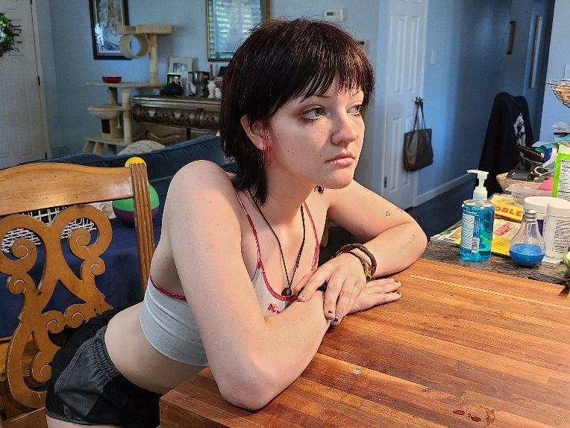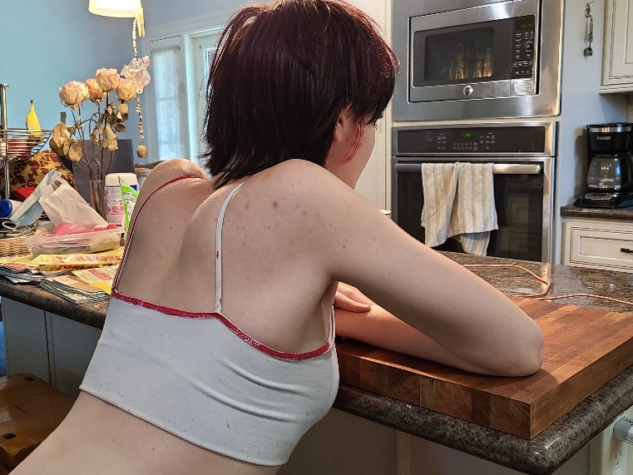

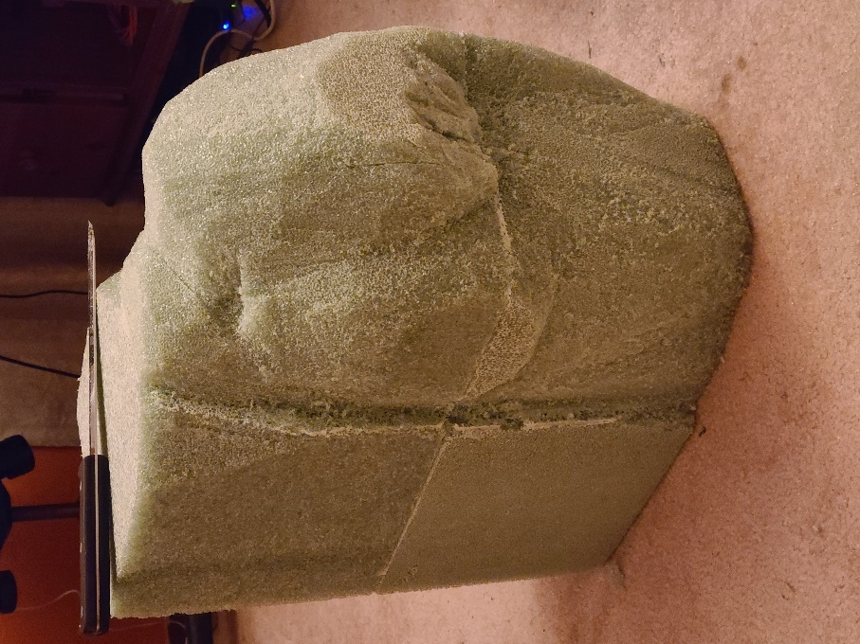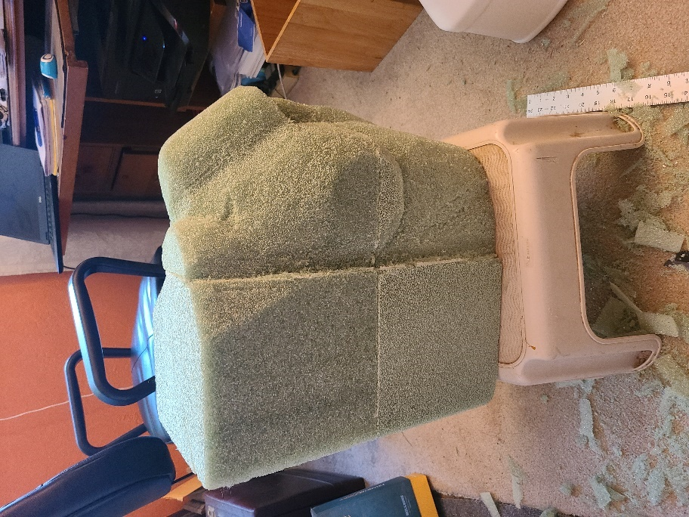

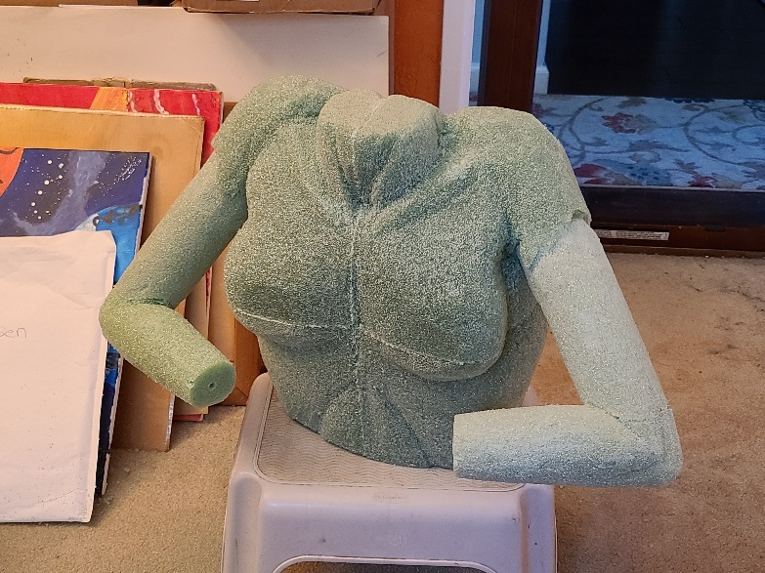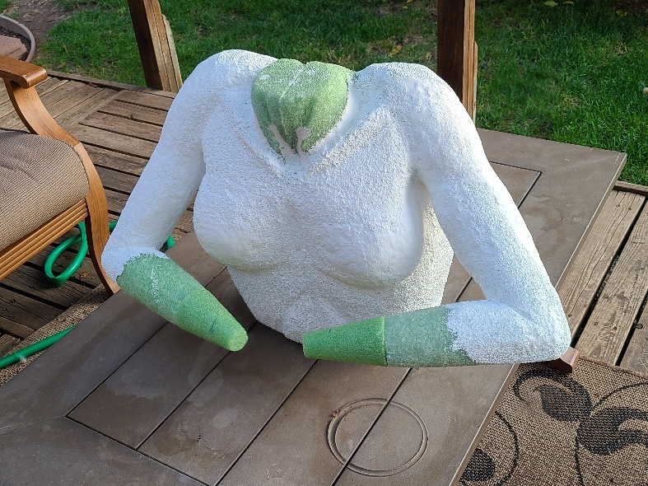

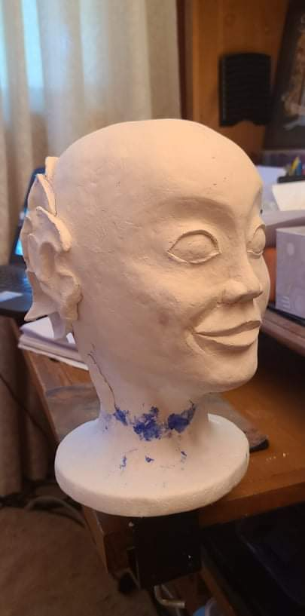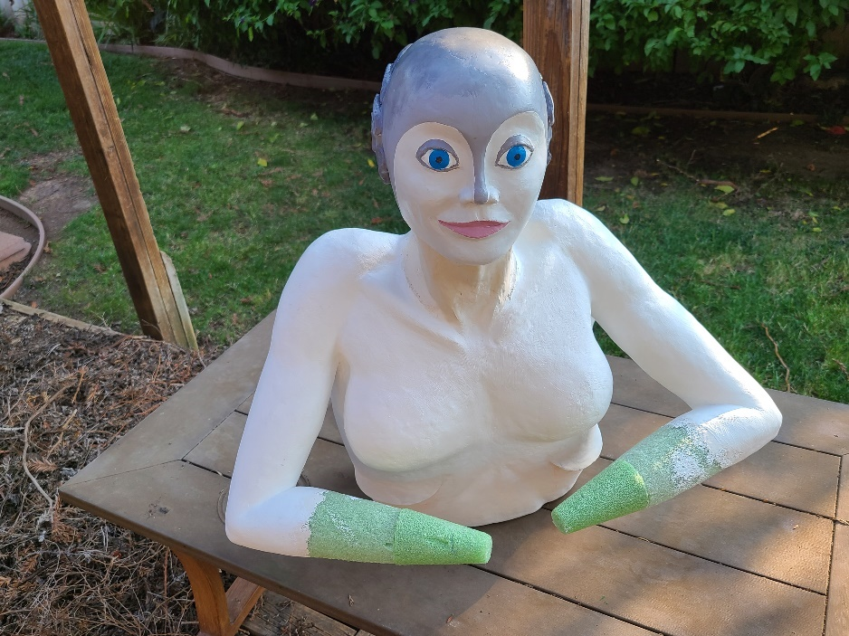

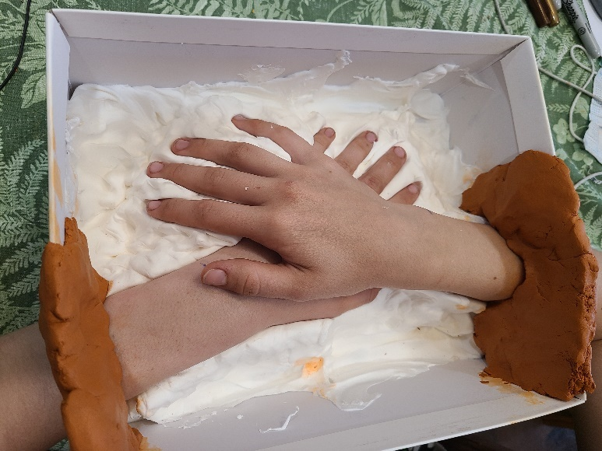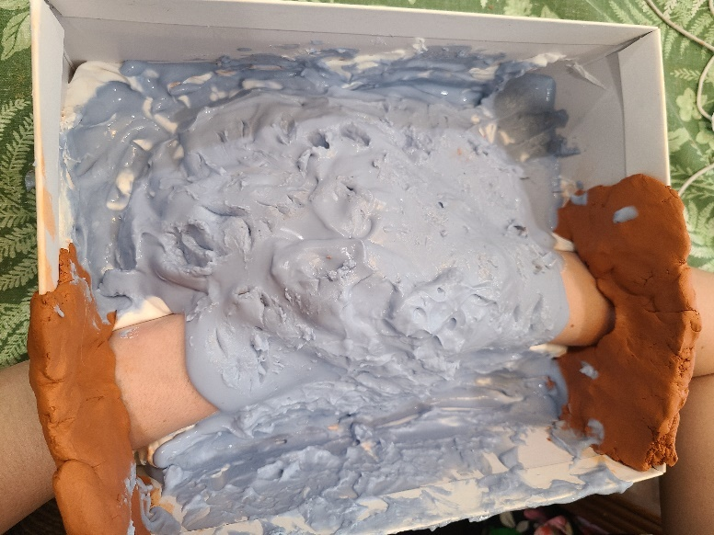

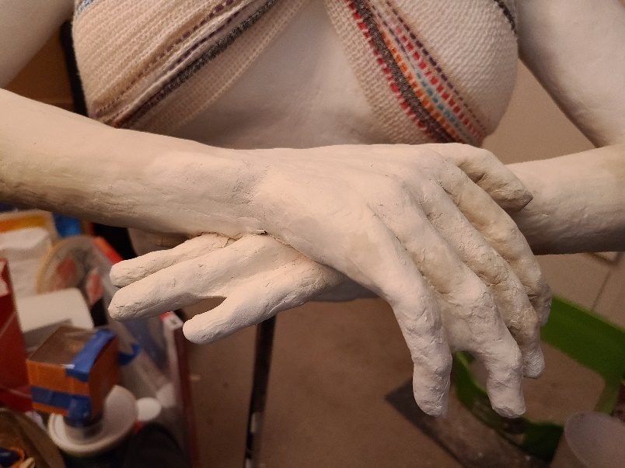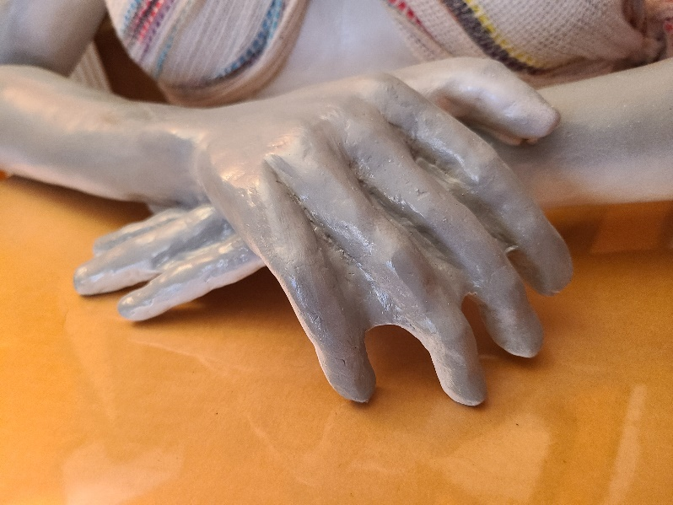

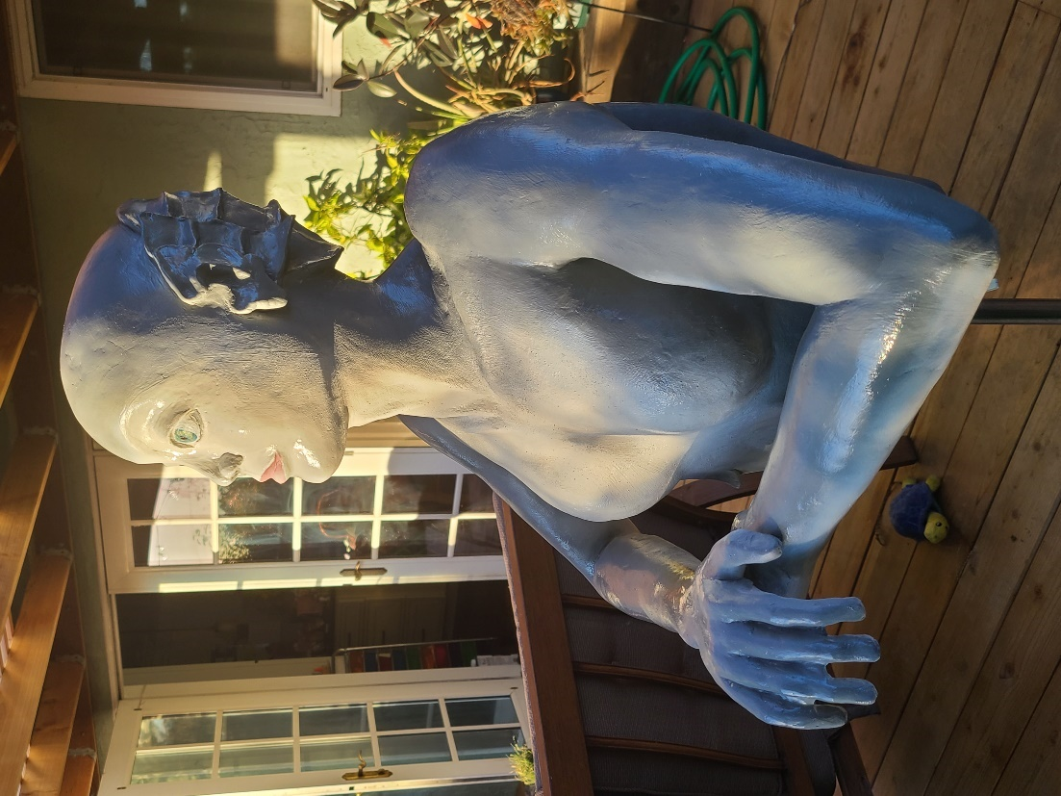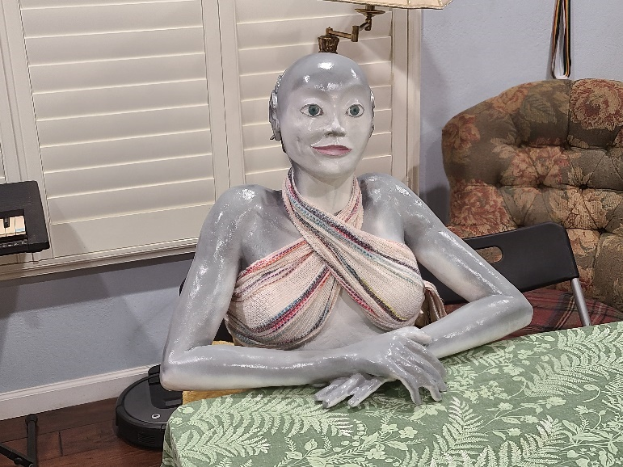

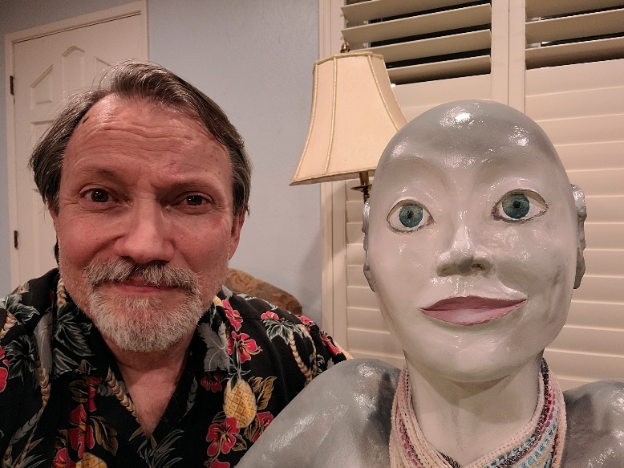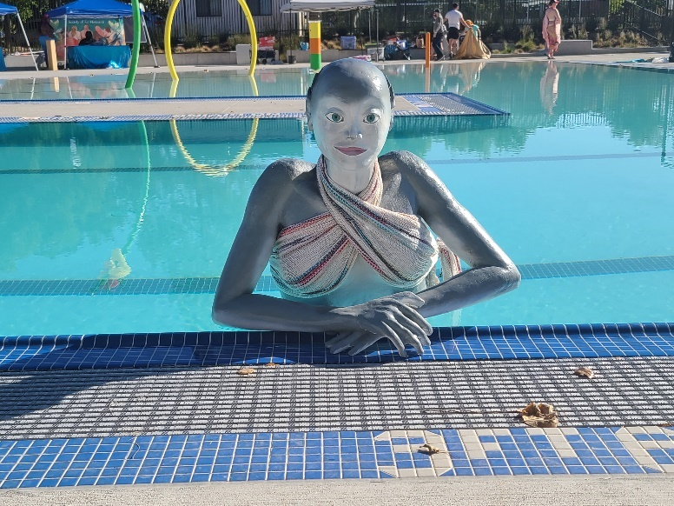

The Aisle Seat
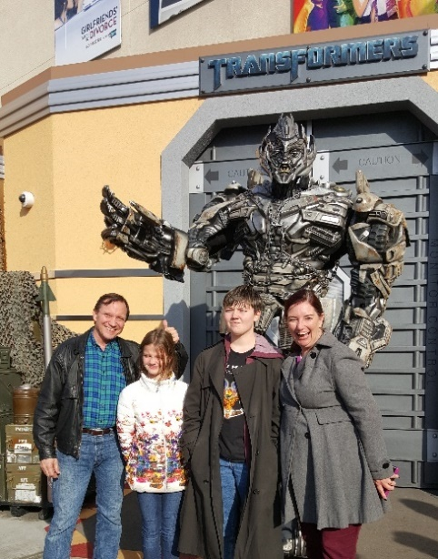
Asteroid City
This month I watched three movies that could not have been more dissimilar. One was a surreal social commentary, one was a somber biography, and one was a dazzling action film.
Asteroid City is a Wes Anderson film. It is a very Wes Anderson film. Garish colors, entirely symmetric cinematography, disjointed dialogue, quirky music, his usual company of players, and an odd framing device in the form of a play within a play. If you’re not a fan of his work, this one will probably not convert you. If you are a fan, as I am, then you ride along to see what he has to say.
We are told the play ran for hundreds of shows. Each time we see the actors getting ready to go onstage, the action cuts to the live-action enactment of what the play would only portray.

What the actors play out, apparently in real life, is rather a condemnation of modern sensibilities. A bunch of young astronomers and their families gather at the tourist site of a meteorite impact to get awards for their work. While there, an alien arrives and steals the meteorite. But the characters, the precocious kids, a movie star, a photographer who is a bad father, are all so self-absorbed they fail to register the historic import of an alien visitation.
(Spoilers!) The military shows up and cordons off the town. But the military leaders are self-absorbed as well. When the alien returns and replaces the meteorite, no one knows what to make of it, and everyone goes home. That’s it. End of film. I came away feeling like Anderson had shared a nasty little secret. Sometimes that’s all a play needs to do.

Oppenheimer
No man is an island. Even when telling the biography of a man who was at the center of a turning point in history, the effects of the other strong people around him must be told. Christopher Nolan wisely chose to tell Oppenheimer’s very personal story with plenty of light shining on the key people around him. The story is really about those interactions. Nolan has developed a style of juggling lots of influences and subplots in films like the Dark Knight series, Tenet, Interstellar, and Dunkirk. He showed this expertise in letting the supporting cast explore their characters fully. The actors all brought their A game. His use of pacing, short takes versus lingering shots, reminds us what an art form cinema can be. At its center, the story tells us there were so many conflicting agendas and strong personalities, it was only because Oppenheimer had such a singular vision that the atomic bomb ever became a reality. I imagine there have been other points in history where science, politics, and the military not only intersected but collided. They would be fascinating tales too. But this one really rang true given the viewers all know how much the world changed after this event. Highly recommended for film buffs and history buffs.

Mission Impossible – Dead Reckoning Part One
Tom Cruise’s Mission Impossible franchise started out with a major misstep. I was disappointed, so much that I hesitated to give him a second chance when the sequel came out. Having Jim Phelps, the leader of the IM team in the original series, go rogue and evil was just not believable. There were lots of other ways they could have handed the torch to a new generation. When I did go see the sequel, I was amazed. It was so much better than the first one. What really blew me away was the third one was even better than the second. I dare say this is the only series I know of that just keeps getting better. The James Bond series had hits and misses along the way (although I did love the entire Daniel Craig reboot series). The Star Trek movies were very inconsistent, as were the Star Wars films. Even the John Wick series had a dud with number 3. Not so with Mission Impossible. Great characters, believable dangers, astonishing stuntwork (natch), and evolving relationships with recurring characters, really raise this series above the crowd. This is part one of a large story that really feels like a real world danger – an AI that threatens world stability. I will be there on opening day of the second part.

Have a Drink
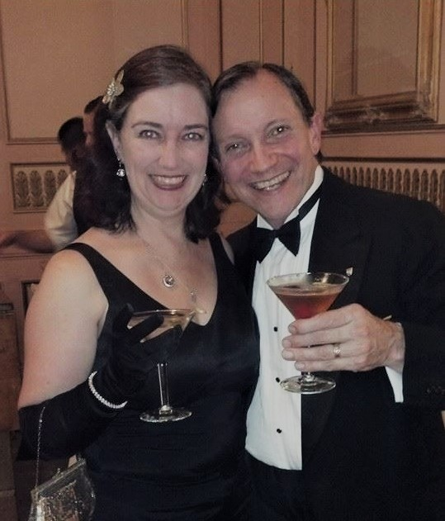
The Amazing Race – Birthday Edition
Denisen and I have been together for 30 years, married for 27. After all those birthdays, anniversaries, and holidays together, what do you get your spouse? We have enough stuff that when our grown kids need anything, I just give them one of the four sets of whatever it is I have in the garage. We are doing well enough that whenever we need something, we get it without waiting for a gift giving occasion. So we’ve largely stopped getting each other more stuff.
Last year I found a movie house in Oakland, the Parkway, that will lets you pick a movie and take over the place with your friends. The public gets to join you, which keeps the cost down. But the joy of picking your own movies (yes, they go rent it for you) and watching it with friends is pretty special. Denisen’s favorite film is the Emma

Thompson Sense and Sensibility. Parkway rented it, and about 15 friends showed up for her birthday viewing. The theater even baked a cake. If you live near Oakland, you should check it out.
This year I got creative again. Denisen is a big fan of the scavenger hunt TV show The Amazing Race. So I set up a round-the-world hunt for her, using Bay Area locations as proxies for the far-flung destinations the show sends its contestants to. The stops included Hawaii (Trader Vic’s in Emeryville), China (SF Chinatown), France (the Joan of Arc statue at the Palace of the Legion of Honor in the Presidio), Egypt (the sphinxes in front of the De Young Museum in Golden Gate Park), and Morrocco (the Marrakech restaurant in downtown). There were little tasks along the way, just like the show. The final clue was concert tickets to see Joan Jett and Bryan Adams at the Chase Center.
We have a tie to Bryan Adams songs. At both our wedding and at our 25th Anniversary celebration, I got up and sang a Bryan Adams song to Denisen. Yeah, I’m a big softie.

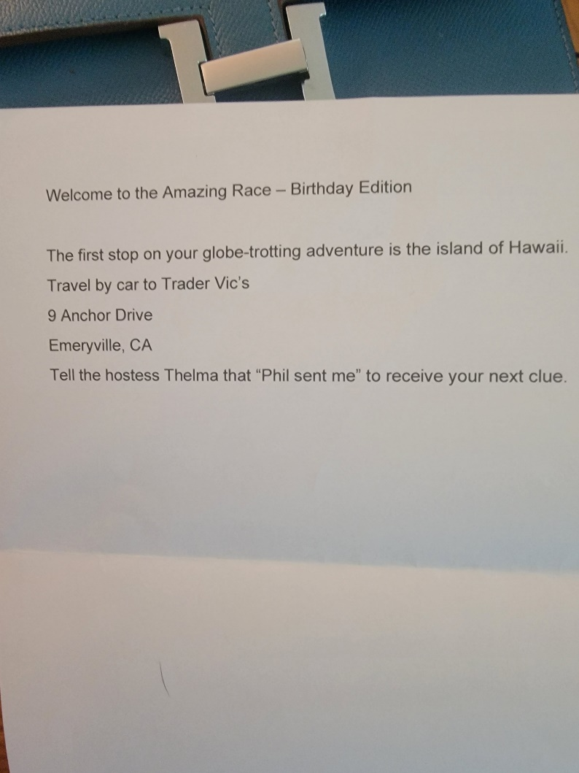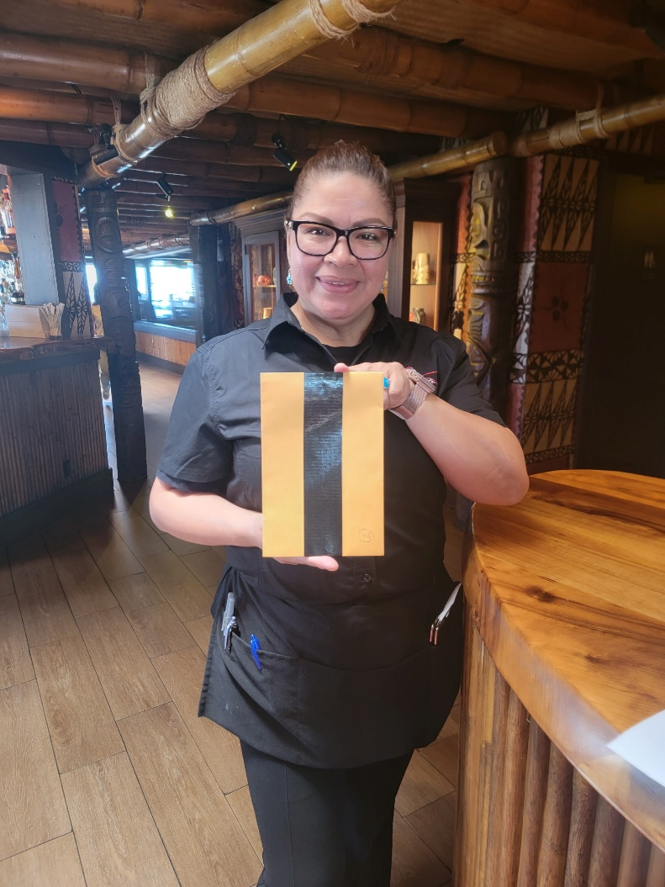

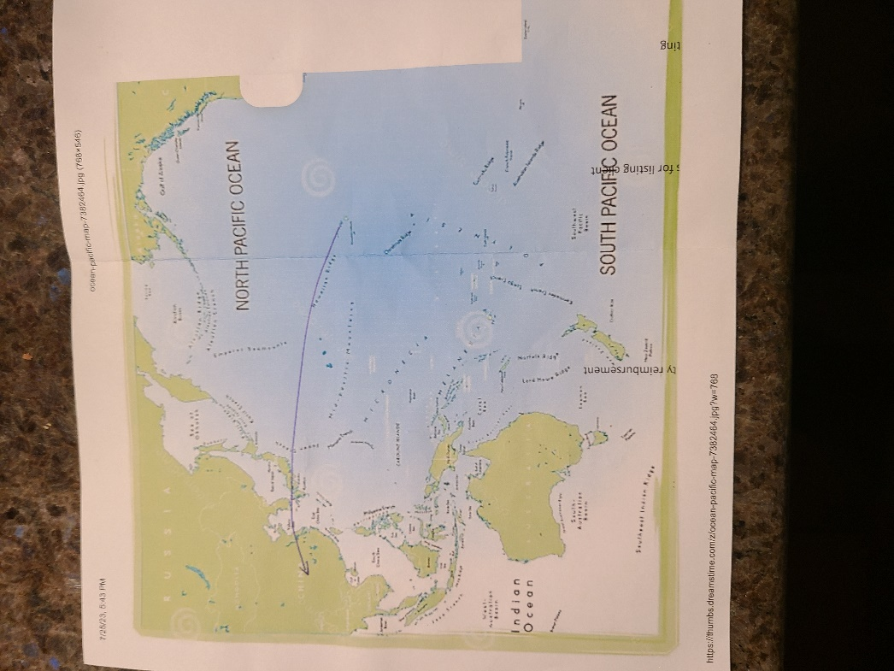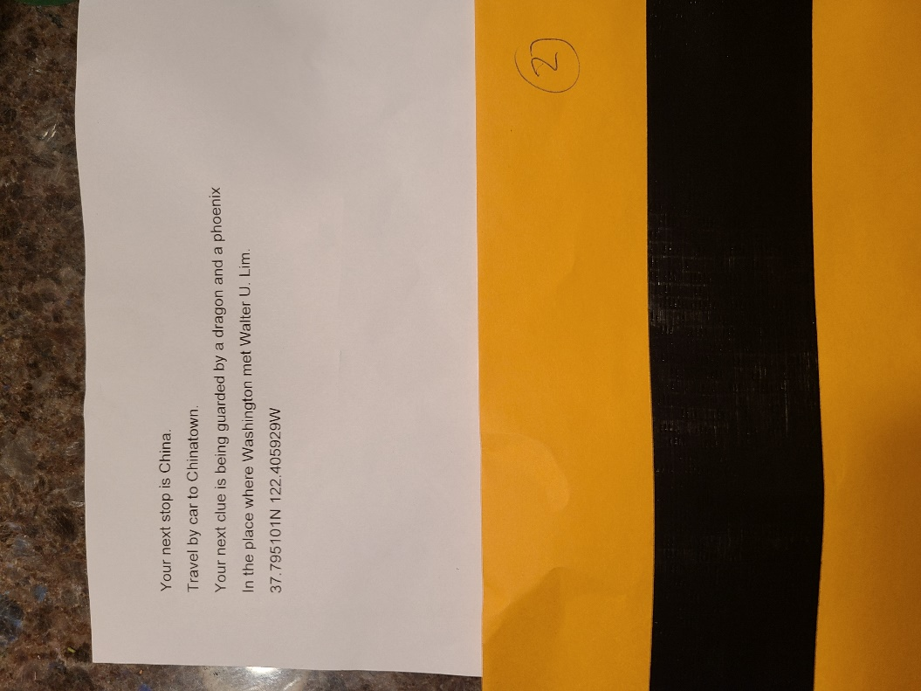

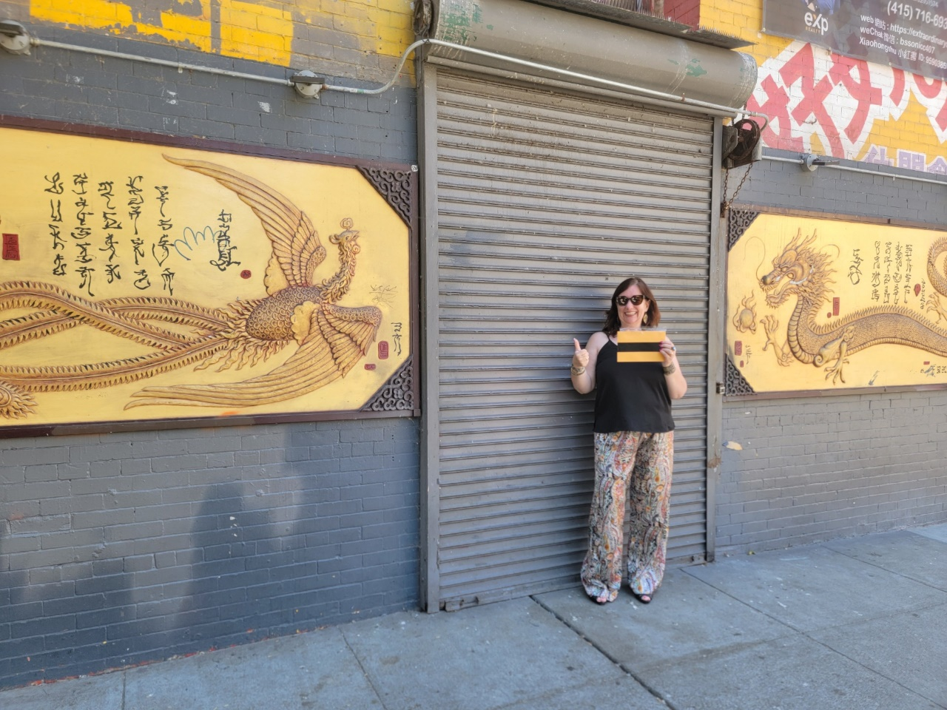
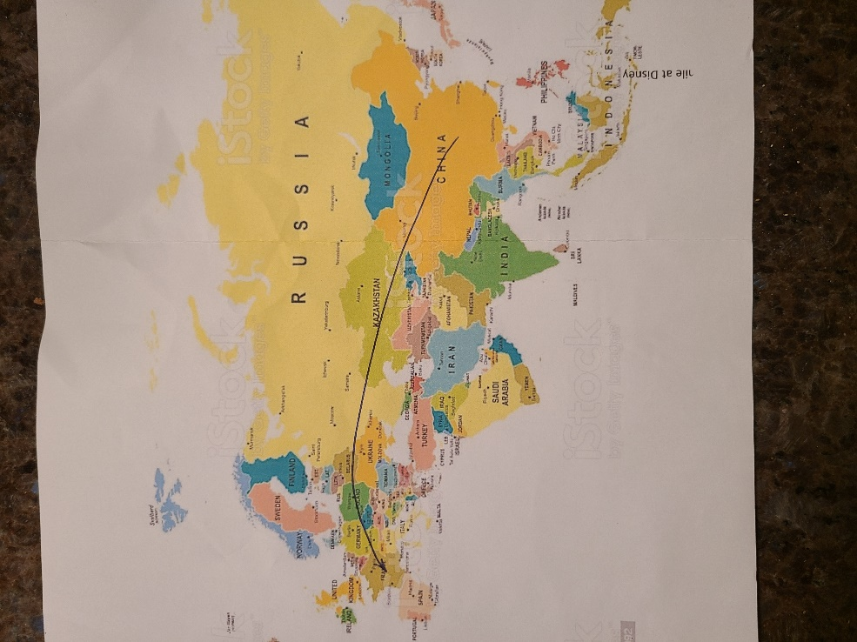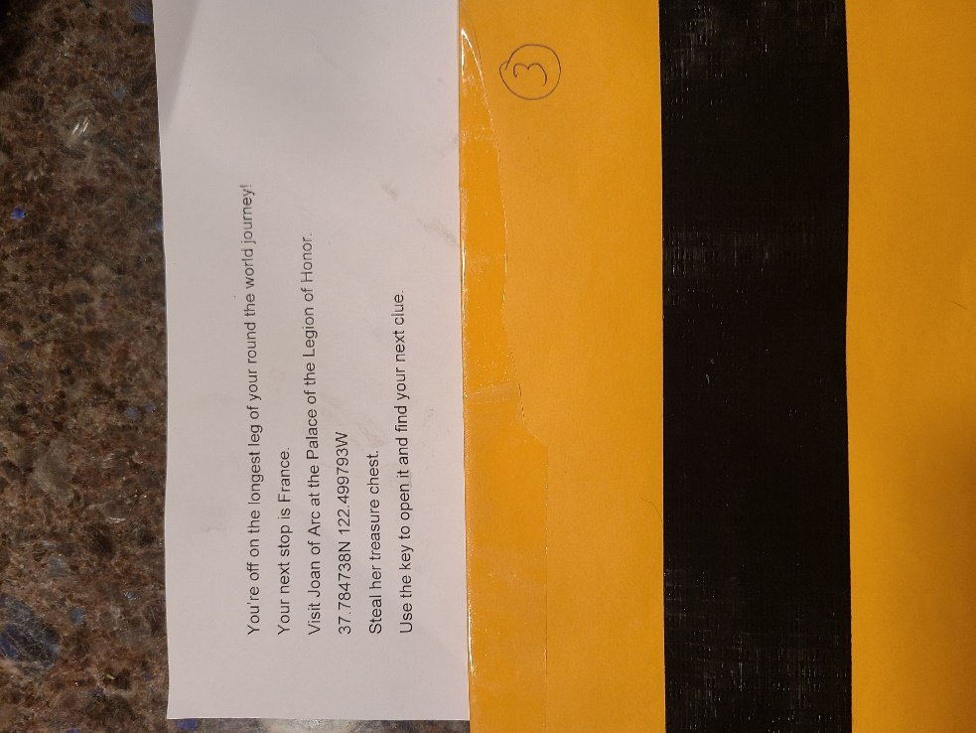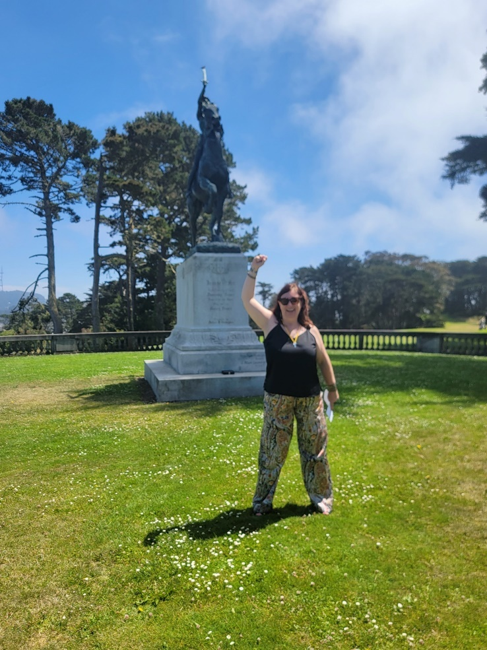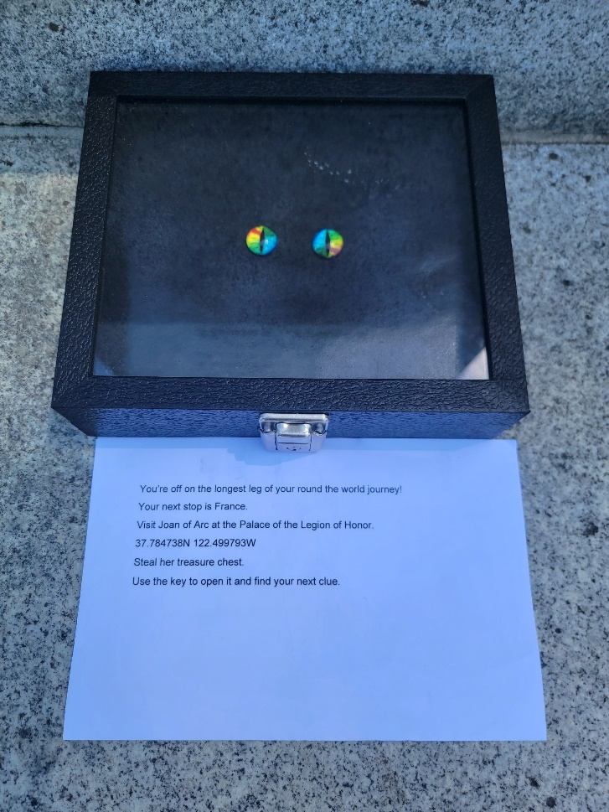

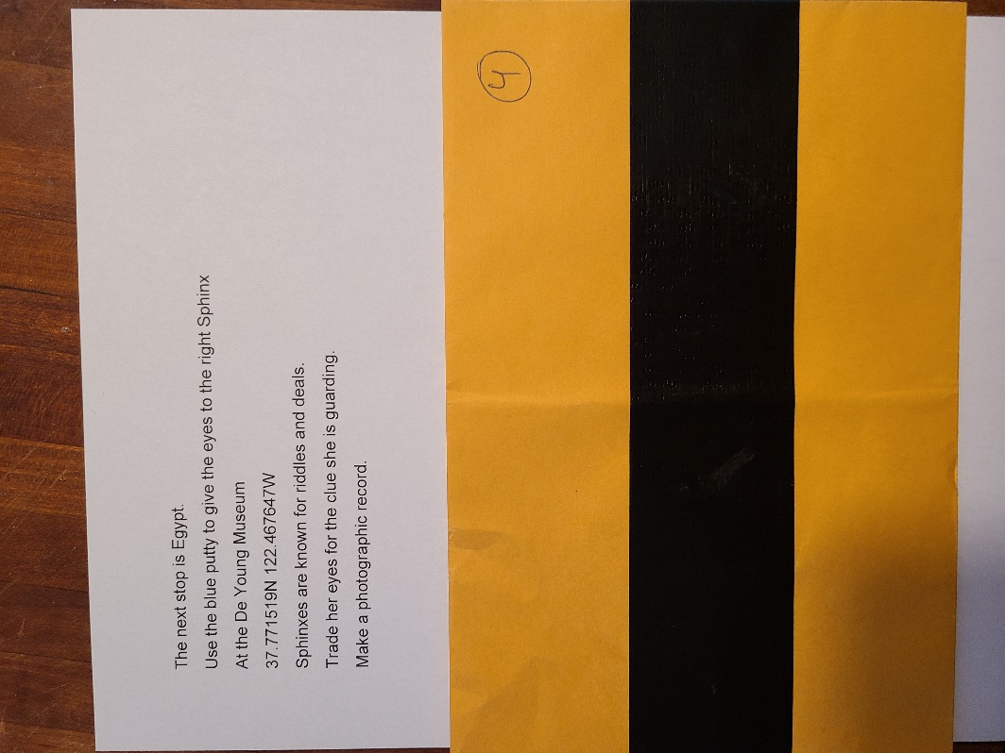
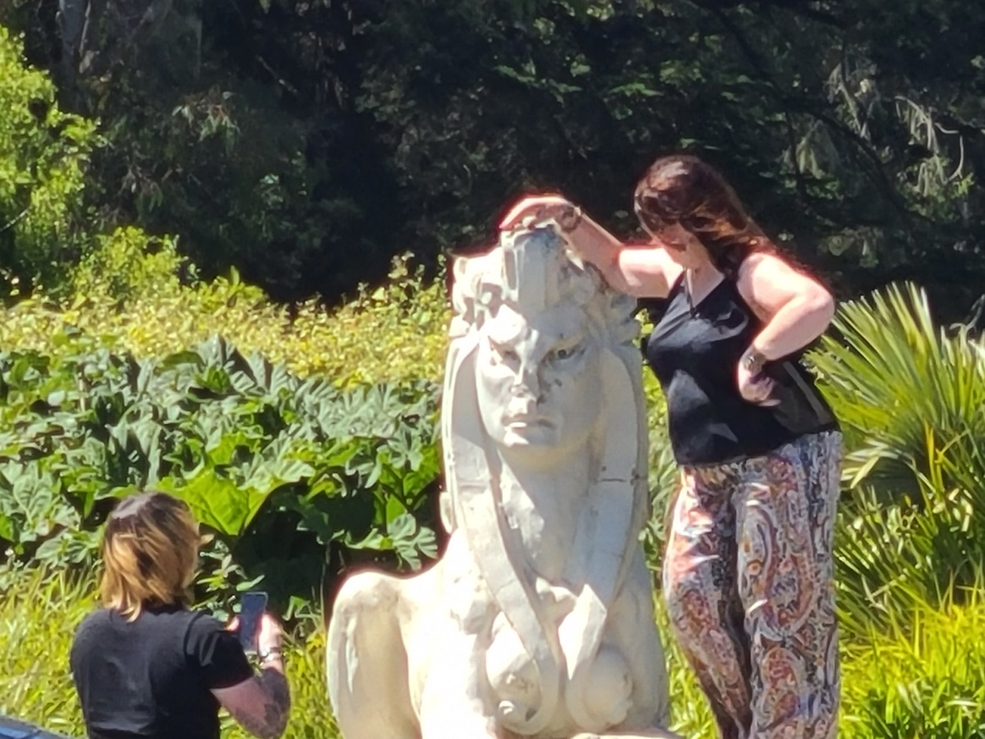

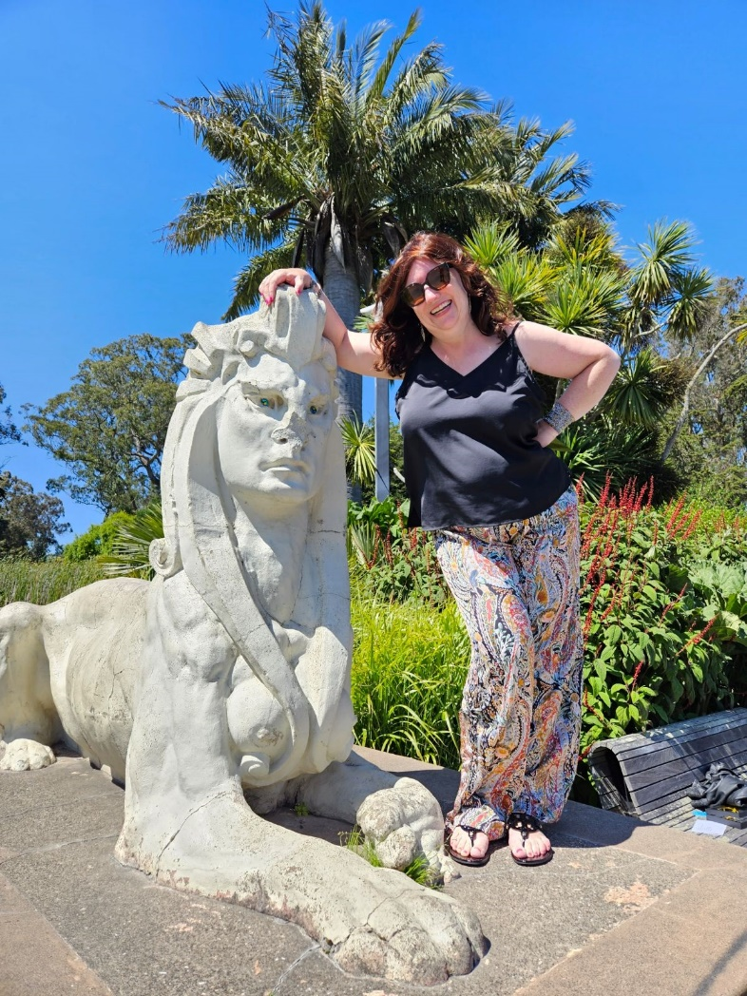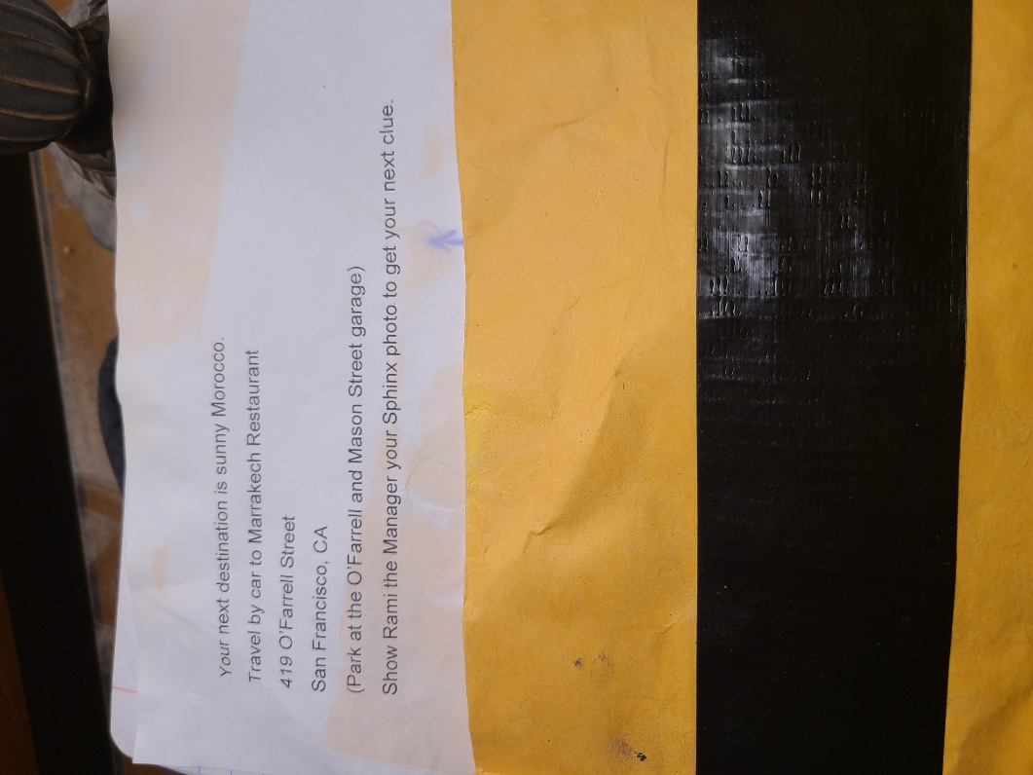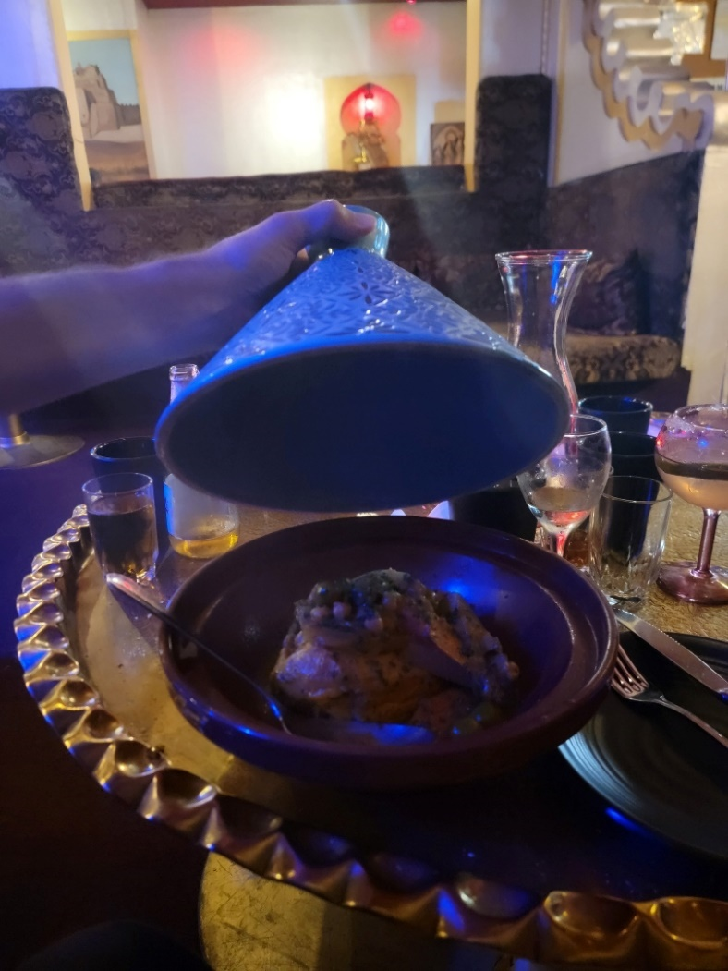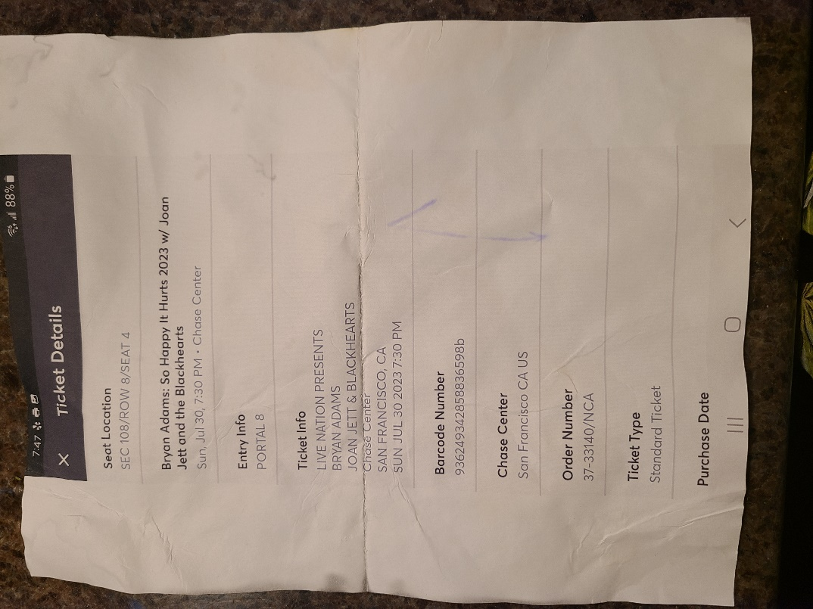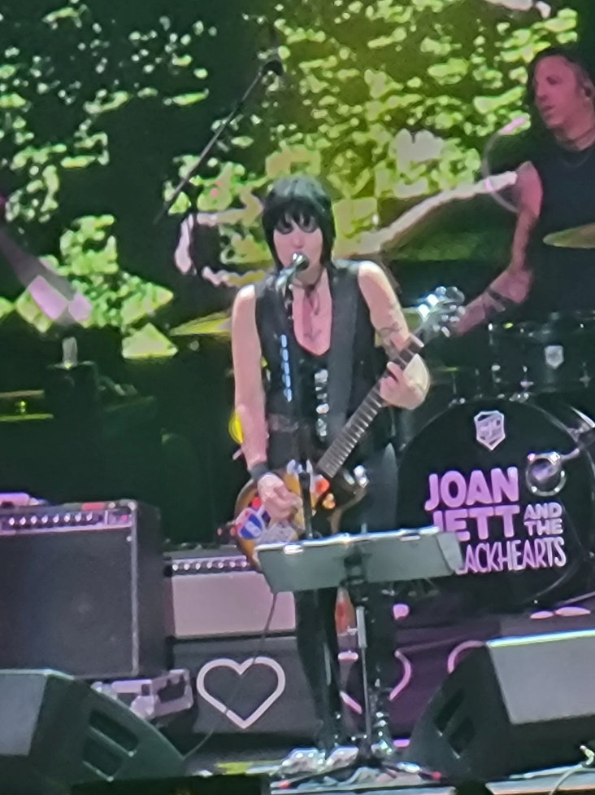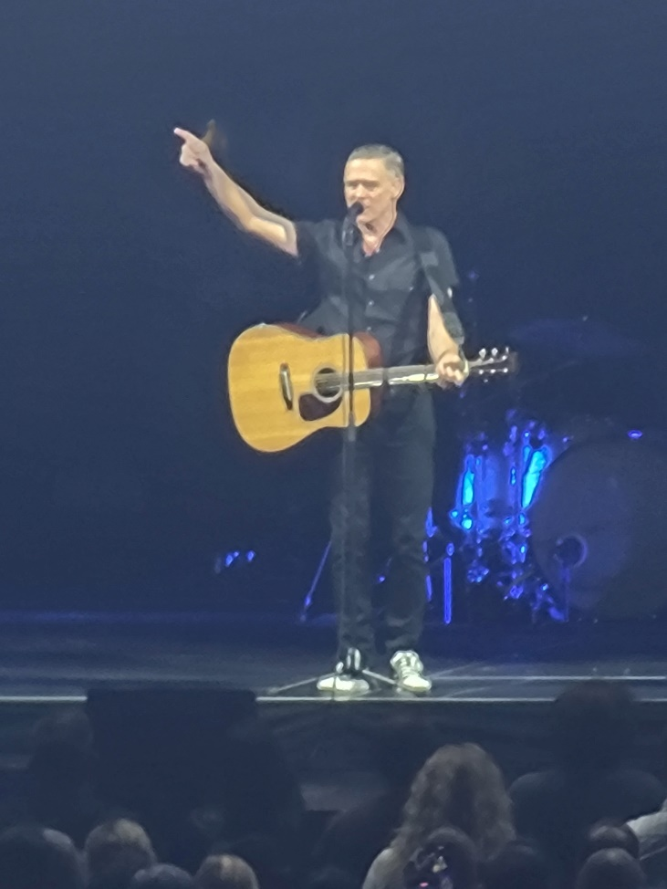
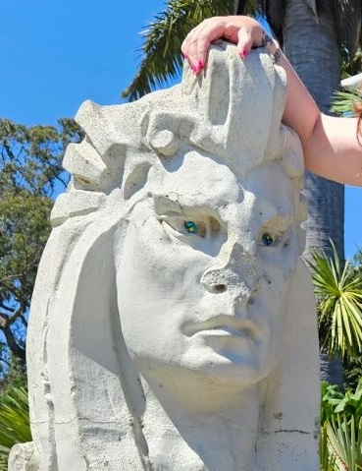

That’s it for this edition. I hope you enjoyed it. Please invite your friends to sign up. I am actively generating content as I never have before. This newsletter is the best place, and in some cases the only place, to hear about it all ahead of publication.
Until next month, be well.

