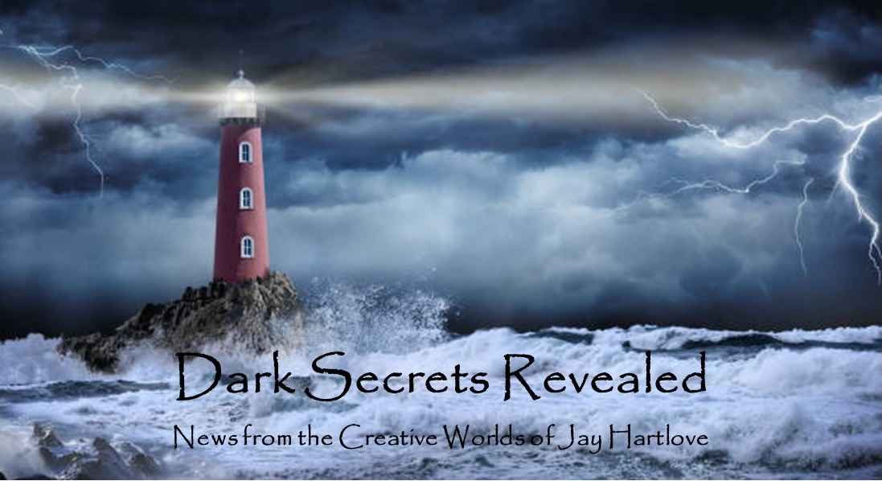

Issue 17 April 2024

I submitted The Dove and the Crow to three literary agencies that I met at writers conferences last year. Two of the agents say on their website that they are not currently taking new clients, but since I met their colleagues, I submitted anyway with that caveat. The third agency referred me to one of their agents who is open to submissions. Agents give themselves up to eight weeks to respond. I need to stop thinking about this book and move on to other projects.

Thankfully, I always have numerous projects simmering on the back burners of my mind. I was invited to add my voice to a horror podcast. I describe this fun little project in an article below.

I am still chewing on how to expand the Godmother comic to its full story length.

I am still collecting music samples and building a thematic sound for the Two Flowers opera. I do not think I will be working with the folks I collaborated with on The Mirror’s Revenge. The music is just too different. I am setting the opera in ancient Atlantis with the music based on ancient Greek rhythms and instruments. This means I need a pretty clear picture of how I want it to sound before I go shopping for a composer.

Speaking of musicals, I have signed up to be in a pitch fest for new musicals next month. I still want to stage The Mirror’s Revenge again, with someone else producing it. There are a couple of songs I want to rewrite and record, but otherwise the package is ready to show. That means I have the script, the stage directions, the sheet music, and the recorded accompaniment music. I have a lot to show for all the work we put into that play. I will tell you how it went in the April edition.

Also in this edition I talk about having fun with dream casting your stories, and how this can help you firm up your grasp of the characters.

I put all the back issues of this newsletter up in an archive on my website [www.jaywrites.com](http://www.jaywrites.com). Check them out if you joined late and missed some editions.

I would very much like your feedback on this newsletter. Please feel free to write me at [jay.hartlove@gmail.com](mailto:jay.hartlove@gmail.com) and let me know your thoughts. This newsletter is for you. I could set it up as a sales tool, with lots of buy links, but that’s not why I write it. I do this to share my work and insights with you.

Also, let me know what you thought of Goddess Revealed. Did you find it interesting? Did it make you want to go back and read the trilogy? Do you think it is a good incentive to sign up for this newsletter?

Here are the usual newsletter columns:

1. What’s Cooking: Previews/discussion of what I am actively working on. Also links to interviews, appearances, and other current writing news.
2. Mister Wizard: Advice and analysis to help my fellow writers.
3. The Aisle Seat: Recommendations. I am a huge movie fan and watch several every month.
4. Have a Drink: Wherein I will share personal stories.

***What’s Cooking***

**Mermaid Steel Merch**

I do not spend anywhere enough time or energy marketing my work. My wife is a successful salesperson (a realtor) and I see what it takes to find a market and reach it. She spends half of her time, and probably three-quarters of her business expenses, on building her brand. And this is for a business where you know what your audience wants, namely to buy or sell a house. I also know independent authors who successfully market their books. They generally do not have day jobs, and every minute they are not writing, they are developing ads, getting themselves interviewed, or making appearances to promote their books. Those who have been lucky enough to be published by a big house publisher can rely at least in part on the publisher’s efforts and budget to reach their audience.

If I were dependent on the sale of my books, I would rearrange my life to market more seriously. I am lucky that I have a thriving career doing something I actually enjoy. At this point in my life, I

write books because I love it. Of course I want as many people as possible to read my work. But I do not need to carve out significant time form my lifestyle to maintain a functional marketing machine.

On the other hand, when a marketing opportunity arises, I am happy to step up. In a previous edition, I detailed the process of scratch-building the life-sized model of Chielle Mmava, the protagonist of Mermaid Steel. I take her to conventions where she sits next to me at the sales table.

A show that I always attend is the California Mermaid Convention, held each spring in the Sacramento, California area. It is a joyous event that I have talked about here before. This year I have in mind to have ready a tourist tee shirt for Celadon, the undersea village where Chielle lives. I have in mind to mimic old-timey travel posters like this one.

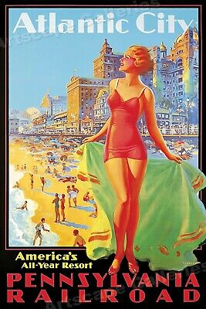

When I made tee shirts for The Mirror’s Revenge ten years ago, the best value was color-separation screen printing. Here is that art, by the fabulous Jeslyn Sebold [www.jeslynkate.com](http://www.jeslynkate.com).

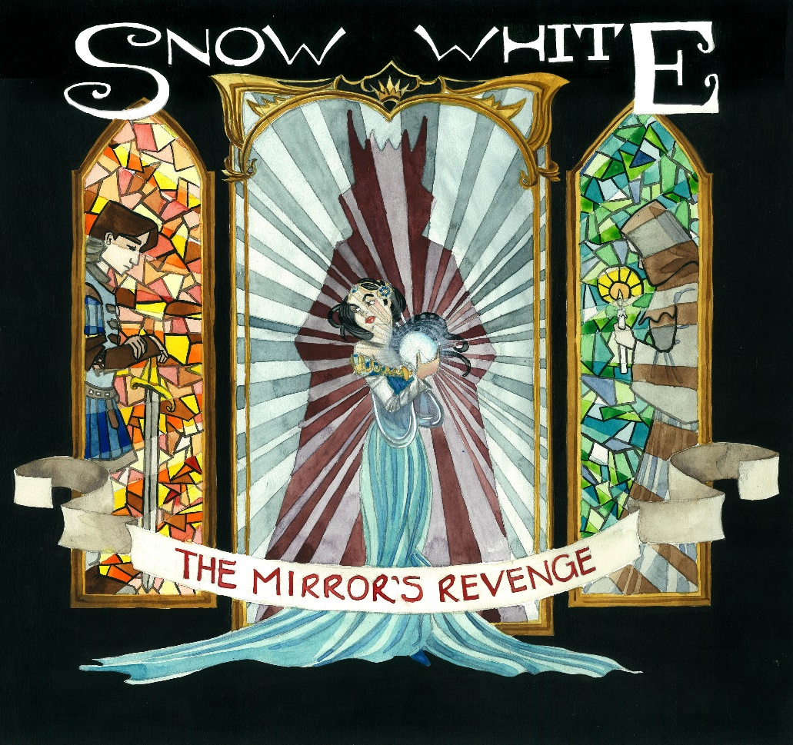

Since then, a new process has been perfected called Direct to Film, or DTF, that captures a full-color piece of art and applies it as a painted layer onto the fabric. The claim is that this transfer will not crack, and it will last as long as the shirt. The price I was quoted was very similar to the price I paid for the show shirts.

I started with this proof-of-concept drawing.

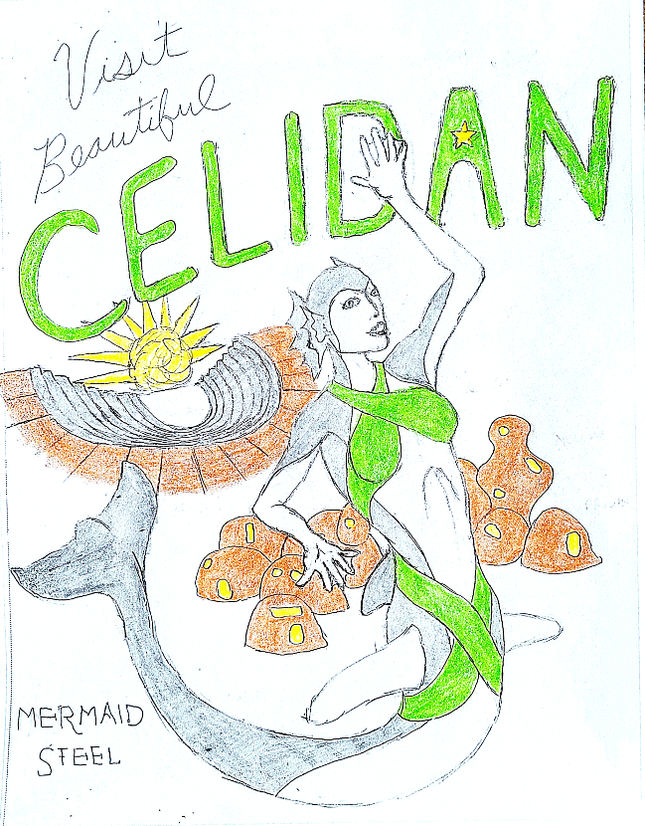

I have hired my son December to create the graphic. He is an accomplished tattoo artist. Check out his work at [www.instagram.com/dogteethink/](http://www.instagram.com/dogteethink/) I will reveal the finished art in next month’s edition, along with details about how you can order your shirt. My plan is to offer the shirts to you either free or at a steep discount. Everybody else can pay full price.

***Mister Wizard***

**Casting Your Stories**

In previous articles I have talked about how I reverse-engineer my characters’ backstories to ensure they will have the experiences and talents they will need to be the right people to tell my story. Once I have finished my theoretical work and I start writing the prose, the characters’ voices evolve and they start giving me feedback as to who they are. Unless their appearance is mandated by the future events of the story, I don’t rush to paint a picture for myself of how they look. Once they have been walking and talking in the story for a while, I come to think of them having specific features. I write more visually than is typical of science fiction, and not quite as floridly as is typical of fantasy. My secret is, the descriptions you start seeing on page one did not develop until the first draft was fifty pages long. I recommend getting to know your characters before you finalize how they look, including accents and quirks of speech. It all seems to fit together more naturally if you don’t hurry, at least for me.

There is much debate about how precisely cover art should portray the characters’ appearances. You want to allow your readers to make up their own minds. If a book is made into a film, there are usually fans who disagree with the casting choices for their favorite characters. After living with the characters of the Goddess Rising trilogy for many years, their appearances, mannerisms, and speech patterns became very clear to me. In one of my earlier, less impressive attempts to market the books, I cast them as movies and shared those images in social media. No one was impressed. But it was a fun exercise. The covers of the books do not show any characters. In both the original editions and the re-released versions, the cover of *Goddess Chosen* (originally called *Chosen*) is the Washington Monument, both because it is an Egyptian obelisk and that is where the story ends. *Goddess Daughter* (originally *Daughter Cell*) is a hypodermic needle because the story revolves around a virus. And *Goddess Rising* is a sword because the story is about the goddess Isis finally getting her justice.

I still like my casting choices. Of course I wrote these books, and cast these actors, twenty years ago. They are significantly older now. (When did Natalie Dormer get to be 41!?) Any casting of these books for film (oh please oh please) would need actors who are the ages of the characters in the books. These are adult stories with adults making adult decisions. The detective who holds the trilogy together is psychiatrist Sanantha Mauwad. In the first book, set in 2001, she is in her mid-forties. By the third book, set in 2009, she is in her early fifties. Yes, my point-of-view protagonist is a middle aged black professional woman.

Here for your entertainment are my casting choices. I would love to hear your opinions, agreement or disagreement, based on the images you came up with when you read the books.

From Goddess Chosen

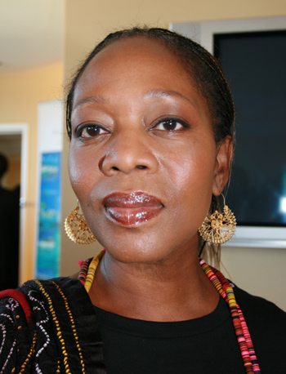 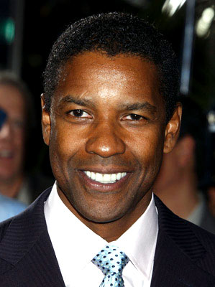

Alfre Woodard as Dr. Sanantha Mauwad Denzel Washington as Charles Redmond

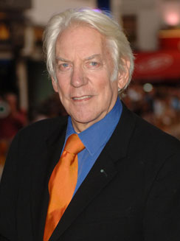 

Donald Sutherland as Silas Alverado Michael Ironsides as Joseph

From Goddess Daughter

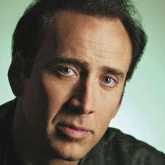 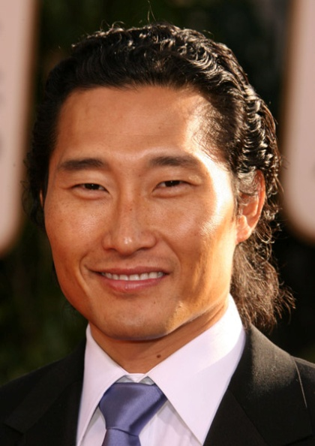

Nicolas Cage as Dr. Randolph Macklin Daniel Dae Kim as Young Nae Yoon

 

Natalie Dormer as Desiree Macklin Randall Duk Kim as Lo Cheung

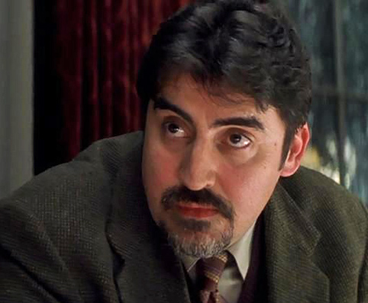

Alfred Molina as Simon Herrera

From Goddess Rising

 

Jack Reynor as Alec Doogan Hugh Jackman as Benito Nomini

 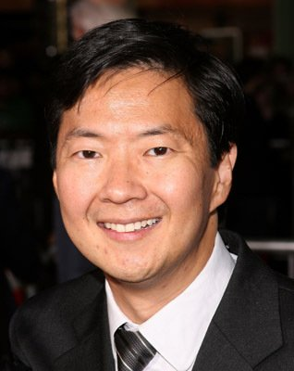

Liam Neeson as Michael Archibald Ken Jeong as Renpo

As an added bonus, when I was figuring out how to promote the first book, I indulged myself and set up LinkedIn profiles for Sanantha Mauwad and Silas Alverado. I never used them for anything, but they are still live.

<http://www.linkedin.com/in/sananthamauwad>

<http://www.linkedin.com/in/silasalverado>

***The Aisle Seat***

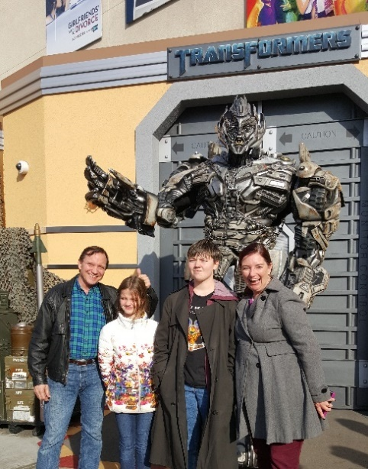

**Dune Two**

This month I talk about three films that went places I did not expect. I try to keep an open mind when I sit down with a movie, to give the filmmakers a fair chance to show me what they’ve got. Still, it’s hard not to have any preconceptions, even from the title. These three left me glad I was initially wrong.

A lot has been said about *Dune Two* and I was tempted to skip commenting on it here. The hardcore fans have lamented how it leaves out the mentats and the guild from the layered agendas of the books. To me, having too many groups competing for power left the story without a clear focus. A reader can only work so hard before the complexity throws the reader out of the story. This is even more true of a movie-goer who is racing to digest all the visuals, action, and dialogue while cataloging the history and

interplay of factions. I too wish we had seen what the guild steersmen look like. But I appreciate the director’s choice to focus on the main conflict between the Harkonnens, the Fremen, the Bene Gesserit and the Emperor. (Yes, there were six competing groups in the book.) That focus let the audience capture the full force of the message that the rising of a messiah is bad for history. That central point was lost in both the 1984 film version and the book. Herbert admitted he wrote the second book when readers came away thinking Paul was a hero. Given the current rise of religious fundamentalism in our politics, I think the director was wise to show the consequences of such a rise. I hoped I would be blown away by the visuals. The commentary was a surprising plus. This film was not only a brilliantly executed portrayal of a science fiction future, but also topical for today.

**The Holdovers**

I did not expect much from this film. How many times have we seen Paul Giamatti whine his way through a sad sack character? His character set up and the plot were for the most part predictable. What was a pleasant surprise was the script and the performances, including the supporting cast. The film reminded me of a film I reviewed last year, A Man Called Otto. In that movie, Tom Hanks played a completely predicable curmudgeon, but the story went deeper than I expected. So does The Holdovers. The professor’s backstory and its similarities to the student’s awful life was a joy to watch unfold. Giamatti showed surprising depth with the frustrations and internal conflicts. And of course, DaVine Joy Randolph’s performance earned her an Academy Award. Not a big screen movie, but a surprising gem of character work.

**May December**

I knew going in that this was going to be a dark story. I did not expect a two-hour bullfight between Natalie Portman and Julianne Moore. Wow. This film should be taught in master level acting classes. Moore plays a teacher who got pregnant with a middle school boy, went to prison, got out, married the grown boy, and went on to have two more children with him. This is based on a real story. Portman plays an actress who is making a film of this woman’s life. She comes to stay with the family for a few weeks to learn who they are so she can accurately and fairly portray them, despite all the sensational coverage they got in the press decades before when it happened. I say bullfight because Portman’s maneuvering to learn the real story and Moore’s denial and obfuscation really reminded me of that deadly dance. Julianne Moore admitted after filming that she had not realized how Portman had mirrored her mannerisms as her actress learned her subject. Fascinating bordering on creepy. And such dark material to being with. You come away not liking either woman, yet the film stays remarkably non-judgmental at its close.

***Have a Drink***

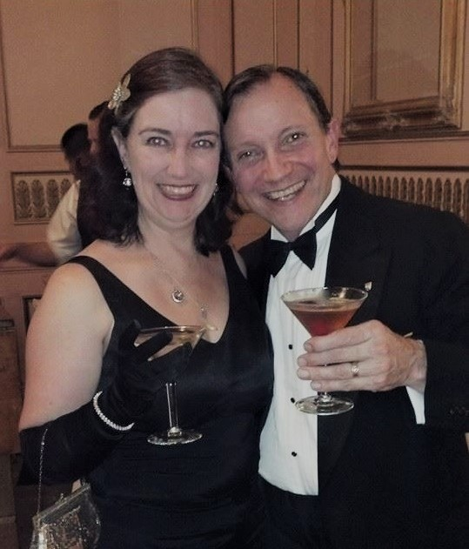

**Best Horror Comic**

I was invited to contribute to an upcoming episode of the Horror Addicts podcast devoted to the best horror comics. The invitation was to submit a three-minute recording trying to convince listeners that my choice was the best. Horror Addicts is an online magazine and book publisher run by my dear friend Emerian Rich. You really should check out the show. My episode will air May 4th. [www.horroraddicts.net](http://www.horroraddicts.net)

Why would a horror podcast ask me to contribute? While my writing is not technically horror, I love to upset my characters’ lives with surprising and scary turns. I sometime indulge in classic horror elements like dread, gore, and shock. My first book, Goddess Chosen, was praised by horror master John Shirley. That rep made some connections to the horror community which I still treasure.

My choice is *John Constantine: Hellblazer*. The character of John Constantine was originally designed by comics legend Alan Moore. As is part of his legend, he had a huge falling out with DC Comics and his name no longer appears on any of the books. You can find the first dozen episodes of his adventures handsomely bound in a book called Original Sins. The character is very British and 1980s. The movie adaptation changed him to American, starring Keanu Reeves. While the film is one of my all-time favorites, the original comics are also favorites of mine. What follows is the text of the narration I submitted for the podcast. Emerian has not yet published a date for this episode.

“Multiple Hugo-award winning horror editor Ellen Datlow once said a good horror story should leave the reader feeling that something is broken in the world. It’s not enough to scare, or to evoke a sense of dread, although these are certainly tools to be used in horror. Good horror makes you look at the world and be worried.

John Constantine, Hellblazer was originally published in 1988 by DC Comics. This was the OG model of the world-weary, sarcastic occultist that has appeared many times since, not the least of which was the very popular Dresden Files books written by Jim Butcher starting in 2000, or the even more popular TV series Supernatural that started in 2005.

John Constantine lives on the edge. The stories don’t dwell on his origins, but rather show that he knows a lot of magic, and has had encounters with many demons and other unsavory characters. The demons are everywhere, hidden just out of sight from daily life. The magic is brutal. The consequences are often grotesque.

Even though his words are steeped in sarcasm and low expectations, he dives into demonic activities with a clear sense of justice. He has a habit of jumping in before he fully understands or is completely prepared. This finds him in harrowing situations from which he often escapes only by taking more outrageous chances than his adversaries expect. He often comments how one day his luck is going to run out.

In this way, the creators coax the reader into sympathizing and identifying with this man who knows more about how the world works than any of us ever will. He is impulsive, has bad habits (he drinks too much and smokes continuously), and survives on his cleverness. You want him to succeed not because he is the hero, but because you want to think you could survive on your wits as well. He is also haunted by his guilt of past mistakes, some of which follow him around as ghosts.

The stories run through a wide spectrum of topics you might find in a detective mystery, from missing persons to murder most foul, to more heartfelt topics like soldiers recovering from the horrors of battle and the guilt of having let people die that you were trying to protect. And always, always with a horrific supernatural twist.”

That’s it for this edition. I hope you enjoyed it. Please invite your friends to sign up. I am actively generating content as I never have before. This newsletter is the best place, and in some cases the only place, to hear about it all ahead of publication.

Until next month, be well!