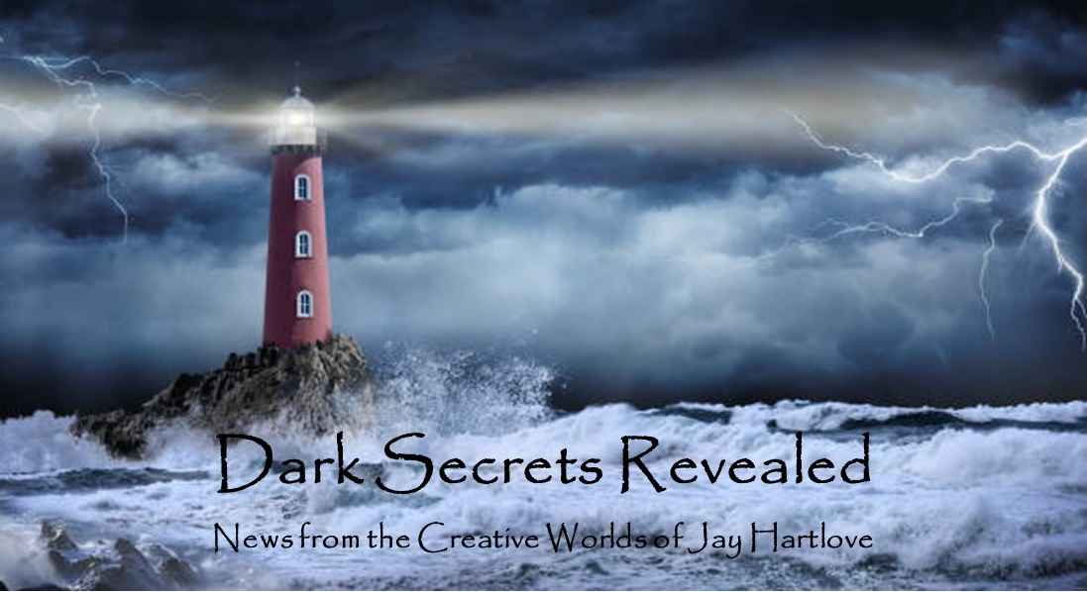

Issue 15 February 2024

Yes, this is a new masthead for the newsletter. I have also switched out the picture on my Facebook author page, and I will be doing the same on my website and business card. This reflects a realization I am taking to heart. I may never turn writing into a profitable profession, but I continue to do it because I love it and I have stories that I need to tell. I have been told this is inspirational to other writers. I speak often about storytelling, and people come to hear me. I drop encouraging tidbits in all of my interviews, and other writers pick these up. I have always seen my writing as making new connections and revealing heretofore undiscovered possibilities, hence the motto Dark Secrets Revealed. But now I see that by shining a light on my discoveries, I am also shining a beacon to other writers, that they can follow me and advance their own writing careers. Where my old logo was filled with lightning, my new one is shining a beacon through the storm. Corny? Probably. But I’m owning it.

In this issue I will look back at the finished manuscript of The Dove and the Crow (86,800 words) and show how I built the structure of the story. I have talked a lot about structure here. Now let’s see it in action.

I also share some of the stunts I am working on. By stunts, I mean actions that will hopefully turn into marketing success.

I put all the back issues of this newsletter up in an archive on my website [www.jaywrites.com](http://www.jaywrites.com). Check them out if you joined late and missed some editions.

I would very much like your feedback on this newsletter. Please feel free to write me at [jay.hartlove@gmail.com](mailto:jay.hartlove@gmail.com) and let me know your thoughts. This newsletter is for you. I could set it up as a sales tool, with lots of buy links, but that’s not why I write it. This is here to share my work and insights with you.

Here are the usual newsletter columns:

1. What’s Cooking: Previews/discussion of what I am actively working on. Also links to interviews, appearances, and other current writing news.
2. Mister Wizard: Advice and analysis to help my fellow writers.
3. The Aisle Seat: Recommendations. I am a huge movie fan and watch several every month.
4. Have a Drink: Wherein I will share personal stories.

***What’s Cooking***

**Stunt Work**

The Insane God was published in November 2022. My publisher Water Dragon Publishers produces ebooks, trade paperbacks and hardbound copies all at the time of publication. They also arrange to have their books narrated for audiobooks. This process takes time and the audiobooks usually appear on Audible and other platforms a few months after the book publication. We hired the same voice actress who narrated Mermaid Steel. Unfortunately, she has faced a number of hardships over the last year, and she finally realized she could not take the job.

The audiobook business has changed since we did Mermaid Steel back in 2020. One of the biggest changes is now, if you buy enough toilet paper from Amazon, they give you a free audiobook

credit. My publisher tells me that audiobooks he produces today will probably never break even due to Amazon giving them away. Audiobooks were not a big seller during the pandemic, but now that folks are returning to work, they are listening to books in their cars again. You would think Amazon would want to cash in on this demand, but they have decided audiobooks are a reward/incentive product and not cash cow.

Before these giveaways, audiobook sales could drive royalty sharing. The last several narrators of my books gave us a lower Per Finished Hour rate in exchange for a slice of the royalties from sales. Narrators have become aware of the low dollar returns and have stopped offering royalty cut deals. Now they charge their full PFH rate up front.

The Insane God is a good book. It won Silver at the BookFest Awards and it made Finalist in the Chanticleer Awards in 2023. It deserves an audiobook edition to reach all those car listeners. I am at that stage in my career that growing audience is more important than making money. So I will be shelling out top dollar to get the audiobook recorded. My publisher has offered to distribute it into all the channels for free, and let me have all the proceeds, since I will be fronting the production cost. Who would have thought an industry could change so much in three years? Since I am looking for a new narrator, I am also hoping to find a trans woman to help tell Sarah’s story.

The other stunt I just pulled also involves The Insane God. Dr. Neil DeGrasse Tyson has developed quite the public exposure providing elegant, accessible explanations for complicated science. He picked up Carl Sagen’s mantle a few years ago and continued the Cosmos series. He makes regular appearances at conferences, both scientific and otherwise. And he has a very successful podcast called Star Talk. I tapped his popularity in The Insane God. Early in the story I needed Sarah to be told about the possibility of parallel universes, since that is key to how the Insane God manipulates reality. She is bored alone in a hotel room and turns on the TV to find Neil DeGrasse Tyson talking about parallel universes.

So I just sent him a nice hardbound copy of the book. I inscribed it thanking him for his fine work, and also saying that I hope he doesn’t mind that I put words in his mouth on pages 22 and 23. I sent it to his podcast production company. We’ll see if he gets it. We’ll see if he reads it. I doubt he will sue me. But he might like the book. He might like it enough to mention it on his podcast. After all, it is about planetary science, and it makes cross-connections to other science (brain chemistry) which is the sort of thing he talks about on his show. Fingers crossed.

***Mister Wizard***

**The Structure of The Dove and the Crow**

I am going to need to reveal a few details about the book in order to tell you about its structure. I will try to avoid plot spoilers. Hopefully whatever details leak into this discussion will tease you into being more interested in reading the book.

Before I start, let me recap that my books turn victims into heroes. While telling ripping yarns, they cover subjects like radicalization, betrayal, and racism. This one takes on spousal abuse.

Here is the back cover blurb. “When Folklorist Willa Freedlund pursues a mysterious fragrance to a Swiss farm, she finds herself in a world with witches, wizards, monsters, and mercurial gods. Her knowledge of myths helps her fit in, but it is her experience with abuse that leads her on a quest to free an enslaved goddess and restore the balance of magic that is essential for her adopted home to survive. As the witch Naomi helps Willa to heal, Willa learns to heal her new world.

This is a pretty standard set up for a fantasy novel, but I mess with the formula. In the first few pages we see Willa giving a lecture on The Hero’s Journey. A key feature of The Hero’s Journey is the protagonist learns by failing on their journey. This opening alerts the reader to watch for that pattern. We also see her decry Portal Fantasies as a cheat, that the fish-out-of-water trope makes it too easy for the author to show off their creative world building.

So I don’t have her fail on her journey, I have her fail three times, each more spectacularly than the last. All of these failures are the result of self-sabotage, which is the key scar left from being abused in her previous relationships.

First, she takes her boyfriend to Paris to try to repair their relationship, and he dumps her. She is left doubting that maybe she was partially to blame. She then falls into Hern, where she realizes she has lost her entire life on Earth. This is Failure Number One, with the lesson not to make assumptions that things cannot get worse.

She meets the witch Naomi who helps her acclimate to her new life. She makes a bunch of innocent assumptions about how similar the worlds are, and then finds out she’s wrong in a very big way. She finds her new world is dangerous, both in ways she is used to from Earth, and in entirely new ways. This forms Failure Number Two, with the same lesson not to make assumptions. These changes come as a shock after she ignored clues as to the real nature of her new world. This self-sabotage triggers the defenses she learned from being abused by men on Earth, including an ex-husband who beat her. She withdraws and starts to give up, thinking that she cannot make her life work here. Naomi convinces her to try again.

She and Naomi go on great adventures trying to fix their world and everything seems to go well. But she grows suspicious of Naomi’s motives, and ends up ruining their relationship. This is an even bigger failure because Naomi is her only anchor. She soon finds out how wrong she was, and she is filled with regret. This is Failure Number Three, caused again by making assumptions that lead to suspicions, which lead to ruin. And again, this is triggered by the self-sabotage from her abuse on Earth that “too good to be true” probably is.

I counter Willa’s original objection to Portal Fantasies by not showing her (and the reader) how clever my world building is, but by only showing her a limited view that she then makes bad assumptions about. We don’t see the full scope of how different Hern is until after Failure Number Two. In fact, important details about Hern continue to unfold nearly to the end of the book.

The main conflict of this story is not the god problems on Hern, but Willa’s recovery from the self-doubt and suspicions she learned back on Earth. If she can accept help from people who care about her, then she is capable of great things.

Interwoven with her journey, we also watch the scientists (on Earth) and wizards (on Hern) who are responsible for Willa falling from the Earth to Hern. We eventually see the hand that certain gods played as well. The story wraps up with the scientist/wizard thread meeting up with the Willa/Naomi thread to resolve that puzzle. Willa finally learns to believe in herself and to trust Naomi, which is allowing love back into her heart.

I borrowed some structure lessons I learned from my earlier novels. In my thriller trilogy, I developed a pattern of successively worsening crises to drive the action up to the main conflict being addressed. Willa’s successive failures are not crises, so the book does not read like a thriller. But her successive failures do build to the central conflict when she ruins her life with Naomi. That marks her succumbing to her old fears, the fears she needs to shed to move on with her life.

I had a long conversation with my beta reader regarding what the story is about. He is very familiar with my work and wanted to hear me explain how this new structure accomplishes what I want to say. It looks like a story about healing the gods’ problem, but the real story is Willa’s healing. This is new for me. I like to think I am growing my craft. I think it works as I have explained it here. My next step is to show it to a professional editor. We’ll see if she thinks this works or not. I will let you know.

Just for fun, here are some images I found on the Internet that kind of, sort of, maybe look a little like things in the book. They are, in order, Willa and Naomi, Naomi’s cottage, Naomi in her kitchen, a two- ostrich cart, Gand the god of Death, and Filada the goddess of the planet Hern.

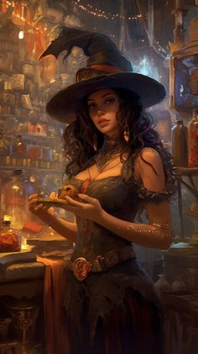 

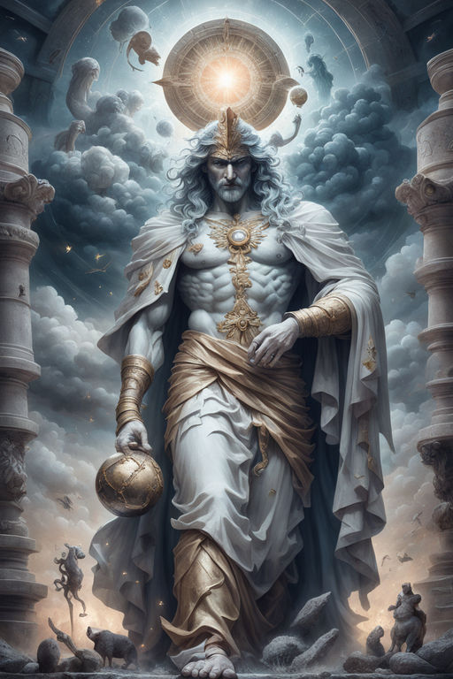 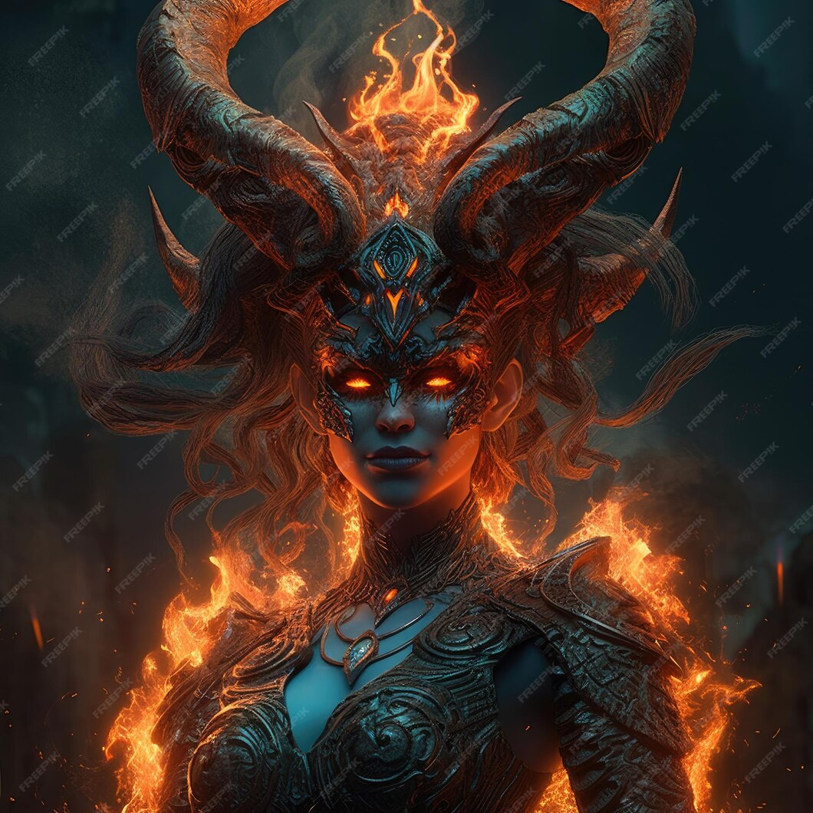

***The Aisle Seat***

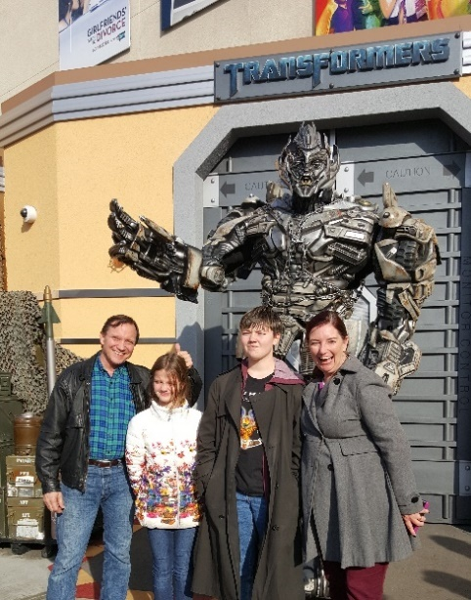

**Poor Things**

Since I skipped a couple of editions of this newsletter in November and December, I feel I owe you some extra movie recommendations this month.

Straight up, I loved everything about Poor Things. If you haven’t seen it, go do so, and on a big screen. The aesthetics of the fully realized steampunk world, combine with completely original characters, to tell a brutally honest, yet humorous life-affirming story. Emma Stone worked with Director Yorgos Lanthimos for four years to perfect the feast that is this film, and it shows in every frame. Willam Dafoe is a marvelous mad scientist. (We know he can do mad scientist – remember his Norman Osborne?) Emma Stone is completely believable as she grows from the mind of an infant into an assertive capable adult. There is also a refreshingly

anarchist tone in how she manages to stay free of society’s rules. I expected this one to be fun. It was big fun.

**Godzilla Minus One**

This was also a very gratifying movie experience. The gritty aesthetic sets the tone of quiet desperation for our hero’s redemption quest. He is an ordinary man faced with a monster suddenly appearing and killing his fellow soldiers. He’s not brave enough to take the bold action needed to save people. This haunts him as he tries to start a normal life. But when the monster returns, as if to test him again, he again misses his chance to make a difference. To the people around him, the monster becomes a metaphor for the war Japan just lost, a chance to win after all. For our hero, this opportunity for heroism is very personal. It is motivating enough to finally drive him to extraordinary heroism. Indeed he thinks he has nothing left to lose. This is more a war movie than a monster movie. The best war stories are very personal, like this one.

**Napoleon**

This too was a very big story told at a very personal level. I expected this film to be a war movie, but despite the many impressive battle scenes, it was not. It is a story about ambition. At the end of the French Revolution, France was in enough chaos that a soldier could seize opportunities and advance rapidly. He stepped into a leadership vacuum and went from soldier to general to emperor. Having been trained in the new art of artillery, he won most of his battles against France’s enemies by out-maneuvering them with combinations of cavalry, infantry, and cannons. He became a lot of things to different people. All the while only his wife really understood him. Their tumultuous relationship was even more important to him than his military campaigns. When he was finally defeated by the amassed forces of the rest of Europe, he regretted his failed marriage more than his lost empire. Joaquin Phoenix did a great job showing us this complex character, especially with very little spoken dialogue.

**Saltburn**

If you’ve seen Peter O’Toole’s The Ruling Class, this story about rich British privilege will not be all that shocking. I am forever disappointed in how poorly movied film critics are. They were all stunned by this portrait of a family so rich and so inside their privilege bubble that they see themselves as beneficent for constantly having guests stay at their sprawling estate. They are so disconnected with the real world, and from each other, that time and again we find they really don’t care who lives or dies. It is into this world of blind naivete that a fellow college student is invited by the family’s son to spend the summer at Saltburn. The parade of quirky characters soon shows how out of touch they are. What starts as classism and sexual advances ramps up to the death of a recent guest, all taken in blithe stride. The director succeeds in creating a sense of foreboding, that something is wrong with the whole arrangement. It’s not surprising that the student takes advantage. Of course, the degree to which he takes advantage is ultimately amazing. By the closing credits, I guess you could say this film is about ambition as well.

**ISS**

This film is also a study in human nature, though very different than Saltburn. It is specifically how emotions can be the enemy of logic and survival. The crew of the International Space Station is made up of three Americans and three Russians. The ISS was set up this way to overcome old Cold War animosities. They witness the outbreak of nuclear war from orbit, and each team gets orders to take the station by any means necessary. So begins a locked room drama that feels very much like a play. Parts seem inspired by Deathtrap and A Stranger Calls. Some of each crew are overcome with emotions, fights break out, while cool heads try to prevail. Matters escalate. People die. Acts of heroism shine. The story does not cheat any details, and all the action makes sense in context. It is quite riveting, better than I expected. And the story stays tight until the end. It only resolves the story it set out. The world below is still on fire at the end.

***Have a Drink***

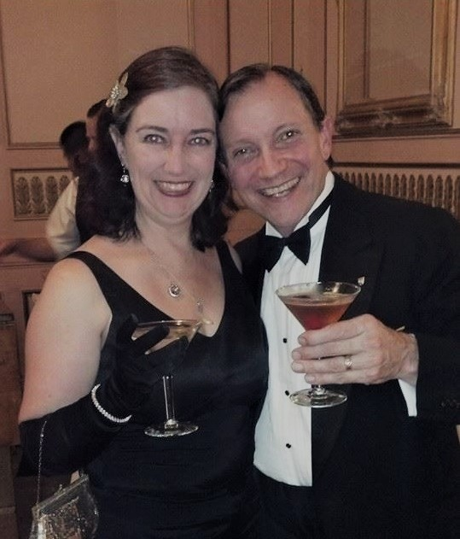

**What Next?**

I am about to send the manuscript of The Dove and the Crow to my freelance editor. She will take two to three weeks to review it and make her suggested edits. I expect it will take me two to four weeks to incorporate her edits. At that point I will contact the three agents I met at writers conferences last year. They will take time to respond.

This means for the next several months, I will be free to move on to other projects.

First up is the rewrite of Godmother. My content editor wants me to double the length of the script for that graphic novel because I have not fully played out the interactions and reactions of the characters in telling the story. I agree. It will take me more than a month to write the “full length” version.

Godmother could fill up the rest of this year, depending on how the back-and-forth goes with the artist. This will be a lot of work, but I am looking forward to sharing my whole vision.

After Godmother, I have a few shorts stories outlined or written. These are part of a series that I hope to publish as an anthology. These are weird tales. I’ve talked about the Weird subgenre here. They play with horrific themes and images but they are designed to be unsettling as opposed to frightening. All of these are set in neighborhoods around the San Franscisco Bay Area. The book would be called Bay Area Weird. I have ten planned and I have finished four. I am halfway through the fifth.

After the anthology, I have two big projects simmering on the back burner. These will each take at least a year.

The Two Flowers

When the kings of two warring city states in ancient lost Atlantis are killed in battle, their children must uncover and break a family curse to find peace. Well-meaning lies layer onto dark secrets to create what appears an impossible tangle. Can the adversary prince and princess overcome meddling gods and overreaching priests to keep their kingdoms from following their fathers' path to mutual destruction?

Status: Two act opera. Libretto completed and being modified to place it in Atlantis. Music not started.

The Price

A prince discovers the lie behind his space faring civilization’s success and gives up his life of luxury to expose the truth. The wealthy and powerful will do anything to stop him. Thus begins the saga of Cedrick, who fights and steals his way across the galaxy to find the core of the greatest conspiracy ever perpetrated. His only allies are the expendable androids who see him as their savior, for it is the secret behind their very existence he is trying to reveal.

Each chapter of this space adventure novel has a different character see Cedrick in a different way, from scoundrel to adversary to savior.

Status: Outline complete. First draft in progress. This may be either a novel or a series of comics, depending on how Godmother goes.

That’s it for this edition. I hope you enjoyed it. Please invite your friends to sign up. I am actively generating content as I never have before. This newsletter is the best place, and in some cases the only place, to hear about it all ahead of publication.

Until next month, be well!