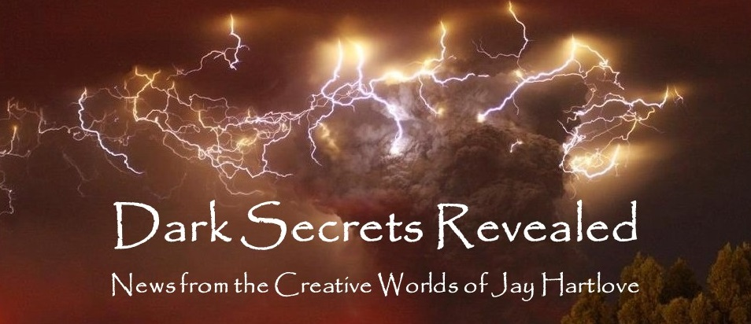

Issue 14 January 2024

You did not count wrong. I skipped two issues in November and December. My apologies. With this issue we bid farewell to 2023 and welcome to 2024. A big project at work ate my brain for most of the winter. Then there were the holidays. And dealing with a family crisis that I will not go into. Yikes. Oh yeah, and being distracted by finishing the new novel.

Yes indeed, The Dove and the Crow is finished. 300 pages and 84,000 words. That is to say, I have said everything I ever wanted to say in this book. I spend a lot of time thinking about my stories in the time I have away from them, such as at the day job, or doing laundry. I think of the characters’ reactions and the consequences of plot twists. In other words, I think of more things to say. When I get to the point where I don’t want to add anything else, when it has all been said, that’s when I know I am done. I like the acronym EIEI - Everything I Ever Intended. Of course I might think of other things later, but those other things will have their chance to be heard during editing.

In this newsletter you will find an article on my publishing journey, including the future of The Dove and the Crow. I also write here about how a believable story can transcend genre categories. Real life is messy and complicated. A protagonist can wonder, or be pushed by circumstance, from a documentary into a mystery and then into a thriller and then back into a romance. As I discuss below, genres are marketing labels to find an audience, and not handcuffs on the author or their characters. My reviewers often comment on how my stories cross genre lines, and they are glad for it.

I also have an article on the evolving scope of the Godmother graphic novel project.

I put all the back issues of this newsletter up in an archive on my website [www.jaywrites.com](http://www.jaywrites.com). Check them out if you joined late and missed some editions.

I would very much like your feedback on this newsletter. Please feel free to write me at [jay.hartlove@gmail.com](mailto:jay.hartlove@gmail.com) and let me know your thoughts. This newsletter is for you. I could set it up as a sales tool, with lots of buy links, but that’s not why I write it. This is here to share my work and insights with you.

So here’s to a new year full of possibilities!

Here are the usual newsletter columns:

1. What’s Cooking: Previews/discussion of what I am actively working on. Also links to interviews, appearances, and other current writing news.
2. Mister Wizard: Advice and analysis to help my fellow writers.
3. The Aisle Seat: Recommendations. I am a huge movie fan and watch several every month.
4. Have a Drink: Wherein I will share personal stories.

***What’s Cooking***

**Godmother Revisited**

Last month I talked about a comic book story I am developing to tell Cinderella from the viewpoint of her stepmother Madame Tremaine. I am working with an old, dear friend of mine, Doselle Young, as a developmental editor. Doselle has worked as an artist, writer, and producer for DC, Dark Horse, and other independent comix publishers. (Look up the The Monarchy series from WildStorm (DC imprint) in 2001.) My current draft is short at 16 pages and about 100 panels. He has been asking me about the character motivations and how those drive the story. After some time talking, I have come to see what he is really asking about is my motivation to tell the story.

Madonna Tremaine starts the story as a frustrated, impulsive young person. She grows up fast as family dynamics change against her.

She hastily makes a bargain with a fairy named Crucible that she comes to regret almost immediately. She is resourceful and rolls with the punches. Once she gains some control over her life, she has to cope with the ever-worsening consequences of her bargain with the fairy.

Once she has children, her conflict with Crucible becomes a war of wills. When she inherits Cinderella she has to make a terrible choice to deny the child affection for fear of Crucible taking the child to settle the bargain.

I made a lot of bad hasty decisions in my youth. I know what that feels like and I know the regret that comes later. I have also had children. I know how blinding the love of a child can be. It is easy to put the child first without considering the larger picture and whether more subtle solutions might be better.

We know how Tremaine appears cruel to Cinderella for no particular reason. I have given her a much more plausible motive. I have her behave like this because she is torn by the possibility of harm befalling her own children.

For a more in-depth description of the plot, see last month’s newsletter. If you subscribed recently and did not get the October issue, you can find it in the archive on my website [www.jaywrites.com](http://www.jaywrites.com).

In discussing these motivations, Doselle made an important observation: I am a novelist. I have written short stories, but my preferred form is much longer. The script for my musical The Mirror’s Revenge was 110 pages and the play was two hours long. The shortest of my six books is Mermaid Steel at 75,000 words. The longest is the one I just finished, The Dove and the Crow, at 86,000 words. I like to fully explore characters’ motives and the consequences of their actions. Looking at the 16-page, 100 panel script I have now, through this lens, I see that it is essentially a synopsis of the story I want to tell. It is a highlight reel, not the whole film. So we are revisiting the scope of the project.

I don’t know how long it will be when it is done. I suspect it will be twice its current length, 32 pages and 200 panels. Once we get it done, Doselle will pitch it to a comix publisher. Doselle is hiring an artist he has worked with before. The pitch package will probably include character sketches and sample pages.

If we cannot find a publisher, then the fall back option is to have the artist draw the entire thing and self-publish it. There are platforms for such publishing, which is not surprising, but still news to me. This will be expensive and I will have to stretch out production over time.

Either way, this is going to get done. And it’s going to be great.

***Mister Wizard***

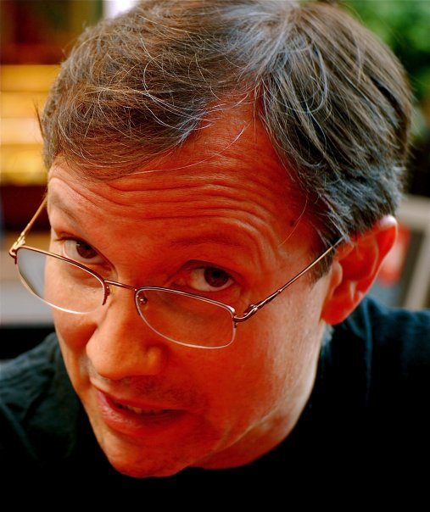**Crossing Genres Reflects Reality**

Of the hundred reviews my five books combined have received, more than half have mentioned that I crossed genres. Genres, as I have discussed here before, are marketing tools to help readers find a book they are seeking. My habit of mixing genres in a book would seem to be either me trying to avoid finding an audience or just me being obtuse. Neither is true. I am trying to portray characters and events that the reader can easily picture themselves living, even if the circumstances of the story could never happen in real life. If a reader has decided to give me their time, then I’m going to make the story seem real for them. And life is messy.

When I first wrote Chosen (which later became Goddess Chosen) I had no idea readers would be surprised that an author would mix a hero on a redemption journey with a villain on a revenge quest in a story that moves between historical fiction and religious horror. I was thrilled to find horror master John Shirley loved the book. But I was surprised at the blurb he gave me for the cover. “Jay Hartlove has fused several genres in a driving narrative sparkling with historical exotica. I recommend you buy this crazy novel.”

Some genre pairings are pretty common. Historical fiction mixes easily with romance because people fell in love during historically significant times. Military strategy mixes easily with science fiction because people will fight wars in the future. Fantasy and horror can share a book when the magic turns dark and threatening. But do readers relate to these twists of plot and mixes of tone? In real life, people are overwhelmed by unexpected events, turning their day-in-the-life comedies temporarily into horror. People fall in love with dangerous people and have their romance turn into a crime drama. Turning points and unexpected twists are opportunities to shift tone and genre. If the characters react believably to a twist in their lives, then the reader gets to ask themselves how they would have reacted.

I love my characters but I put them through hell. I test their mettle. I show the reader who they are by showing how they react to extraordinary changes. They fall in love, they exercise agency, they get frightened, they make mistakes, they reflect on their pasts and their decisions. Therefore I keep certain genre tropes in my tool kit and I pull them out when I decide a twist is the best thing to happen next in the story. I try to tailor my characters’ reactions to their personalities. It shows you that much more of who they are. I throw some very big things at them, like the betrayal of a lifelong friend, or bystanders turning into a bloodthirsty mob. I’ve had readers tell me they would have freaked out whereas my character stayed collected. Well, that says a lot about the traumas the character has already survived.

I guess I am drawn to complex problems. I could have written Mermaid Steel about how a human and a mermaid fall in love. But that wouldn’t test their love or show us who they are in the face of adversity. So I made it a story about systemic racism against merpeople. Falling in love against adversity just seemed more interesting to explore. You know, like Romeo and Juliet, without the headstrong teenager melodrama. Does that cross a genre line? Romance, fantasy, and race drama?

I admit I pushed the boundaries with The Insane God. Science fiction about both planetary physics and brain chemistry, driven by horror tropes of being taken over against your will, told by a transexual protagonist. Sounds like I threw in the kitchen sink, until you see how they fit together. The story is about coping with change. The asteroids affect people’s minds, specifically people with schizophrenia. They are forced to act upon visions from space creatures. No one in the story can cope with this much change except our heroine who is an expert at changing yourself due to her transition. She is the perfect person to tell the story of how to stop an alien invasion.

My first attempt at a novel was a fantasy called Horns. There were elements of religious fervor, a touch of romance, and dash of horror, but it really was a straight down the middle fantasy, a coming of age fantasy at that. I was young when I wrote it and I poured a lot of angst into it along with a lot of imagination. I had spent a lot of time playing D&D and reading fantasy novels. I thought my book was everything a fantasy story should be. I still love the characters and think it has some of the best visuals I have ever come up with. The big publishing house editor I got to read it said it was not as imaginative as the competition, and it needed to be more so to make a mark. After licking my wounds, I realized I had my protagonist rolling with the punches and dealing with the conflicts, but it boiled down to my hero versus the villain. There was no turning point, no escalation that showed the hero’s true strength. We didn’t get to see why he was unique.

Ever since then I have written my characters to have backgrounds that set them up to be the best possible person to tell the story. That means when I throw some outrageous change at them, they get to shine in their own unique way. Sometimes my changes come in the form of a shift in the story’s tone to cross into a different genre. I cross those lines because life throws curve balls, and change brings out my characters’ strengths.

What other authors do you read who cross genre lines? Do they make it work? Does it make sense? Do they spring the change on you so that you start off thinking the book will go one way and then it goes another? Do the characters’ reactions to that shift tell you more about them?

***The Aisle Seat***

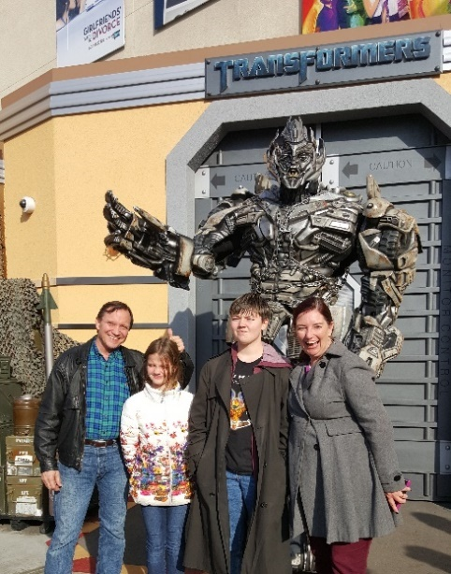

**The Killer**

I have heard several actors say that the difference between acting on stage and on film is the subtlety of expression On stage you need to react big enough for the whole audience to see. A camera picks up every twitch and blink, so the acting should scale down. Michael Fassbender understands this. This is a fairly typical hitman story about patience and resourcefulness. It takes a nice turn when things go wrong and he becomes the hunted. And then they turn again when he turns the tables again and becomes the hunter. The story depends almost entirely on our protagonist’s reactions and calculations. There are lots of close ups on his face as he races to keep up with, and then surpass his adversaries. There are lots of engaging supporting parts as well, in particular Tilda Swinton. This film won’t win any awards, but if you are a fan of hitman and gritty spy movies, then check it out.

**The Marvels**

Remember when comicbooks were fun? The makers of this film do. Sure, this story ties back to a serious thread in the MCU. Most comicbooks are part of an ongoing story that often explores a deeper and/or darker theme. Comicbooks usually have a moral. As an artform they are sometimes discounted as immature because they keep their adventures fun. For this reason this film impressed me as more comicbook than a lot of superhero movies. Bringing in two inexperienced heroes to help a veteran hero deal with an old mess is a great way to tie into the larger MCU arc while keeping it fun. Lightyears better than the travesty that was GotG3.

Good effects and action – check

Acting with heart – check

Good campy villain – check

Fun worldbuilding – check

Strong family theme – check

Teamwork wins the day – check

Fun time at the movies – check

**She Came to Me**

This film reminds us that romances can be fun too. This one delightfully takes familiar romance tropes and gives them a twist. Not only does a chance encounter give our protagonist hope for surviving his failing marriage, but also his failing artistic career. He is shocked and tries to deny that she could be his muse, but it is clear she is. Helping a young couple who are falling in love is another familiar trope, but I thought it cleverly added urgency to the main romance. The actors are all terrific in these parts. Peter Dinklage is perfectly frustrated, confused, and overwhelmed. Marisa Tomei is a force of vital energy. And Anne Hathaway clearly had a ball being zany. Lightweight and a bit tidy, but a lot of fun.

***Have a Drink***

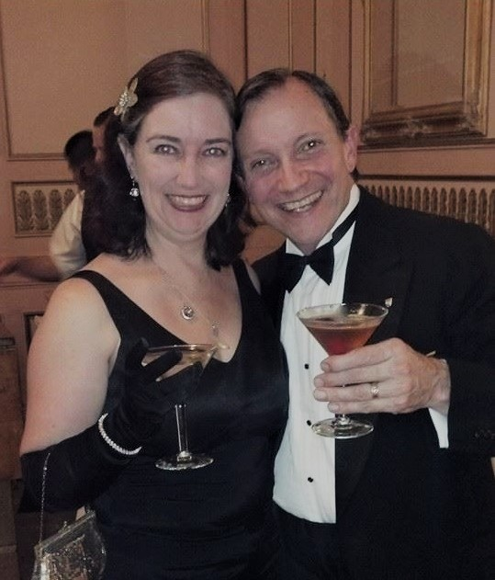

**My Publishing Journey**

As of this year, I have been writing fiction for forty years. I wrote Supergame in 1980 and them rewrote it for a Second Edition in 1984. It was right after that I started working on Horns. Horns is a sword and sandal high fantasy that benefitted from years of my playing fantasy RPGs and watching fantasy movies. You will recall the 1980s produced some amazing fantasy films. My creative mind was right there. Of course, I had no formal training and really no idea about even the basics of novel writing. The book is loaded with clichés and voice errors.

I wrote it in a writers’ group that I formed with Janine Goldfarb Young and her future husband Doselle Young. We met every week with several other friends and read aloud what we had written that week. It was highly motivating and

great for spotting inconsistencies and character POV issues. It was not great for spotting the kinds of problems an editor finds by looking at the page.

In the 1980s, the editors of big publishers were fishing for new writers at science fiction conventions. I met three of them and pitched the book. Melissa Ann Singer actually met me for lunch and we talked about the book. Shawna McCarthy was kind in her rejection letter. Laura Ann Gilman wrote me a very nice rejection letter wherein she told me to keep with my writing even though this book did not connect with her. I have mentioned before in these pages that her letter, and the encouragement of all these editors I met, was why I stuck with this lonely vocation that gives so little feedback during the process. Looking back at Horns now, I have to thank these professionals for being so kind. The book is a mess. I started to fix it a few years ago and realized I would need to rewrite it entirely.

By the late 1980s I became attached to the idea that the biblical book of Exodus was not telling the whole story, that there was a court intrigue that drove the familiar events. This led me to research the historical events around the Exodus story. As it turns out, this is one of the biggest rabbit holes in all of biblical research. There are several pharaohs who could be the Ramses of the Bible, and there are several similar stories before and after the time popularly attributed. The fact that there is no mention of the events in any Egyptian writings is further frustrating. What were the plagues? Which king was on the throne? What was the impact to nations afterwards? There are so many conflicting pieces of data and so much conjecture. I decided to stick to the story I was telling. There was ample evidence to support it, all the way down to the individuals I claim ran that court intrigue.

The intrigue, of course, was that the fallen Hebrew archangel Sammael (later known as Lucifer or Satan) wanted to destroy the Egyptians for their insolence in believing themselves separate from Yahweh’s creation. He nearly succeed in Exodus. The gods of the Egyptians had been adopted across Africa, and in adapted forms, made their way to the Caribbean with the slave trade thousands of years later. That meant I needed to research Haitian Voodoo as the inheritor of this pantheon and faith. That was another rabbit hole to go down. There was also a fair amount of research on Malaysia and the religions of Korea. This book really went places.

By the time I was done with the research and had finished the first draft of the novel, twenty years had gone by and it was the early 2000s. I did this research before the advent of computer search engines. I travelled to England and New Orleans to visit museums, occult bookstores, and talk to people. I bought dozens of books.

The book I wrote was huge and complicated. I thought it had to be to cover the topic. But it was not an easy read. Beta readers said they liked where I went, but that the book structurally seemed flawed. No one could tell me what was wrong I hire a freelance editor, one who knows ancient Egypt. Hundreds of dollars later, she gave me back a line edit but said she could not tell me how to fix it. After a year of tinkering, I put it on the shelf and moved on to other projects.

I put developed outlines for a space opera called The Price about freeing robots from slavery. That outline is still simmering on a back burner. I toyed with fixing Horns. My wife and I were raising children by that time, so a lot of my mental bandwidth went there.

Finally, in about 2005, I picked up The Chosen and realized it was two main story threads that I had wound together, and that they did not need to happen concurrently, but could work even better sequentially as a book and a sequel. I unwound the two and they became The Chosen and Daughter Cell. I finally had a salable product.

By the early 2000s, the publishing industry had changed significantly from what I saw back in the 1980s. Mergers had reduced the number of big publishers of science fiction books from over a dozen to only six. They all had imprints, but an author really only had six sets of editors to convince I made inquiries and never heard back. I tried contacting agents. The few with who I made contact were uninterested. My story wasn’t the kind of thing they were looking for. They were tied to the market of what the few publishers were looking for. I did not write to a market. I never have. Markets move too quickly and change away from what you’re writing.

After two years of getting nowhere, I started researching small press publishers. Because the big houses had created this barrier, the 2000s were a time when lots of small press houses were opening. Most of them had no idea what they were doing. They charged fees, they threw together garbage covers, they had no real contacts to promote, and they often had terrible long-term contracts. I finally found one that looked reasonable.

Damnation Books had been producing a science fiction and horror magazine for years, and they seemed to understand how to make the leap into book publishing. They changed The Chosen into just Chosen because they thought there were too many books called The Chosen. Other than that, they produced the two books with few other changes. They line edited them and gave them good covers. They printed them in an odd size that was not quite trade-paperback and not quite mass-market paperback. But they were good looking books. They helped me promote the books. I entered Chosen in a contest and it won Best Thriller at the Independent eBook Awards. I met horror master John Shirley at a World Fantasy Convention. I was lucky enough to be on a reading panel with him and he said he liked what he heard. He wrote me a wonderful cover blurb. I tried to hire the Rosicrucian Museum in San Jose, which is a re-created Egyptian temple grounds, to have a launch party. Their religious leader did not like how I made the reincarnated Egyptian High Priest to be the villain, and he denied my application. So Chosen is a banned book!

I then saw that what I had started in the two books really needed a conclusion to wrap up all the threads I had started. So a third book was needed. That’s when Damnation Books went out of business. I turned my attention to finishing the third book. I became obsessed with doing justice to the bigger story arc. So many trilogies drop the ball at the end. I was determined to get it right. But I had so many threads, I started to think it was impossible. I realized I had been stuck in this world for twenty-five years. I need a break to regain perspective.

With no publisher and no deadline, I decided to take a break and write something completely different. A palette cleanser, so to speak. I normally plot extensively, research facts, plug them in and build a story that I know will work before actually writing the prose. I also had been writing thrillers, using structures like the Fichtean Curve where one crisis leads to another. I decided to write a romance, by the seat of my pants with no outline. I would publish it online as I went so I could not go back and edit anything I had written so far, forcing myself to push ahead. This produced the first draft of Mermaid Steel. I ran it by some friends who read romance and they gave me great advice. To my surprise, the story worked and I really like the characters. So did my fans who gave me feedback. I went back and added in all the things I had thought of in the meantime, and that fleshed out the book to its current form.

As soon as I picked up the third Chosen book I saw how to finish it. That was a joy. All those threads going all the way back to the first pages of the first book, all wrapped up in a big blockbuster ending.

Meanwhile, I was trolling publishers to find someone who was willing to reprint the first two Chosen books if I had the trilogy completed. Word was, this was a tall order. Baen was one of the few big houses known to ever do this, and they typically take a year to tell you if they are interested. I finally bumped into Steven Radecki of Paper Angel Press at a Baycon. He was amenable and suggested new covers, new unified titles, and editing the first two books to drop breadcrumbs and tie all three together. Steven released them every eight months, Goddess Chosen, Goddess Daughter, Goddess Rising, and then eight months later, Mermaid Steel.

When the trilogy gathered lots of very positive reviews on Amazon and GoodReads, I felt maybe I had figured out how to write novels. When Mermaid Steel took Silver at the BookFest Awards, I started thinking about who my audience is. I have never written for a market. I feel I can share my passion with a reader better if I am telling a story I am excited to tell. Readers can tell if it comes from my heart. On the other hand, I need to know who my audience is to be able to reach them, to let the right people know what I am offering. At this point I had written a supernatural thriller, a medical thriller, a superhero fantasy, and a fantasy romance. Upon closer reflection, I had written books about revenge and redemption, betrayal and forgiveness, justice, and love overcoming systemic prejudice. Hold on, these are actually stories about a radicalized man, a betrayed man, a wronged woman, and a woman who has been discriminated against. I have been turning victims into heroes. So, my audience is people who want to see victims overcome.

With that in mind, I launched into my most ambitious novel, The Insane God. It mixes astrophysics with brain chemistry, and gender identity with cult violence. It is about a girl who is overwhelmed by unwanted change who, by being transgender, succeeds by being the only person who can cope with that much change. She starts out being the victim of mental illness and psychic influence who wins by turning herself into the perfect weapon. Readers were dumbfounded at the audacity of this book. Science fiction master David Brin endorsed it. It was selected as a Finalist by Chanticleer Book Reviews, beating out hundreds of other books.

So maybe this means I know what I’m doing and I should try to breach the high walls of traditional publishing again. That means writing a book that excites an agent enough for them to put their reputation on the line and pitch to an editor at a big house publisher, and that will excite that editor enough for them to put their reputation on the line to pitch it up to their organization.

Right now I make between 50 cents and dollar for every book I sell, depending on format. With the DIY marketing I have on five books with a small press, I sell a couple hundred books a year. With a traditional (big house) publisher, I would make 3 or 4 cents per sale, but I would sell in the thousands, not hundreds, because of the big house reputation and contacts. So I will not make any more money. BUT, I will grow my audience by orders of magnitude. And they will all also buy my backlist, for which I make much better money per copy. By the way, this is the path that Brandon Sanderson took. He had six books in print with small press when he finally got discovered by an agent. He is now the highest selling science fiction author alive.

This is my plan for The Dove and the Crow. I travelled to several conferences over the last two years and have talked to a handful of agents who said they were interested. This book is not as ambitious as The Insane God. On the surface it is a straightforward portal high fantasy. What sets it apart is it is about healing, not conquest or justice. A woman who survived spousal abuse falls into a parallel world that is nearing cataclysm due to a failed love triangle among their living gods. The people of this world, including a powerful witch she befriends, have tried everything they know, but she understands what the troubled goddess is suffering. I expect my audience will be mostly women. The market seems open to this kind of story, even though I did not aim for this market. The book is finished and with a trusted beta reader. After I incorporate his feedback, I have hired a freelance editor who edits fantasy full time for a British publisher and as a side gig. After that editor’s changes, it will go to the agents. I will keep you posted on the feedback.

Wish me luck.

That’s it for this edition. I hope you enjoyed it. Please invite your friends to sign up. I am actively generating content as I never have before. This newsletter is the best place, and in some cases the only place, to hear about it all ahead of publication.

Until next month, Happy New Year!