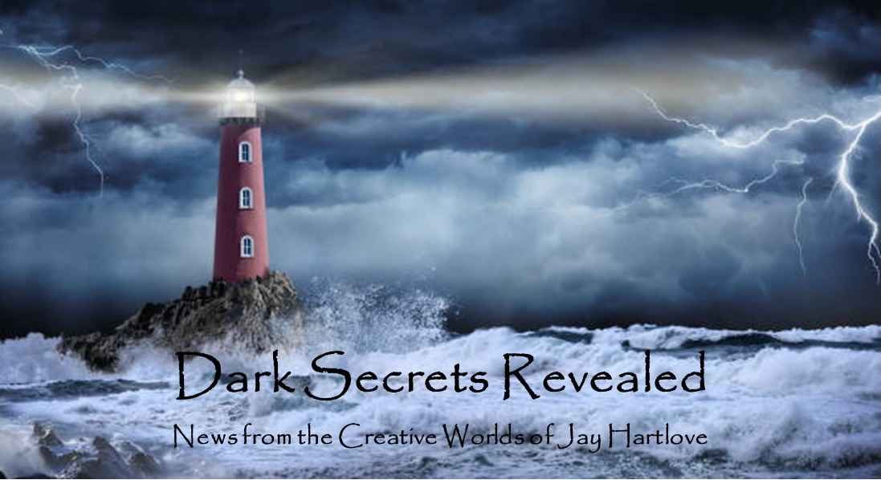

Issue 16 March 2024

My big news this month is the editing of The Dove and the Crow. Having run this process a few times, I can confidently say that my job in writing the drafts is to include everything I ever wanted to say in a story. The editing process is to fix the words so that the book actually says what I was trying to say. As I have discussed here before, I do a lot of rewriting as I produce the drafts. But once it’s all down, this process goes fast and shows immediate results. Writing is sculpting. Editing is sanding and polishing.

My editor gave me line edits throughout and a list of objectives. Several hundred word-frequency and overused phrases later, I was left with one major structural flaw. The all-important first chapter was trying too hard to do too much too fast and it broke down. I discuss the fix in the article below on Writing Cinematically.

Below also is an article on whether books should have messages the readers can use. I usually explore literary themes, but are those anything a reader can take with them after they finish the book?

I finish this month’s newsletter with a treat for you, my biggest fans.

I put all the back issues of this newsletter up in an archive on my website [www.jaywrites.com](http://www.jaywrites.com). Check them out if you joined late and missed some editions.

I would very much like your feedback on this newsletter. Please feel free to write me at [jay.hartlove@gmail.com](mailto:jay.hartlove@gmail.com) and let me know your thoughts. This newsletter is for you. I could set it up as a sales tool, with lots of buy links, but that’s not why I write it. I do this to share my work and insights with you.

Also, let me know what you thought of Goddess Revealed. Did you find it interesting? Did it make you want to go back and read the trilogy? Do you think it is a good incentive to sign up for this newsletter?

Here are the usual newsletter columns:

1. What’s Cooking: Previews/discussion of what I am actively working on. Also links to interviews, appearances, and other current writing news.
2. Mister Wizard: Advice and analysis to help my fellow writers.
3. The Aisle Seat: Recommendations. I am a huge movie fan and watch several every month.
4. Have a Drink: Wherein I will share personal stories.

***What’s Cooking***

**Messages in the Books**

I have said a lot in these pages about how I try to turn victims into heroes while addressing moral issues. I like to say my books are “about something” in addition to being entertaining. If I am going to spend years of my free time writing a book, then I feel I should have something to say. Among others, I have had a radicalized man find redemption, a betrayed man find forgiveness, and a marginalized girl save a world that hates her.

While my readers may like to read about characters who rise above, they might like to see characters they can identify with succeed even more. If I’ve done my job, the readers will understand and empathize with my protagonists, but how many of my readers personally have been possessed by a goddess? Does my writing fantasy remove my work from that immediacy? Is it a stretch for my

readers to see themselves in such extraordinary circumstances? Other than perseverance, have I given my readers examples that they can use in their own lives? Should I be concerned about giving my readers a “message” they can use?

In Mermaid Steel the message is to take the high road. That can mean expelling anger which can be a tough choice. In Goddess Rising the message is to trust in the team. Again, that’s useful but a high hurdle when you’re under pressure.

Literary Fiction is marked by commentary on larger issues or the exploration some part of the human condition. I guess I’m doing that. Of course Literary Fiction is a term almost always paired in contrast with Genre Fiction. Why can’t my work be both?

Before I crawl down that snobbery hole, I am happy to report I may have struck a balance with the WIP The Dove and the Crow. The book is “about” recovering from abuse. Willa is someone readers can easily identify with. A series of abusive relationships has left her questioning her self-worth. Her extraordinary circumstance is she is given an opportunity to start over with people who know nothing about her. Stripped of reminders of her baggage, she shines. This attracts someone with whom she falls in love. But her scars have wired her to suspect that too good to be true is in fact too good to be true.

I have struggled with how things work out well for Willa because she found Naomi. What about those readers who haven't been so lucky as to find someone willing to risk death for you? I worry that folks who are hurting are going to dismiss the book as unrealistic and unhelpful. So I've taken a step back to look at the message being sent. I think it looks like this:

If you have suffered abusive relationships that left you doubting whether you deserve love, then don't let that stop you from showing your other strengths. Do what you do well, let your flag fly. If that attracts someone who believes in you, then don't push them away. They will be key to you learning to believe in yourself again.

Hopefully that lesson will be easy for folks to apply, and therefore that much easier for them to sympathize and identify with both Willa and Naomi.

***Mister Wizard***

**Writing Cinematically**

I've been told by fans that I write cinematically. I always took that to mean they found it easy to visualize scenes from my writing. I have recently discovered it may also reflect how I pace my stories.

I originally wrote The Mirror's Revenge as a screenplay. When I rewrote it for the stage, I realized changing the audience's perspective with each scene meant changing the stage every few minutes. I tried to combine and rearrange scenes to cut down on the scenery traffic, but we were still whipping furniture on and off the stage for the whole two hours.

When I recently watched Oppenheimer, I was taken by Christopher Nolan's understanding of pacing through how long each shot lingered, or did not. During tense or high action sequences, each camera shot would last only a couple of seconds. In reflective scenes, the camera would linger for a minute or more. This editing and camera cadence is part of the art of cinema.

I grew up watching far more films than reading books. When I think about how a story unfolds, I blithely shift to different locations and different sets of characters to give my reader what information should come next. I often run stories on multiple rails, and I will shift between them to give the reader a sense of simultaneity.

Some thriller writers use this to excess. For example, James Patterson changes chapters every three or four pages as he changes the scenes. His books have upwards of seventy chapters. I always suspected he was writing for readers who only get to read on workplace bathroom breaks.

This is, I now learn, a cinematic pattern. Plays should run on as few sets as necessary, with the action proceeding at one location for sometimes entire acts. Movies bounce around because film editing lets you do that. Books should be somewhere in between.

My four thrillers bounce around a lot. It adds to the sense of urgency. My romance lingers on each setting longer to build mood. What I did not realize is, the bouncing takes a lot more work for the reader because they need to reset their sense of living in the scenes. In movies the whole set changes for you. You're along for the ride. In a book, the reader needs to keep up.

I recently watched the third season of HBO’s True Detective. The story centers on two detective partners who spend 35 years solving a missing child case. Action happens in 1980 when the crime happened, 1990 when the case is reopened, and 2015 when the detectives finally solve it in their old age. The camera jumps between the three timelines at every scene change. Watching the mystery unfold was fascinating, but frankly a lot of work. It was taxing even with all the visual cues each era supplied. I am both an experienced film buff and a writer, and building the puzzle out of order made me glad for the pause button. If not for the compelling acting, I can see where a casual viewer would give up after a couple of episodes.

Readers need to work harder to visualize than filmgoers. With them working harder to begin with, an author should not make them work even harder by resetting the stage every couple of pages. My WIP The Dove and the Crow is my best example (and my most recent lesson). The book is comprised of seven chapters of about 45 pages each. The first chapter has 15 scenes. That means, on average, each scene is only three pages. There are two timelines. To show the reader the intertwining of the timelines, my first draft bounced to a new locale with each scene change. I never let the reader spend enough time in each locale to get a feel of being there. More importantly, the reader did not have time to learn enough about the characters’ situations to care about them.

Once this was pointed out, I rearranged the same scenes into seven locale transitions. That is, the first three scenes all take place back-to-back in generally the same place. This allows the reader to build a sense of place and to care about the people. As it stands now, the sequence and locales are as follows:

Earth: several scenes showing Willa’s life and her emotional baggage

Hern: a couple of scenes showing the wizard who builds the Hern side of the portal

Earth: a couple of scenes where Willa encounters the perfume that enchants her

Earth and Hern: a couple of scenes showing the Earth scientists opening their half of the portal

Earth: a couple of scenes showing Willa’s life falling apart

Earth and Hern: a couple of scenes of the scientists and wizard experimenting with the portal

Earth: Willa falls from Earth to Hern

The book is now back with my editor for a second round of fine-tuning edits. I’ll let you know if she agrees with my rearrangement solution. In the meantime, here is an early cover concept I am considering. Of course, if all goes well, the book cover will be designed by the publisher, not me.

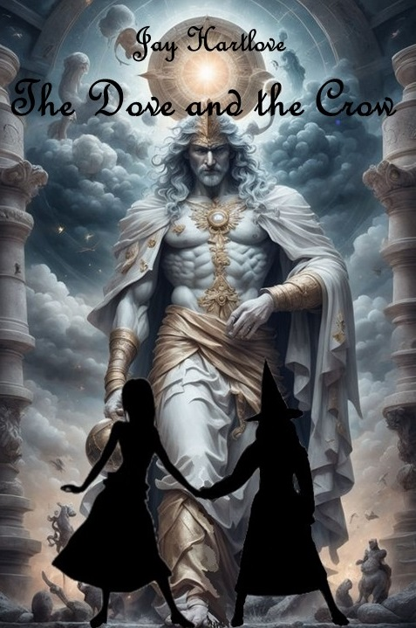

***The Aisle Seat***

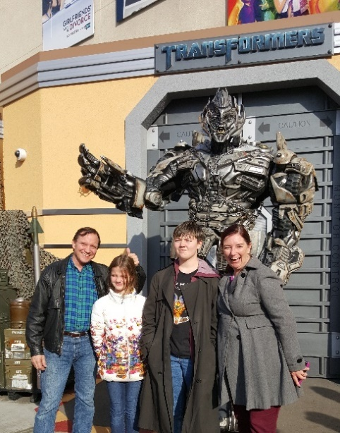

**Out of Darkness**

If you’ve been counting, you may have noticed that I have not reviewed Barbie. I loved it but I will not offer a critique. There has been so much commentary that I don’t think I could add much else that hasn’t already been said.

On the other hand, Out of Darkness will probably come and go without anyone noticing. That’s a shame. It is really well-made with some great acting and a powerful message that should be heard. I cannot tell you what that message is without giving away the end of the movie. I can tell you it hits all the right notes. When it’s scary, it’s really scary. When it pulls at your heartstrings, it does a great job. Gritty pre-history survival against possibly supernatural unknowns. I admit, I am a sucker for stories about bravery and perseverance. Yes, they invented a language. With so much care

on the screen, this was obviously a passion project for all involved. Highly recommended.

**Drive Away Dolls**

Ethan Coen made this movie without his usual collaborator brother Joel, but it still has all the quirkiness one hopes to find in a Coen movie. Their best work is usually about desperados, people either running away from something or at the end of their rope, or both. It’s almost like they have a theme: people in trouble can be hilarious. This one plays in that same sandbox. Gangsters chasing a couple of women down the east coast looking for a mysterious box in the trunk of a rental car while the women have no idea they are being pursued. Accidents and misunderstandings combine with whiny mob bosses and quite a bit of free love. Ridiculous cameos from Matt Damon and Miley Cyrus cap things off. Not a big screen movie, but still a lot of fun.

**The Retirement Plan**

Sadly this one was nowhere near as much fun as it should have been. It should have played with the same zaniness as Drive Away Dolls, but the script just failed. Nicolas Cage plays a retired assassin rescuing his estranged daughter and granddaughter from incompetent yet lethal gangsters, played for laughs. With Ernie Hudson. This should have been hilarious. There was nothing funny or charming about this movie. Nothing. It’s as if the screenwriter died halfway through his first draft, and the Director quit just before shooting started. By the way, that is pretty much the entire plot. And I don’t mind giving it away because I don’t want you to go see this one. I hope Nicolas Cage and Ernie Hudson have other real projects lined up soon to erase the public’s memory of this bomb.

***Have a Drink***

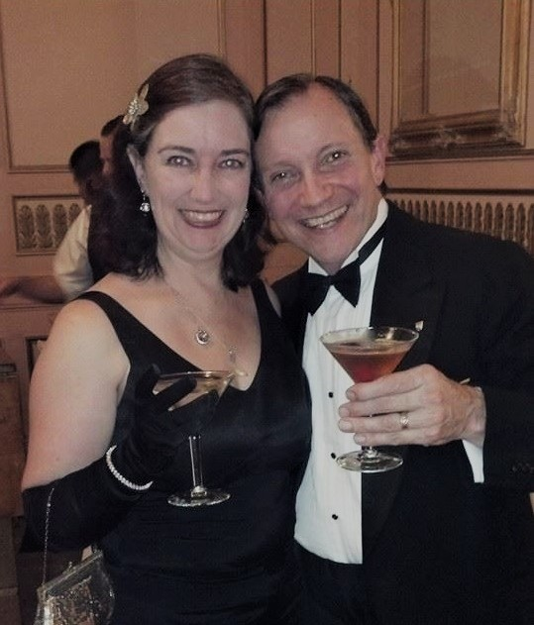

**Excerpt**

You’ve been patient long enough. Thank you. Here is an exclusive excerpt from The Dove and the Crow. Only my beta reader and my editor have seen this before. This scene is in the third act. It should give you a feeling for how the story unfolds without giving away too much of the plot. Enjoy.

It was slow going as they picked their way around exposed boulders and roots, and navigated loose soil. Doing so with one hand holding a torch did not help. The crack did not get any smaller as they descended. After a while, Willa turned around and could no longer see the opening. Despite the size of the tunnel, she started feeling closed in. At least their torchlight reached the top some fifty feet above them,

although she wondered if they should be concerned about a cave-in.

A clicking sound up ahead made them both freeze. It was not loud, but Willa recognized it from the Utam Kasca caverns. She expected male flyers to attack first, but a whistling sound came with a volley of arrows. Naomi deflected them with a “Shield” spell. Willa ducked for cover in case. Then she noticed the air smelled of smoke, and everything became darker.

“Hold your breath and run!” Naomi ordered. They scrambled over the broken terrain as quickly as they could to get away from the cloud of poison gas the Lumessi had drawn up out of the soil. Naomi handed Willa her torch, then stood up with both hands out and yelled, “Spark,” which lit everything flammable in front of her, including exposed tree roots and the Lumessi’s leather body armor. As they scrambled to disrobe, she advanced and pointed at the airborne flyers one by one, casting “Heavy!” which forced them to the ground.

Three of the horned females stood up and yelled something Willa could not understand but which filled the cavern with a deafening, echoing roar that persisted. Willa was holding the torches so she couldn’t plug her ears. *Does that sound cancel Naomi’s spells?* She saw Naomi grimace and make hand gestures. Whatever she was trying did not have any visible effect. Suddenly, the three Lumessi women stopped their siren call and yelled in pain. The males that Naomi had not pinned down flew to their aid and seemed to struggle with their women’s feet. Naomi advanced and Willa followed.

Naomi’s fierceness in battle left Willa in awe, which was good since Willa was feeling pretty useless. A female clinging to the tunnel wall yelled a word in Lumessi and Willa heard a loud snap above them. Naomi parried the falling stalactite with a “Seize” spell and counterattacked with an “Avalanche” spell, knocking the assailant off the wall and partially burying her in rubble.

Willa noticed that Naomi and the Lumessi were only using gravity-based magic, even though Naomi knew lots of other kinds of magic. *She’s only fighting them with their own spells. And none of her attacks are lethal.*

Naomi ran up into a circle of them. Willa didn’t understand her strategy but followed close behind. The enemy immediately closed in, and Naomi threw up a “Barrier.” The red-bodied attackers slammed against the invisible wall, clawing and punching it to no effect. “I could kill you all with a word,” Naomi warned. “I have shown you I have mastered your magic, and I have shown restraint. We are your prisoners. By your own law, you must take us to your Riccot.”

The nine Lumessi around them quickly conferred and started nodding. One of the horned females stepped forward. “We will take you. No harm will come to you as our prisoners.”

Naomi said, “Unblock.”

One of the winged males seized Willa by the right arm. She cried out and pulled away, dropping her torch. His claws cut open her palm.

Their leader yelled, “I said no harm!” as she pointed at the male, who tumbled back from her magical punch.

They proceeded without incident down to where the tunnel opened into a cavern. The hall was lit by fires in pits all around the floor. Upon closer inspection, each pit was at the center of alcoves that were carved into the rock to form huts. The Lumessi were gathered around those fires in what Willa assumed were family groups. As they walked down to the floor, Willa noticed many of them were being treated for wounds, as if there had been a battle.

Up close, she also studied their captors’ features. Their long, lean limbs were matched by overlong fingers and elongated faces with high cheekbones. Their red skin was actually variegated, ranging from dark orange to very dark brown. Their thick, straight, black hair was braided back in tight rows, the same as she had seen on the warriors on Utma Tasca. Their armor, albeit burned by Naomi’s spell, was well-crafted with carved insignias. Willa thought they were elegant, even if they did look like Earth devils.

Traversing the cavern, Willa and Naomi noticed a large side passage that was blocked by what seemed to have been a cave-in.

The path up the center of the cavern floor led to a large structure of terraces and enclosures beautifully carved into the far wall. Their escorts walked them up the steps of this palace.

Two male and two female guards came out and took up position either side of the landing. All four carried long spears and were very muscular and heavily armored. Their queen strutted out on her clawed, bird-like feet, dressed in a gown made of strips of black-and-red leather that flowed from a jeweled collar and belts around her body, hanging down to drag on the floor. Her curved horns were covered in gold, the same as the horns on Naomi’s Helmet of Power. Her black hair was swept up in a dramatic pompadour. Her cheekbones and the angle of her eyes were even more severe than the rest. She was followed by an entourage of half a dozen, all dressed in more modest versions of the queen’s outfit.

Naomi took off her hat.

“Are you Naomi Delecor, Frieden’s witch of Filada?”

“Yes, Your Honor. This is Wilhelmina Freedlund. I’m sorry, I don’t know your name.”

*Your Honor. So she’s a judge, not a queen*.

“I am Hadshup the Third, Riccot of Ungenis. Both of you stink of the God of Death. Why is that?”

“We negotiated a bargain with him recently. I smell his presence here as well.”

“Did you send him to rape our Holy Mother?”

“No, we brought him the Light of the Moon to give to Filada as a token of his constant love.”

“Constant love?” she scoffed. “With Hulud dead, and her in chains, who’s to stop him from forcing his rapine lust on her?” She stomped down the stairs to face Naomi. “I’ll tell you who. I did.”

Naomi nodded toward the cave-in. “You triggered that avalanche to block him. And he shook the countryside in his anger as he left.”

“That’s right.”

“Gand was coming to free her. We talked with him on top of Utam Kasca and he proclaimed his undying love for her. He took the Light to give back to her. Hulud has prevented Filada from seeing Gand for centuries. She has lost hope of ever seeing Gand again.”

Willa noticed that her entourage perked up at Naomi’s explanation.

“She’s better off without him.”

Willa couldn’t hold her tongue any longer. “As terrible as Hulud was to her, he was the only love she has seen for hundreds of years. She has stopped sharing her magic with the world. Surely you’ve felt that. She needs to know Gand never stopped loving her.”

“Our Holy Mother is the source of magic that keeps us alive. If she leaves, we will perish without her magic.”

Again, the entourage reacted on their own, with some nodding but others frowning.

“I am tied to her magic as well,” Naomi said. “Filada has given up. The world is dying with her withdrawing and mourning Hulud. Hulud chained her for himself. Gand has never done her harm.”

“You may use her magic, but you won’t die without it. We will.”

*That makes no sense. Filada will give the world more magic once Gand rescues her. Hadshup is afraid she will lose her position as defender of the goddess.*

Naomi met her gaze. They both nodded toward Hadshup and then to each other.

*They stopped attacking when Naomi invoked their laws of combat. Hadshup’s ministers are making up their own minds. Fairness matters to them.*

Willa stepped forward. “As the master of justice among your people, I offer myself as collateral that we are telling the truth, that Gand means to free Filada, not harm her.”

Naomi blinked in surprise and the entourage leaned in.

Hadshup frowned. “You are my prisoner, why shouldn’t I kill you now?”

“That would not be just. I have done nothing to deserve such a punishment. If Gand returns, and you let him go down to Filada, be ready to repel him. If he does her harm, then come kill me. If he does not, then you will see we are right.”

The ministers checked each other and then all nodded. Hadshup noticed.

Willa pressed. “Filada will give the world more magic if she is happy. Please give her the chance to be happy again.”

The Riccot’s stare faltered.

Willa stuck out her bleeding hand.

Hadshup started to raise her hand to match. Naomi dropped her hat, and in one fluid motion, pulled out her belt knife, snatched up Hadshup’s right wrist, and drew a small cut across her palm. The four guards dropped their spearpoints to inches from Naomi’s neck, and she did not flinch. Willa and Hadshup were astonished by the move. “Seal it in blood,” Naomi said.

Hadshup checked her hand, waved off the guards, and shook Willa’s. Willa was amazed not only that she’d agreed against her own self-interest, but that Naomi had put such faith in Willa’s claim that a blood handshake would be as binding in this world as it was back on Earth.

Naomi pulled out a white cloth and clasped their hands to capture the blood. Willa watched her tuck it into a vest pocket. “There are soldiers coming to investigate. I will close the opening if you excavate the path to Filada.”

Hadshup turned to Willa. “If this goes badly, I will find you.”

Willa bowed her head. “Agreed.”

That’s it for this edition. I hope you enjoyed it. Please invite your friends to sign up. I am actively generating content as I never have before. This newsletter is the best place, and in some cases the only place, to hear about it all ahead of publication.

Until next month, be well!